**BAPTA AFRICAN SAFARIS ITENERARY**

**6 DAYS LUXURY WESTERN CORRIDOR MIGRATION**

(**Tarangire, Western Serengeti, Ngorongoro Crater & Lake Manyara)**

**PARKS**

**• Tarangire National Park**

**• Ngorongoro crater**

**• Lake Manyara National Park**

**• Western Serengeti**

OVERVIEW

This 6-day luxury safari on the northern circuit of Tanzania, takes you to the most famous and incredible parks whereby you will visit all major parks which are Tarangire, Serengeti, Lake Manyara and Ngorongoro. In Tarangire, you will be astonished by the large African elephants as well as the huge and ancient baobab trees. Ngorogoro crater will be the icing on the cake and the best place to visit the endangered black rhinos, Lake Manyara National Park which is famous for the tree climbing lions and the birds’ population as well as the western corridor of the Serengeti following the great migration. You will sleep in luxury lodges with private showers.

**DETAILED ITINERARY**

**DAY 1: ARRIVAL AT THE AIRPORT TO ARUSHA**

Upon arrival at the airport in Arusha (ARK) or Kilimanjaro international airport (JRO), you will be met and welcomed by your representative from Bapta African Safaris who will give you a short brief before you drive to your lodge/hotel in Arusha for overnight.

**Destination: Arusha city**

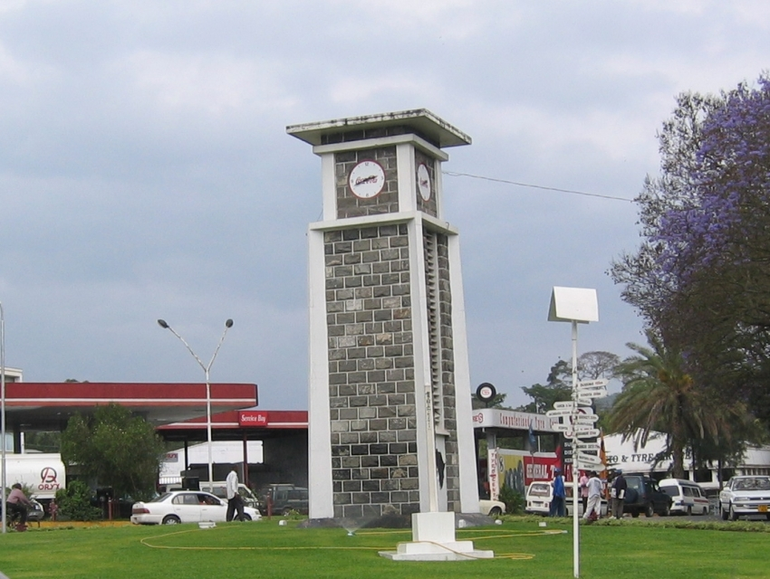

**Accommodation:** Mount Meru Hotel / Arusha Coffee Lodge / Gran Melia Arusha

Meal: Bed & Breakfast

**DAY 2: ARUSHA TO TARANGIRE NATIONAL PARK**

Early morning after having breakfast at your hotel in Arusha at around 0730hrs to 0800hrs you will be picked up by your personal driver guide and depart straight to Tarangire National Park whereby the drive is approximately 2.5 hours to the gate. Tarangire National Park is located on the northern part of Tanzania with a wide variety of animals and landscape whereby the best part is the elephant herds. It is known to be the park which has the greatest concentration of African elephants and the ancient baobab trees. Tarangire has an area of approximately 2603 square Kilometers and within the park it is possible to see plenty of animals like the giraffes, Zebras, Buffalos, warthogs, Lions, Leopards, Impala, gazelles, dik dik and many more species. In this park, there are more than 500 birds’ species like the bee eaters, swallows, ostriches, kori bustards, hammerkops, vultures etc. The word Tarangire comes from Mbugwe tribe whereby “Tara” means river and “Ngire” means warthogs therefore it is the river of warthogs. The Tarangire river is the life giving opportunity for both herbivores and carnivores and it is the best spot for the lions to hunt their prey as they search for water especially during the dry season. Lunch will be served at a picnic site at around 1200hrs to 1300hrs and after that you will proceed with your game drive until in the late afternoon where you will exit the park and drive straight to your lodge in Karatu for relaxation, dinner and overnight.

**Destination: Tarangire National Park**

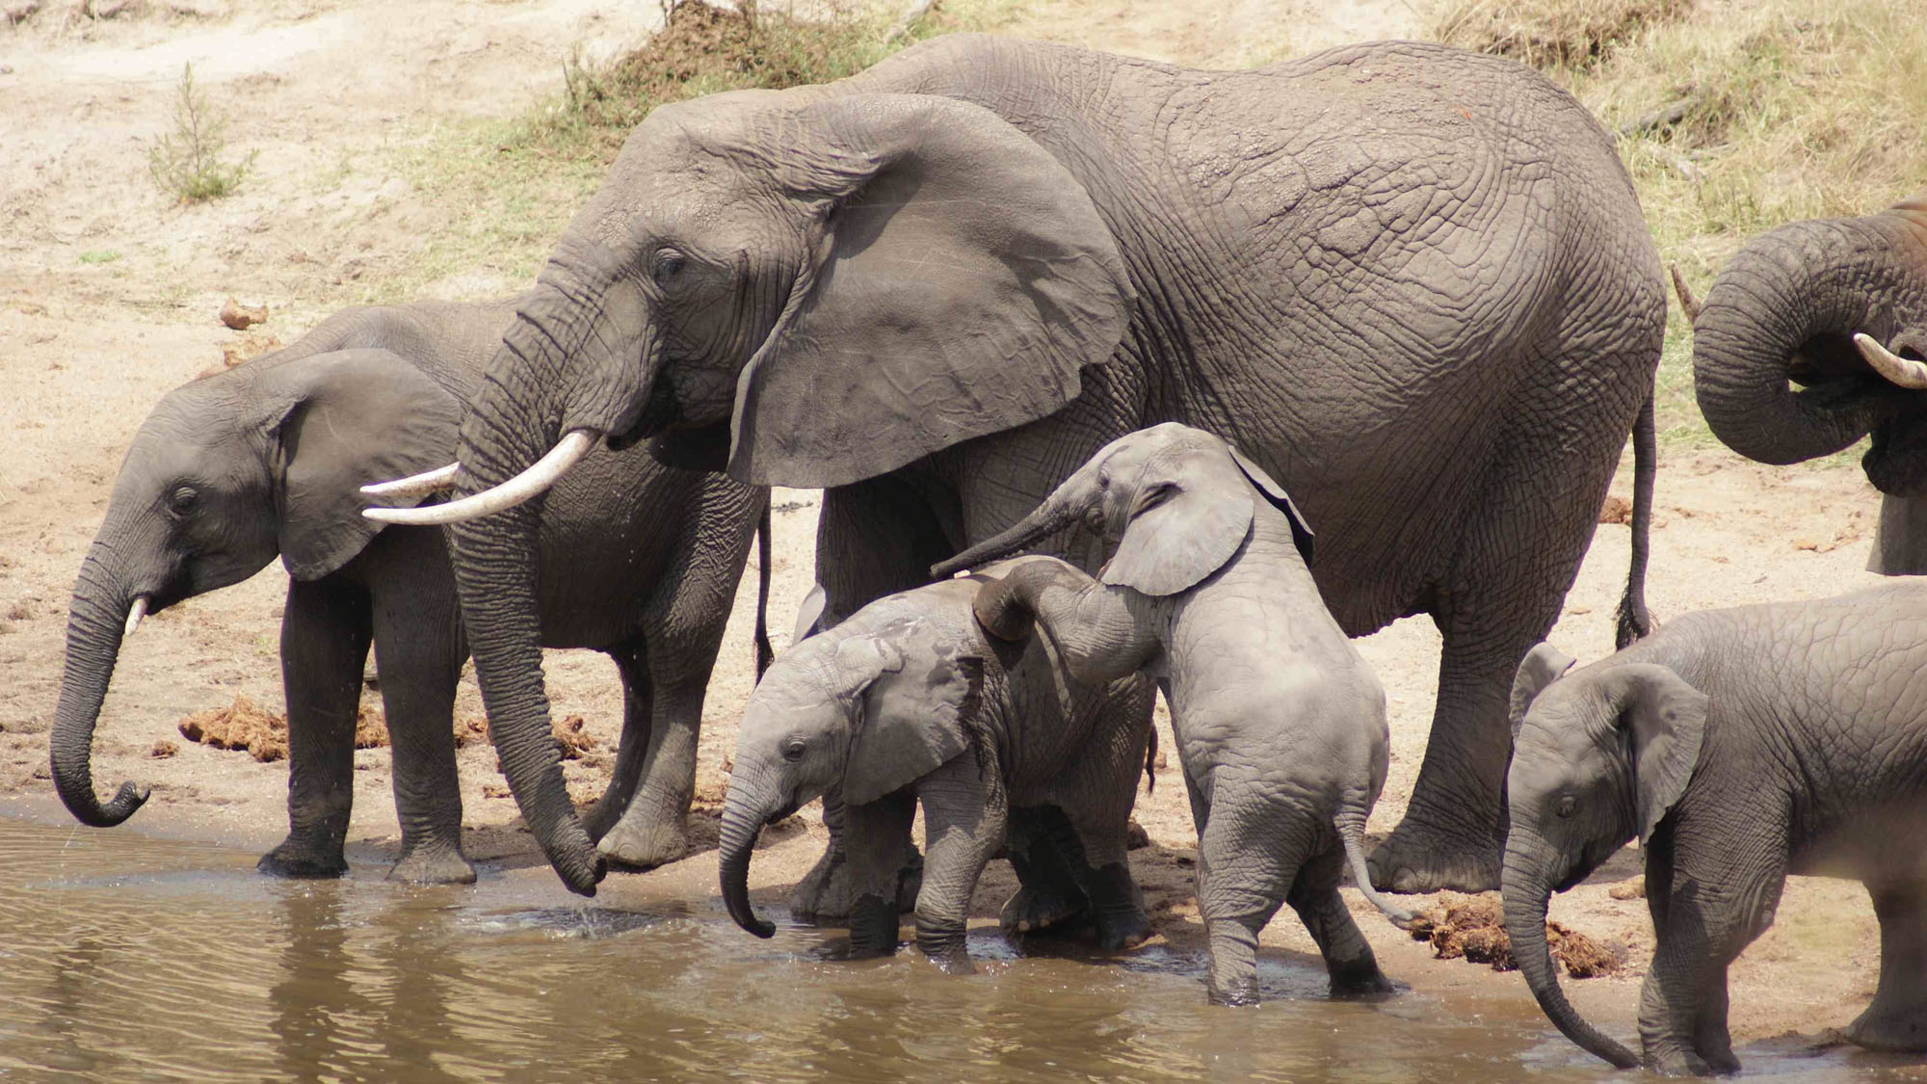

**Accommodation:** Kitela Lodge / Neptune Ngorongoro / Gibb’s Farm

Meal: Full Board (Breakfast, Lunch & Dinner)

**DAY 3-4: KARATU TO WESTERN SERENGETI FOLLOWING THE GREAT MIGRATION**

Early morning after breakfast, we depart to Western Serengeti. Around end of April, May and June, a vast army of wildebeests along with its partners: zebras, elands and gazelles mill around the Western Corridor of the Serengeti, south of the Grumeti River. Harassed behind by lions, cheetahs, leopards and hyenas and ahead by giant Nile crocodiles, many hundreds perish as some hazard the river crossing while others detour it. But the beauty of the landscape, stretching without end beneath an infinite sky on a Serengeti West Safari, changes something within the watcher, who becomes more aware of the place of humankind within the drama of the animal world. After Lunch and an extensive game drive, we head for our Tented partner lodges for dinner and overnight. You will spend 2 nights at Western corridor.

**Destination: Western Serengeti**

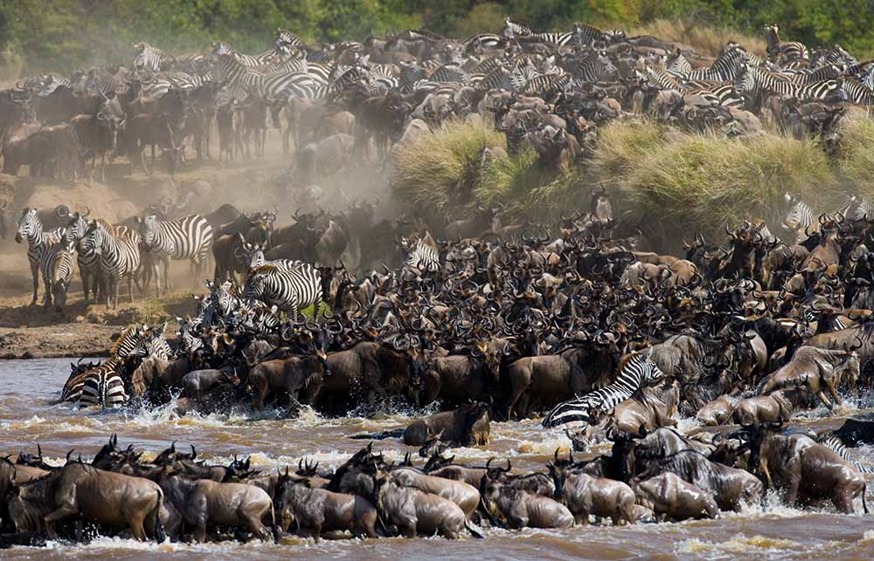

**Accommodation:** Lahia Tented Lodge/similar

Meal: All-inclusive (Breakfast, Lunch & Dinner) + drinks

**DAY 5: WESTERN SERENGETI NATIONAL PARK TO NGORONGORO CRATER TO KARATU**

Early morning after having breakfast at your accommodation inside Serengeti, you will drive straight to Ngorongoro Conservation Area en-route whereby the drive is approximately 4 hours to the floor of the crater. Ngorongoro crater is a world heritage site as well as a geo-park. It is 600m deep and before you descend thecrater you will stop at a view point where you can see the crater below. The Ngorongoro crater hasapproximately 25000 mammals and has more than 500 birds’ species where there are also migratory birds likethe flamingos. The interesting part with Ngorongoro crater is that it is the best place in East Africa to witness the endangered black rhinos which completes the big 5. In Ngorongoro you can find animals like the Zebras, wildebeests, hyenas, lion prides, gazelles, impalas, kudus, waterbucks, buffalos and many more. The Ngorongoro crater has a diameter of approximately 20km whereby it is easy to spot animals and one can spend 5-6 hours exploring the park if you have a limited time. The other attraction in Ngorongoro crater is the Ngoitoktok picnic site which is a permanent hippo pool where most of the clients have their fabulous lunch at this place. The beauty of Ngorongoro can never be untold to the visitors who have visited this area. After having packed lunch at a picnic site at the hippo pool, you will finalize your game drive before you ascend the crater and drive straight to your accommodation in Karatu for relaxation, dinner and overnight.

**Destination: Ngorongoro crater**

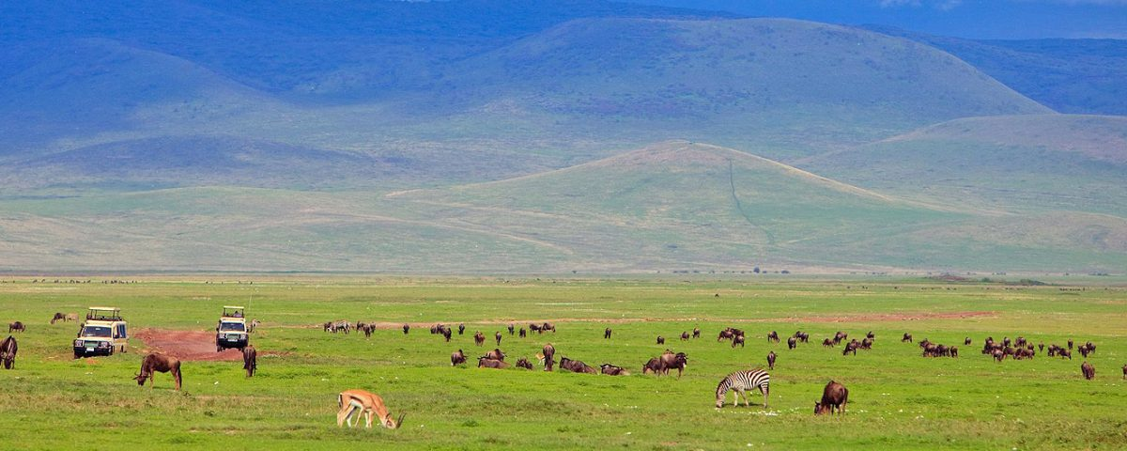

**Accommodation:** Kitela Lodge / Neptune Ngorongoro / Gibb’s Farm

Meal: Full Board (Breakfast, Lunch & Dinner)

**DAY 6: LAKE MANYARA NATIONAL PARK TO ARUSHA**

Early morning after having breakfast at your lodge in Karatu at around 0730hrs to 0800hrs you will depart straight to Lake Manyara National Park whereby the drive is approximately 1 hour to the gate. Lake Manyara National Park is well known for its birds’ life and also known as the home of tree climbing lions. The park has an area of about 325 square kilometers whereby a third of the area is the land and the rest is the lake which makes Lake Manyara the best attraction. Lake Manyara is a shallow alkaline lake that attracts a number of birds to the area. The birds’ species that can be found in Lake Manyara includes both migratory birds and native birds species like the flamingos, pelicans, storks, herons, cranes, secretary birds, ground hornbills, ostriches and many more birds species. Animals that can be found in lake Manyara are like the lions, elephants, giraffes, zebras, warthogs, wildebeests, baboons, blue monkeys, waterbucks, bushbucks, rarely leopards, buffalo etc. The park is located on the south western part of Arusha at the rift valley region which makes it easier to do different activities like the forest hike on the rift valley and other activities include canoeing, tree canopy walk, walking safari around the lake etc. Lunch will be served at the picnic site, and after that you will drive straight to Arusha where you will meet one of the representatives from Bapta African Safaris who will give you a special farewell. If you would like to have an extra night in Arusha we can arrange that for you in advance or if you have a flight, we will drive you straight to the airport to catch your onwards flight back home or to your next destination.

**Destination: Arusha.**

Meal: Breakfast & Lunch

**INCLUSIONS**

• Private Toyota Land cruiser 4x4 with pop-up roofs

• Private professional safari guide

• All nights’ accommodation in Arusha & during Safari

• All Park Fees

• Government Tax

• Unlimited drinking water, tea, coffee

• Some soft drinks & beers inside the safari vehicle

• Domestic flights

• Flying Doctors Insurance (AMREF)

EXCLUSIONS

• International flights

• Tips

• Personal needs

• Visa

**All cost in usd**

**$ 7,705 1 PAX $ 13,000 2PAX $ 18,152 3PAX $ 23,223 4PAX $ 28,213 5PAX $ 33,121 6PAX**

**$ 1,284 PPD $ 1,083 PPD $ 1,008 PPD $ 968 PPD $ 940 PPD $ 920 PPD**

**30% 30% 29% 28% 27% 26%**

**7 DAYS LUXURY NORTH MIGRATION SAFARI**

(Tarangire, Serengeti & Ngorongoro Crater)

**PARKS**

• Tarangire National Park

• Ngorongoro crater

• Serengeti National Park

**OVERVIEW**

This 7-day Luxury safari on the northern circuit of Tanzania, takes you to the most famous and incredible parks whereby you will visit all major parks which are Tarangire, Serengeti and Ngorongoro. In Tarangire, you will be astonished by the large African elephants as well as the huge and ancient baobab trees. Ngorogoro crater will be the icing on the cake and the best place to visit the endangered black rhinos and Serengeti will be the major highlight of the tour where you will visit the northern Serengeti following the great migration on the mara river. You will sleep in luxury lodges with private showers.

**DETAILED ITINERARY**

DAY 1: ARRIVAL AT THE AIRPORT TO ARUSHA

Upon arrival at the airport in Arusha (ARK) or Kilimanjaro international airport (JRO), you will be met and welcomed by your representative from Bapta African Safaris who will give you a short brief before you drive to your lodgings in Arusha for overnight.

**Destination: Arusha city**

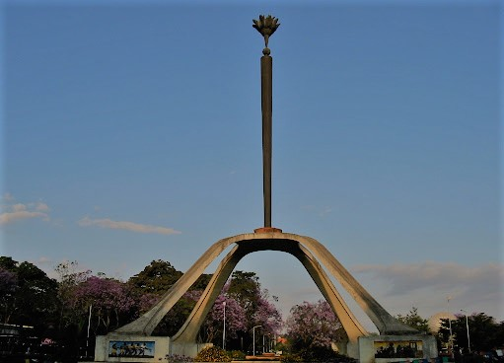

**Accommodation:** Mount Meru Hotel / Arusha Coffee Lodge / Gran Melia Arusha

Meal: Bed & Breakfast

**DAY 2: ARUSHA TO TARANGIRE NATIONAL PARK**

Early morning after having breakfast at your hotel in Arusha at around 0730hrs to 0800hrs you will be picked up by your personal driver guide and depart straight to Tarangire National Park whereby the drive is approximately 2.5 hours to the gate. Tarangire National Park is located on the northern part of Tanzania with a wide variety of animals and landscape whereby the best part is the elephant herds. It is known to be the park which has the greatest concentration of African elephants and the ancient baobab trees. Tarangire has an area of approximately 2603 square Kilometers and within the park it is possible to see plenty of animals like the giraffes, Zebras, Buffalos, warthogs, Lions, Leopards, Impala, gazelles, dik dik and many more species. In this park, there are more than 500 birds’ species like the bee eaters, swallows, ostriches, kori bustards, hammerkops, vultures etc. The word Tarangire comes from Mbugwe tribe whereby “Tara” means river and “Ngire” means warthogs therefore it is the river of warthogs. The Tarangire river is the life giving opportunity for both herbivores and carnivores and it is the best spot for the lions to hunt their prey as they search for water especially during the dry season. Lunch will be served at a picnic site at around 1200hrs to 1300hrs and after that you will proceed with your game drive until in the late afternoon where you will exit the park and drive straight to your luxury lodge in Karatu for relaxation, dinner and overnight.

**Destination: Tarangire National Park**

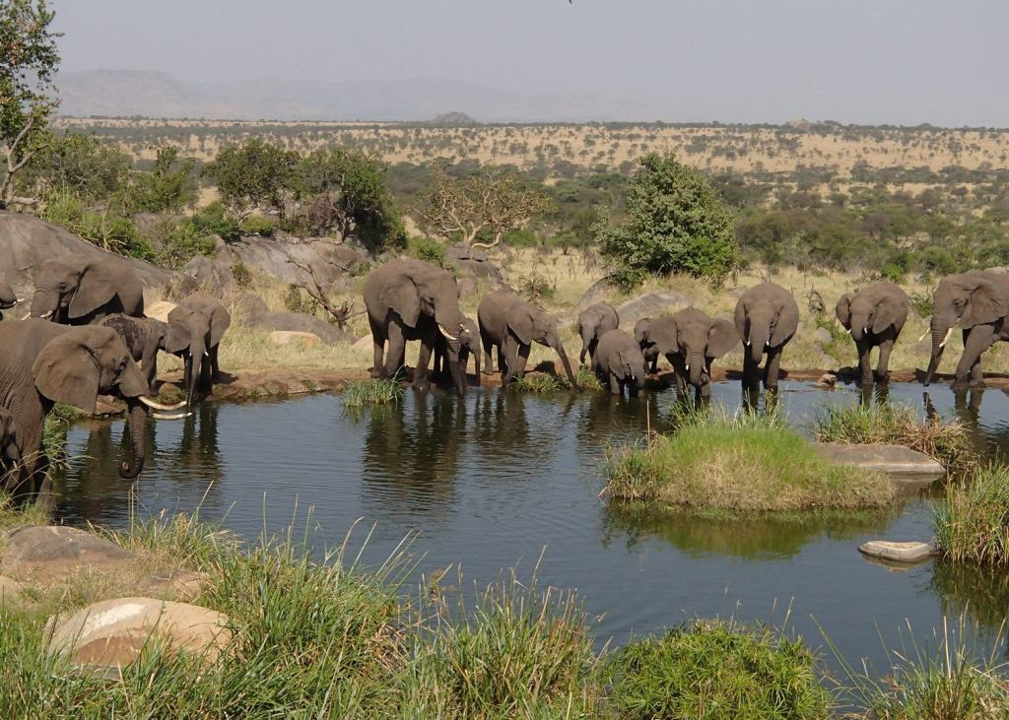

**Accommodation:** Kitela Lodge / Neptune Ngorongoro / Gibb’s Farm

Meal: Full Board (Breakfast, Lunch & Dinner)

**DAY 3: KARATU TO SERENGETI NATIONAL PARK**

Early morning after having breakfast at your lodge in Karatu at around 0730hrs to 0800hrs you will depart straight to Serengeti National Park passing through the Ngorongoro Conservation Area. Serengeti National Park is the most famous park on the northern circuit of Tanzania with the greatest population of wildlife than anywhere else on this planet. The word Serengeti originates from Maasai tribe, the word “Seringiti” which means endless plains. The park covers a total area of approximately 14,763 square kilometers with more than 2 million mammals inhabiting the park. The great annual migration involves more than a million wildebeests accompanied by some 250,000 zebras and antelopes and it is one of the 7 wonders of the world. This is exactly what makes this park the most famous park. The park is also home to more than 500 birds’ species including the ostriches, kori bustard, starlings, weavers, marabou storks, vultures, eagles, kingfishers, rollers etc. Animals that can be found inside the park are like the impalas, gazelles, topi, hartebeest, giraffes, hippo, buffalo, dik dik, waterbuck and predators such as lions, leopards, cheetahs, hyena, jackals, caracals, serval cats etc. The scenery of Serengeti on the south east is the short grass plains. The northern part of Serengeti also known as kogatende has more hills and rocks. To the western corridor known as Grumeti there are rivers, valleys as well as forests. Some areas in the heart of Serengeti heading up north of Serengeti are dotted with kopjes. The Serengeti National Park can be visited all year round but the best time to visit is during the dryseason from June to October. Lunch will be served inside the park and afterwards, proceed with game viewing until the evening where you will drive straight to your accommodation for dinner and overnight.

**Destination: Serengeti National Park**

**Accommodation:** Kubu Kubu Tented Lodge / Serengeti Serena Safari Lodge / Melia Serengeti

Meal: Full Board (Breakfast, Lunch & Dinner)

**DAY 4: CENTRAL TO NORTH SERENGETI**

Early morning after breakfast at your accommodation inside Serengeti, you will drive to the northern part of Serengeti which is also known as kogatende following the great migration. We will do a game drive en-route. As we head to the north, good sightings of giraffes, herds of buffalo and elephants can often be seen. While the Serengeti has abundant wildlife, it is best known for the annual Great Migration.  Vast numbers of wildebeests accompanied by large numbers of zebra and antelope migrate in an annual pattern, constantly seeking fresh grazing.  The precise timing of the Migration is entirely dependent upon the rainfall patterns each year. During End of July to September the Migration can be found in the Northern Serengeti where they are crossing the Mara River following the greener pastures of Maasai Mara where the provide the Mara river resident Nile crocodiles with annual fist. After Lunch and an extensive game drive, we head for our partner tented camp for dinner and overnight.

**Destination: Serengeti National Park**

**Accommodation:** Mara Mara Tented Lodge / Mara Under Canvas

Meal: Full Board (Breakfast, Lunch & Dinner)

**DAY 5: FULL DAY GAME DRIVE ON NORTH SERENGETI**

Early morning after having breakfast at your accommodation will start with an early morning game drive following the great migration. If you’re lucky enough you can spot predators hunting their prey as well as the majestic river crossing while hungry crocodiles wait their meal. Lunch will be served at a picnic site and after that you will proceed with your game drive until the late evening where you will drive to your accommodation for sinner and overnight stay.

**Destination: Serengeti National Park**

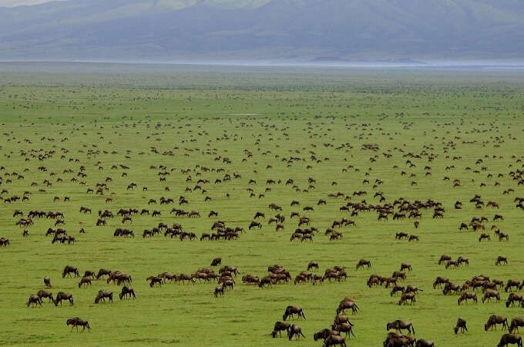

**Accommodation:** Mara Mara Tented Lodge / Mara Under Canvas

Meal: Full Board (Breakfast, Lunch & Dinner)

**DAY 6: SERENGETI NATIONAL PARK TO NGORONGORO CONSERVATION AREA**

Early morning after having breakfast at your accommodation inside Serengeti, you will drive straight to Ngorongoro Conservation Area to your accommodation for dinner and overnight stay.

**Destination: Ngorongoro Conservation Area**

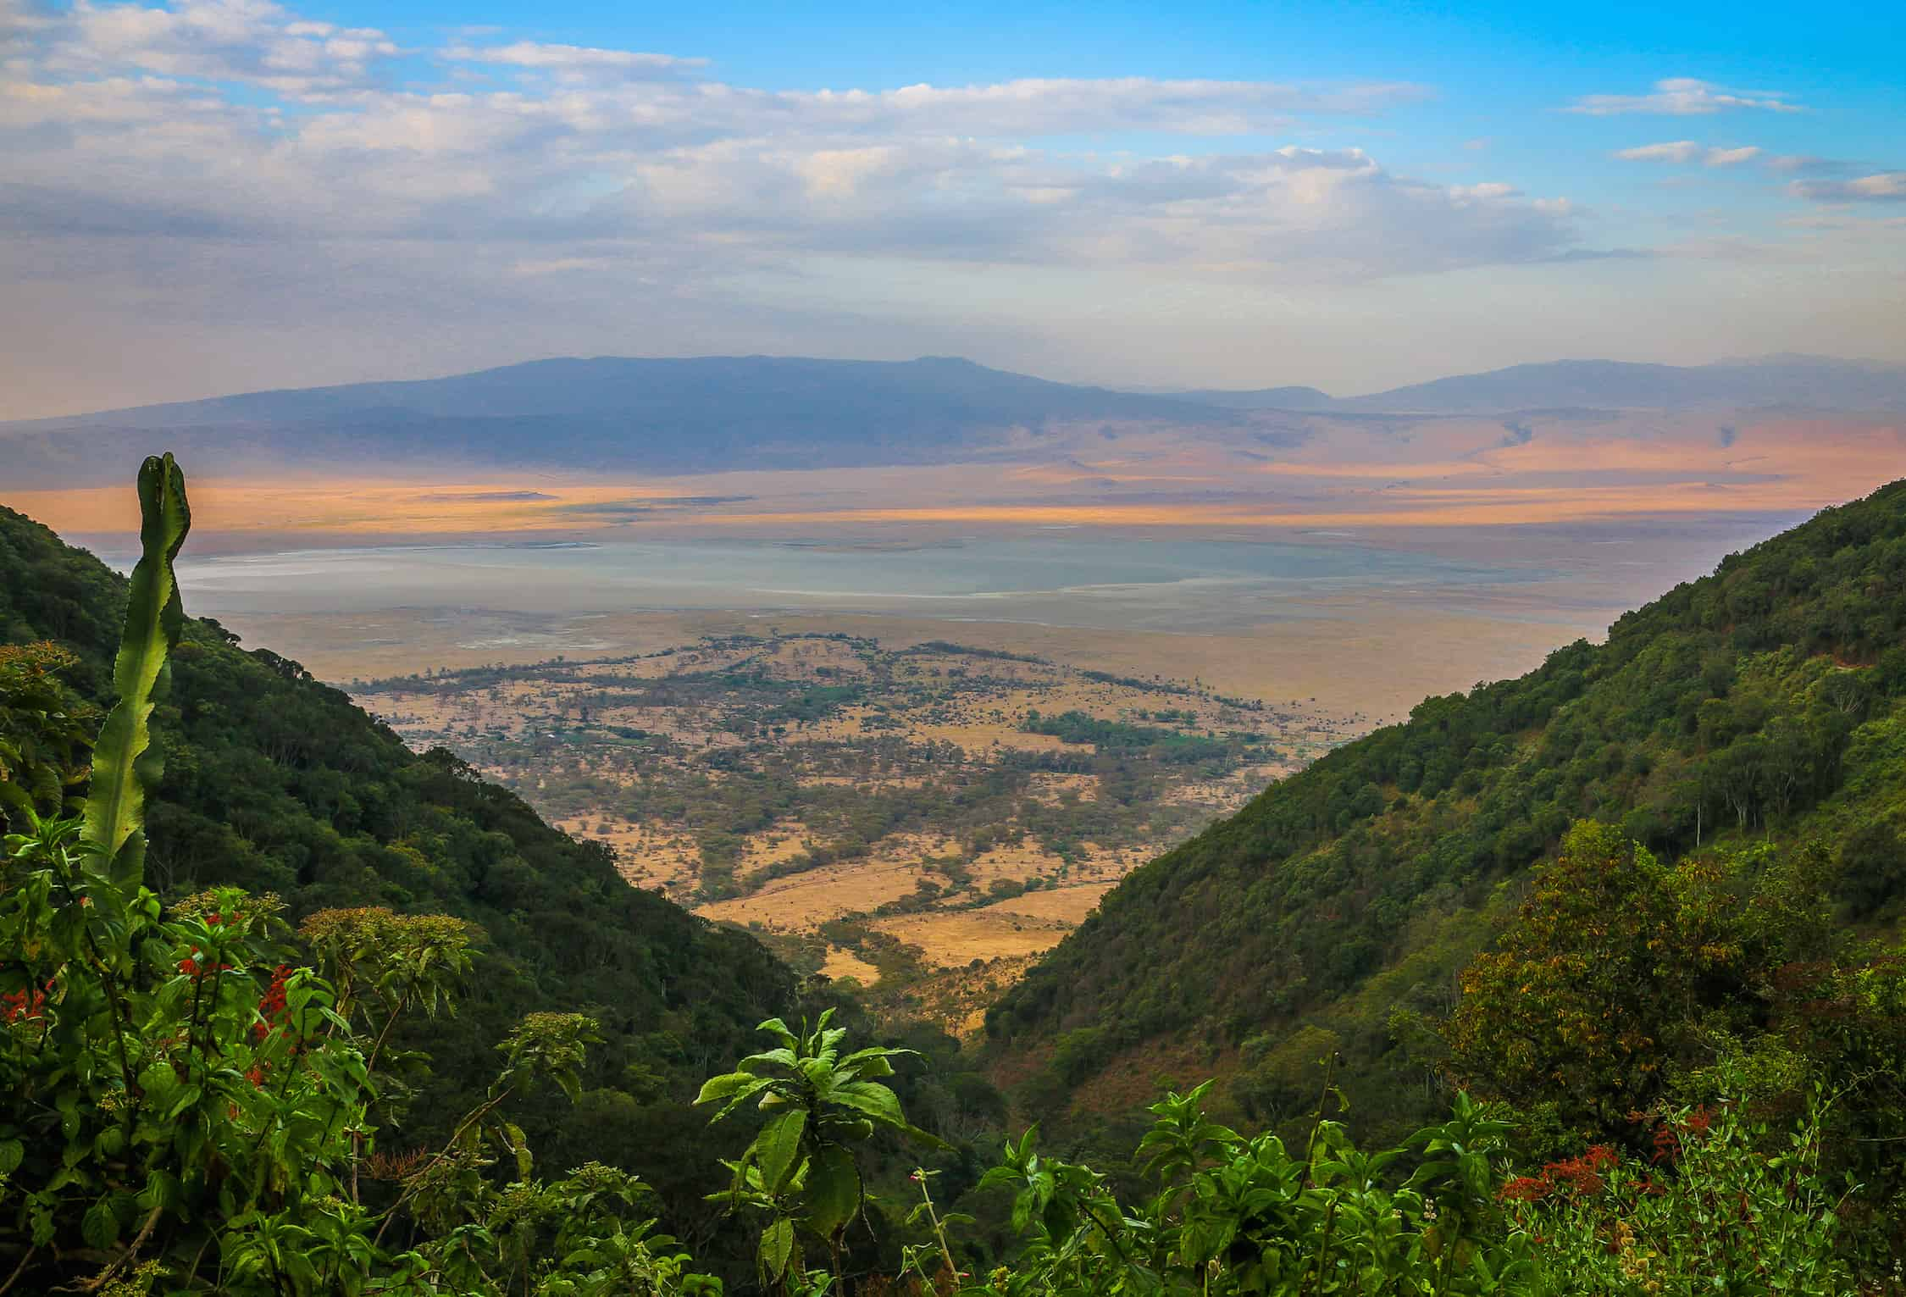

**Accommodation:** Ngorongoro Serena Safari Lodge / Ngorongoro Lion’s Paw

Meal: Full Board (Breakfast, Lunch & Dinner)

**DAY 7: NGORONGORO CRATER TO ARUSHA**

Early morning after having breakfast at your accommodation, you will drive straight to the floor of the crater. Ngorongoro crater is a world heritage site as well as a geo-park. It is 600m deep and before you descend the crater you will stop at a view point where you can see the crater below. The Ngorongoro crater has approximately 25000 mammals and has more than 500 birds’ species where there are also migratory birds like the flamingos. The interesting part with Ngorongoro crater is that it is the best place in East Africa to witness the endangered black rhinos which completes the big 5. In Ngorongoro you can find animals like the Zebras, wildebeests, hyenas, lion prides, gazelles, impalas, kudus, waterbucks, buffalos and many more. The Ngorongoro crater has a diameter of approximately 20km whereby it is easy to spot animals and one can spend 5-6 hours exploring the park if you have a limited time. The other attraction in Ngorongoro crater is the Ngoitoktok picnic site which is a permanent hippo pool where most of the clients have their fabulous lunch at this place. The beauty of Ngorongoro can never be untold to the visitors who have visited this area. After having packed lunch at a picnic site at the hippo pool, you will finalize your game drive before you ascend the crater and drive straight to Arusha.

**Destination: ARUSHA**

Meal: Full Board (Breakfast, Lunch & Dinner)

**3INCLUSIONS**

• Private Toyota Land cruiser 4x4 with pop-up roofs

• Private professional safari guide

• All nights’ accommodation in Arusha & during Safari

• All Park Fees

• Government Tax

Unlimited drinking water, tea, coffee

• Some soft drinks & beers inside the safari vehicle

• Domestic flights

• Flying Doctors Insurance (AMREF)

**EXCLUSIONS**

• International flights

• Tips

• Personal needs

• Visa

**All cost in usd OK**

**$ 9,200 PAX $ 15,478 2PAX $ 21,658 3PAX $ 27,748 4PAX $ 33,731 5PAX $ 39,616 6PAX**

**$ 1,314 PPD $ 1,105 PPD $ 1,031 PPD $ 991 PPD $ 963 PPD $ 943 PPD**

**30% 29% 28% 27% 26% 25%**

**6 DAYS LUXURY TANZANIA SAFARI CALVING SEASON**

**(Tarangire, South Serengeti, Ngorongoro Crater & Lake Manyara)**

**PARKS**

**• Tarangire National Park**

**• Ngorongoro crater**

**• Lake Manyara National Park**

**• Southern Serengeti National Park**

**OVERVIEW**

This 6-day luxury safari on the northern circuit of Tanzania, takes you to the most famous and incredible parks whereby you will visit all major parks which are Tarangire, Serengeti, Lake Manyara and Ngorongoro. In Tarangire, you will be astonished by the large African elephants as well as the huge and ancient baobab trees. Ngorogoro crater will be the icing on the cake and the best place to visit the endangered black rhinos and LakenManyara National Park which is famous for the tree climbing lions and the birds’ population. You will sleep in luxury lodges with private showers.

**DETAILED ITINERARY**

**DAY 1: ARRIVAL AT THE AIRPORT TO ARUSHA**

Upon arrival at the airport in Arusha (ARK) or Kilimanjaro international airport (JRO), you will be met and welcomed by your representative from Bapta African Safaris who will give you a short brief before you drive to your lodgings in Arusha for overnight.

**Destination: Arusha city**

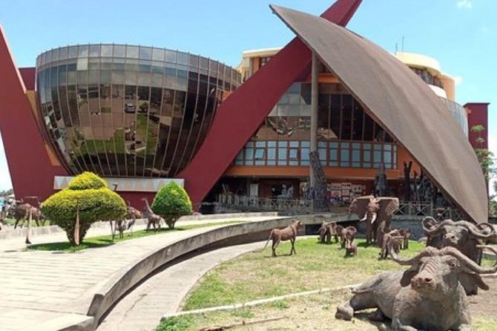

**Accommodation:** Mount Meru Hotel / Arusha Coffee Lodge / Gran Melia Arusha

Meal: Bed & Breakfast

**DAY 2: ARUSHA TO TARANGIRE NATIONAL PARK**

Early morning after having breakfast at your hotel in Arusha at around 0730hrs to 0800hrs you will be picked up by your personal driver guide and depart straight to Tarangire National Park whereby the drive is approximately 2.5 hours to the gate. Tarangire National Park is located on the northern part of Tanzania with a wide variety of animals and landscape whereby the best part is the elephant herds. It is known to be the park which has the greatest concentration of African elephants and the ancient baobab trees. Tarangire has an area of approximately 2603 square Kilometers and within the park it is possible to see plenty of animals like the giraffes, Zebras, Buffalos, warthogs, Lions, Leopards, Impala, gazelles, dik dik and many more species. In this park, there are more than 500 birds’ species like the bee eaters, swallows, ostriches, kori bustards, hammerkops, vultures etc. The word Tarangire comes from Mbugwe tribe whereby “Tara” means river and “Ngire” means warthogs therefore it is the river of warthogs. The Tarangire river is the life giving opportunity for both herbivores and carnivores and it is the best spot for the lions to hunt their prey as they search for water especially during the dry season. Lunch will be served at a picnic site at around 1200hrs to 1300hrs and after that you will proceed with your game drive until in the late afternoon where you will exit the park and drive straight to your lodge in Karatu for relaxation, dinner and overnight.

**Destination: Tarangire National Park**

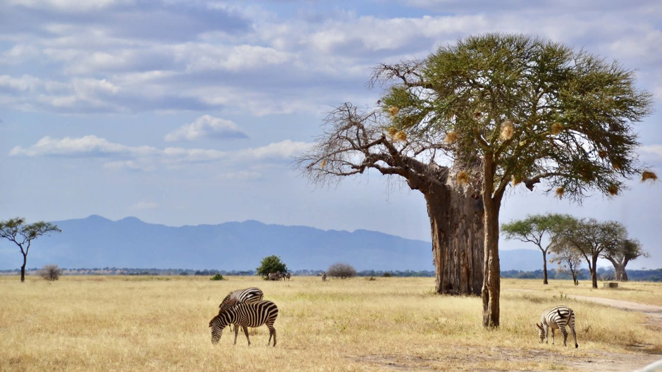

**Accommodation:** Kitela Lodge / Neptune Ngorongoro / Gibb’s Farm

Meal: Full Board (Breakfast, Lunch & Dinner)

**DAY 3: KARATU TO SOUTHERN SERENGETI NATIONAL PARK (NDUTU**)

Early morning after breakfast, you will drive to the south of Serengeti known as Ndutu. This is where there are more than 250000 calves are born. From late January to February it is where this spectacular event happens and when you’re lucky enough you might spot hunting from the predators like the hyenas and the lions. Lunch will be held at your picnic site and after further game viewing, you will drive straight to your camp or lodge for Dinner and overnight stay.

**Destination: South Serengeti National Park / Ndutu**

**Accommodation:** Lake Masek Tented Lodge

Meal: All-inclusive (Breakfast, Lunch & Dinner) + drinks

**DAY 4: FULL DAY GAME DRIVE IN SOUTH SERENGETI NATIONAL PARK (NDUTU)**

Early morning after having breakfast at your accommodation inside southern Serengeti, you will continue to explore the southern Serengeti searching for the herds. Lunch will be served and after that you will have a final game drive to your accommodation for relaxation, dinner and overnight.

**Destination: South Serengeti National Park / Ndutu**

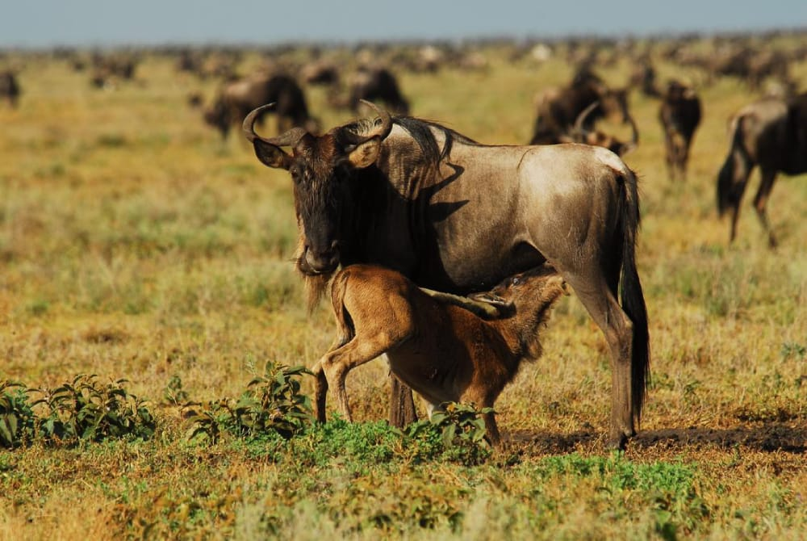

**Accommodation:** Lake Masek Tented Lodge

Meal: All-inclusive (Breakfast, Lunch & Dinner) + drinks

**DAY 5: SOUTH SERENGETI NATIONAL PARK TO NGORONGORO CRATER TO KARATU**

Early morning after having breakfast at your accommodation inside Serengeti, you will drive straight to Ngorongoro Conservation Area en-route whereby the drive is approximately 3 hours to the floor of the crater. Ngorongoro crater is a world heritage site as well as a geo-park. It is 600m deep and before you descend the crater you will stop at a view point where you can see the crater below. The Ngorongoro crater has approximately 25000 mammals and has more than 500 birds’ species where there are also migratory birds like the flamingos. The interesting part with Ngorongoro crater is that it is the best place in East Africa to witness the endangered black rhinos which completes the big 5. In Ngorongoro you can find animals like the Zebras,wildebeests, hyenas, lion prides, gazelles, impalas, kudus, waterbucks, buffalos and many more. The Ngorongoro crater has a diameter of approximately 20km whereby it is easy to spot animals and one can spend 5-6 hours exploring the park if you have a limited time. The other attraction in Ngorongoro crater is the Ngoitoktok picnic site which is a permanent hippo pool where most of the clients have their fabulous lunch at this place. The beauty of Ngorongoro can never be untold to the visitors who have visited this area. After having packed lunch at a picnic site at the hippo pool, you will finalize your game drive before you ascend the crater and drive straight to your accommodation in Karatu for relaxation, dinner and overnight.

**Destination: Ngorongoro crater**

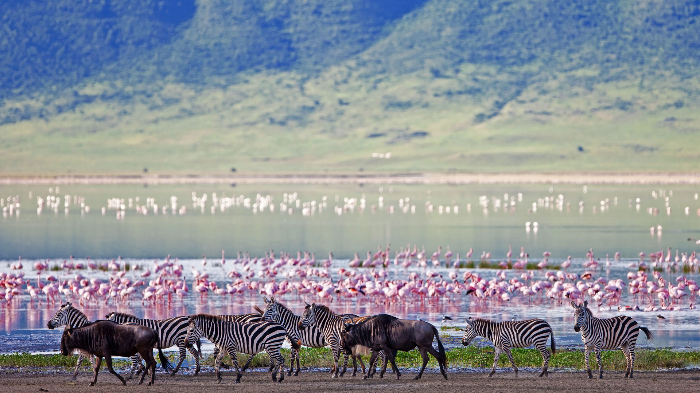

**Accommodation: Kitela Lodge / Neptune Ngorongoro / Gibb’s Farm**

**Meal: Full Board (Breakfast, Lunch & Dinner**)

**DAY 6: LAKE MANYARA NATIONAL PARK TO ARUSHA**

Early morning after having breakfast at your lodge in Karatu at around 0730hrs to 0800hrs you will depart straight to Lake Manyara National Park whereby the drive is approximately 1 hour to the gate. Lake Manyara National Park is well known for its birds’ life and also known as the home of tree climbing lions. The park has an area of about 325 square kilometers whereby a third of the area is the land and the rest is the lake which makes Lake Manyara the best attraction. Lake Manyara is a shallow alkaline lake that attracts a number of birds to the area. The birds’ species that can be found in Lake Manyara includes both migratory birds and native birds species like the flamingos, pelicans, storks, herons, cranes, secretary birds, ground hornbills, ostriches and many more birds species. Animals that can be found in lake Manyara are like the lions, elephants, giraffes, zebras, warthogs, wildebeests, baboons, blue monkeys, waterbucks, bushbucks, rarely leopards, buffalo etc. The park is located on the south western part of Arusha at the rift valley region which makes it easier to do different activities like the forest hike on the rift valley and other activities include canoeing, tree canopy walk, walking safari around the lake etc. Lunch will be served at the picnic site, and after that you will drive straight to Arusha where you will meet one of the representatives from Bapta African Safaris who will give you a special farewell. If you would like to have an extra night in Arusha we can arrange that for you in advance or if you have a flight, we will drive you straight to the airport to catch your onwards flight back home or to your next destination.

**Destination: Lake Manyara National Park**

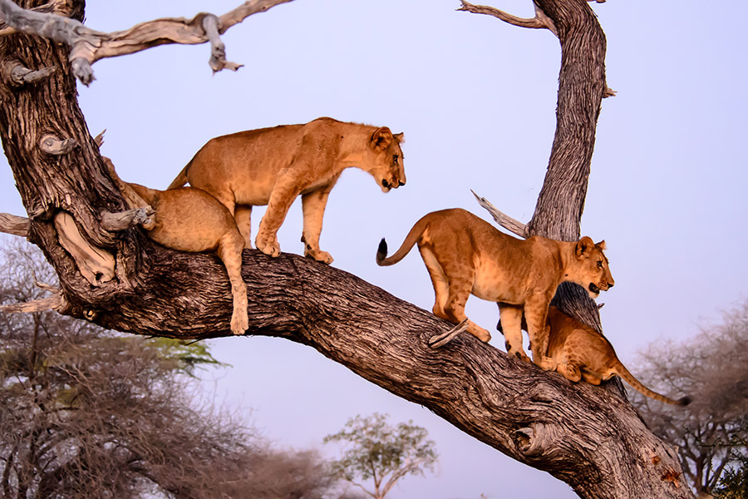

**Meal: Breakfast & Lunch**

**INCLUSIONS**

• Private Toyota Landcruiser 4x4 with pop-up roofs

• Private professional safari guide

• All nights’ accommodation in Arusha & during Safari

• All Park Fees

• Government Tax

• Unlimited drinking water, tea, coffee

• Some soft drinks & beers inside the safari vehicle

• Flying Doctors Insurance (AMREF)

• Domestic flights

**EXCLUSIONS**

• International flights

• Tips

• Personal needs

• Visa

**All cost in usd OK**

**$ 7,705 1 PAX $ 13,000 2PAX $ 18,152 3PAX $ 23,223 4PAX $ 28,213 5PAX $ 33,121 6PAX**

**$ 1,284 PPD $ 1,083 PPD $ 1,008 PPD $ 968 PPD $ 940 PPD $ 920 PPD**

**30% 30% 29% 28% 27% 26%**

**6 DAYS MIDRANGE WESTERN CORRIDOR MIGRATION**

**(Tarangire, Western Serengeti, Ngorongoro Crater & Lake Manyara)**

**PARKS**

**• Tarangire National Park**

**• Ngorongoro crater**

**• Lake Manyara National Park**

**• Western Serengeti**

**OVERVIEW**

This 6-day midrange safari on the northern circuit of Tanzania, takes you to the most famous and incredible parks whereby you will visit all major parks which are Tarangire, Serengeti, Lake Manyara and Ngorongoro. In Tarangire, you will be astonished by the large African elephants as well as the huge and ancient baobab trees. Ngorogoro crater will be the icing on the cake and the best place to visit the endangered black rhinos, Lake Manyara National Park which is famous for the tree climbing lions and the birds’ population as well as the western corridor of the Serengeti following the great migration. You will sleep in midrange lodges with private showers.

**DETAILED ITINERARY**

**DAY 1: ARRIVAL AT THE AIRPORT TO ARUSHA**

Upon arrival at the airport in Arusha (ARK) or Kilimanjaro international airport (JRO), you will be met and welcomed by your representative from Bapta African Safaris who will give you a short brief before you drive to your lodgings in Arusha for overnight.

**Destination: Arusha city**

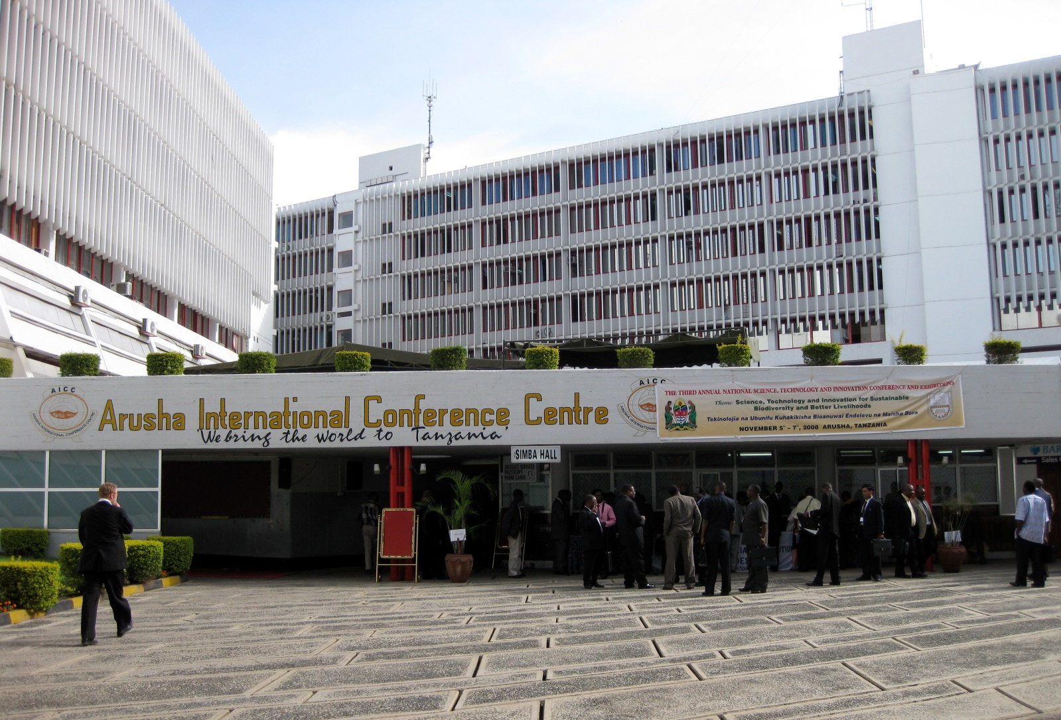

**Accommodation:** Arusha Planet Lodge / A1 Hotel & Resort / Tulia Boutique Hotel & Spa

Meal: Bed & Breakfast

**DAY 2: ARUSHA TO TARANGIRE NATIONAL PARK**

Early morning after having breakfast at your hotel in Arusha at around 0730hrs to 0800hrs you will be picked up by your personal driver guide and depart straight to Tarangire National Park whereby the drive is approximately 2.5 hours to the gate. Tarangire National Park is located on the northern part of Tanzania with a wide variety of animals and landscape whereby the best part is the elephant herds. It is known to be the park which has the greatest concentration of African elephants and the ancient baobab trees. Tarangire has an area of approximately 2603 square Kilometers and within the park it is possible to see plenty of animals like the giraffes, Zebras, Buffalos, warthogs, Lions, Leopards, Impala, gazelles, dik dik and many more species. In this park, there are more than 500 birds’ species like the bee eaters, swallows, ostriches, kori bustards, hammerkops, vultures etc. The word Tarangire comes from Mbugwe tribe whereby “Tara” means river and “Ngire” means warthogs therefore it is the river of warthogs. The Tarangire river is the life giving opportunity for both herbivores and carnivores and it is the best spot for the lions to hunt their prey as they search for water especially during the dry season. Lunch will be served at a picnic site at around 1200hrs to 1300hrs and after that you will proceed with your game drive until in the late afternoon where you will exit the park and drive straight to your lodge in Karatu for relaxation, dinner and overnight.

**Destination: Tarangire National Park**

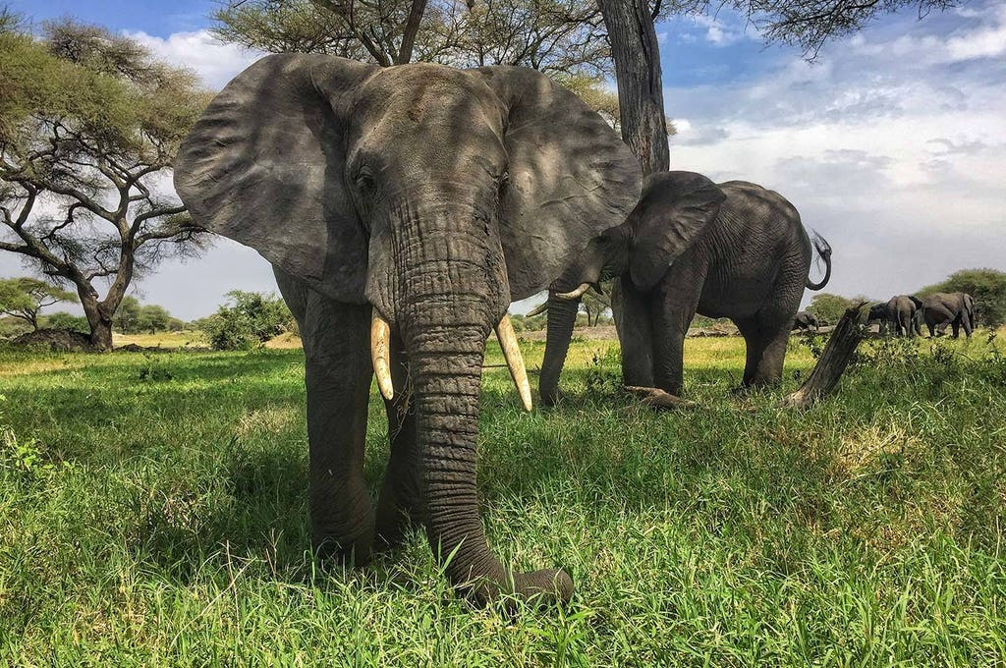

**Accommodation:** Marera Valley Lodge / Farm of Dreams Lodge / Bougainvillea Safari Lodge

Meal: Full Board (Breakfast, Lunch & Dinner)

**DAY 3-4: KARATU TO WESTERN SERENGETI FOLLOWING THE GREAT MIGRATION**

Early morning after breakfast, we depart to Western Serengeti. Around end of April, May and June, a vast army of wildebeests along with its partners: zebras, elands and gazelles mill around the Western Corridor of the Serengeti, south of the Grumeti River. Harassed behind by lions, cheetahs, leopards and hyenas and ahead by giant Nile crocodiles, many hundreds perish as some hazard the river crossing while others detour it. But the beauty of the landscape, stretching without end beneath an infinite sky on a Serengeti West Safari, changes something within the watcher, who becomes more aware of the place of humankind within the drama of the animal world. After Lunch and an extensive game drive, we head for our Tented partner lodges for dinner and overnight. You will spend 2 nights at Western corridor.

**Destination: Western Serengeti**

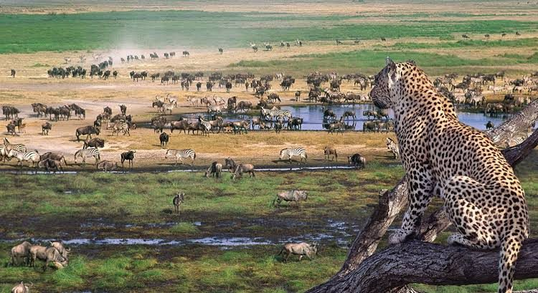

**Accommodation:** Mbalageti Serengeti

Meal: (Breakfast, Lunch & Dinner)

**DAY 5: WESTERN SERENGETI NATIONAL PARK TO NGORONGORO CRATER TO KARATU**

Early morning after having breakfast at your accommodation inside Serengeti, you will drive straight toNgorongoro Conservation Area en-route whereby the drive is approximately 4 hours to the floor of the crater.Ngorongoro crater is a world heritage site as well as a geo-park. It is 600m deep and before you descend thecrater you will stop at a view point where you can see the crater below. The Ngorongoro crater hasapproximately 25000 mammals and has more than 500 birds’ species where there are also migratory birds likethe flamingos. The interesting part with Ngorongoro crater is that it is the best place in East Africa to witnessthe endangered black rhinos which completes the big 5. In Ngorongoro you can find animals like the Zebras,wildebeests, hyenas, lion prides, gazelles, impalas, kudus, waterbucks, buffalos and many more. TheNgorongoro crater has a diameter of approximately 20km whereby it is easy to spot animals and one canspend 5-6 hours exploring the park if you have a limited time. The other attraction in Ngorongoro crater is theNgoitoktok picnic site which is a permanent hippo pool where most of the clients have their fabulous lunch atthis place. The beauty of Ngorongoro can never be untold to the visitors who have visited this area. Afterhaving packed lunch at a picnic site at the hippo pool, you will finalize your game drive before you ascend thecrater and drive straight to your accommodation in Karatu for relaxation, dinner and overnight.

**Destination: Ngorongoro crater**

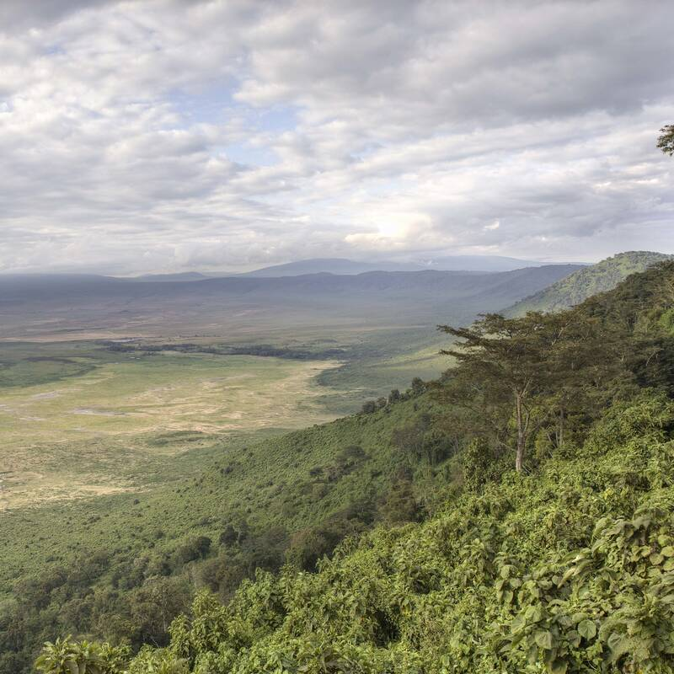

**Accommodation:** Marera Valley Lodge / Farm of Dreams Lodge / Bougainvillea Safari Lodge

Meal: Full Board (Breakfast, Lunch & Dinner)

**DAY 6: LAKE MANYARA NATIONAL PARK TO ARUSHA**

Early morning after having breakfast at your lodge in Karatu at around 0730hrs to 0800hrs you will depart straight to Lake Manyara National Park whereby the drive is approximately 1 hour to the gate. Lake Manyara National Park is well known for its birds’ life and also known as the home of tree climbing lions. The park has an area of about 325 square kilometers whereby a third of the area is the land and the rest is the lake which makes Lake Manyara the best attraction. Lake Manyara is a shallow alkaline lake that attracts a number of birds to the area. The birds’ species that can be found in Lake Manyara includes both migratory birds and native birds species like the flamingos, pelicans, storks, herons, cranes, secretary birds, ground hornbills, ostriches and many more birds species. Animals that can be found in lake Manyara are like the lions, elephants, giraffes, zebras, warthogs, wildebeests, baboons, blue monkeys, waterbucks, bushbucks, rarely leopards, buffalo etc. The park is located on the south western part of Arusha at the rift valley region which makes it easier to do different activities like the forest hike on the rift valley and other activities include canoeing, tree canopy walk, walking safari around the lake etc. Lunch will be served at the picnic site, and after that you will drive straight to Arusha where you will meet one of the representatives from Bapta African Safaris who will give you a special farewell. If you would like to have an extra night in Arusha we can arrange that for you in advance or if you have a flight, we will drive you straight to the airport to catch your onwards flight back home or to your next destination.

**Destination: Lake Manyara National Park**

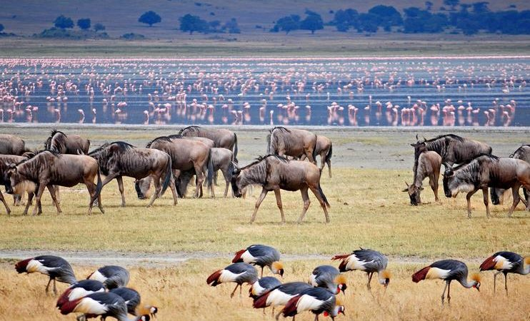

Meal: Breakfast & Lunch

**INCLUSIONS**

• Private Toyota Landcruiser 4x4 with pop-up roofs

• Private professional safari guide

• All nights’ accommodation in Arusha & during Safari

• All Park Fees

• Government Tax

• Unlimited drinking water, tea, coffee

• Some soft drinks & beers inside the safari vehicle

• Flying Doctors Insurance (AMREF)

• Domestic flights

**EXCLUSIONS**

• International flights

• Tips

• Personal needs

• Visa

**ALL COST IN USD OK**

**$ 4,715 1 PAX $ 6,782 2PAX $ 8,990 3PAX $ 10,931 4PAX $ 13,059 5PAX $ 15,148 6PAX**

**$ 785 PPD $ 565 PPD $ 499 PPD $ 455 PPD $ 435 PPD $ 420 PPD**

**30% 22% 20 % 16% 15% 14%**

**6 DAYS MIDRANGE TANZANIA SAFARI CALVING SEASON**

(**Tarangire, South Serengeti, Ngorongoro Crater & Lake Manyara)**

**PARKS**

**• Tarangire National Park**

**• Ngorongoro crater**

**• Lake Manyara National Park**

**• Southern Serengeti National Park**

**OVERVIEW**

This 6-day midrange safari on the northern circuit of Tanzania, takes you to the most famous and incredible

parks whereby you will visit all major parks which are Tarangire, Serengeti, Lake Manyara and Ngorongoro. In

Tarangire, you will be astonished by the large African elephants as well as the huge and ancient baobab trees.

Ngorogoro crater will be the icing on the cake and the best place to visit the endangered black rhinos and Lake

Manyara National Park which is famous for the tree climbing lions and the birds’ population. You will sleep in

midrange lodges with private showers.

**DETAILED ITINERARY**

**DAY 1: ARRIVAL AT THE AIRPORT TO ARUSHA**

Upon arrival at the airport in Arusha (ARK) or Kilimanjaro international airport (JRO), you will be met and welcomed by your representative from Bapta African Safaris who will give you a short brief before you drive to your lodgings in Arusha for overnight.

**Destination: Arusha city**

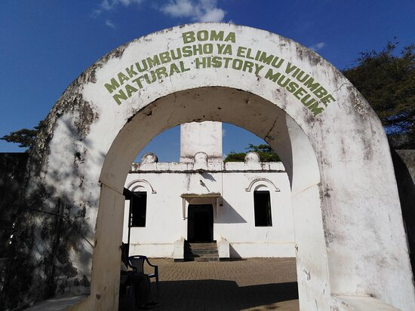

**Accommodation:** Arusha Planet Lodge / A1 Hotel & Resort / Tulia Boutique Hotel & Spa

Meal: Bed & Breakfast

**DAY 2: ARUSHA TO TARANGIRE NATIONAL PARK**

Early morning after having breakfast at your hotel in Arusha at around 0730hrs to 0800hrs you will be picked up by your personal driver guide and depart straight to Tarangire National Park whereby the drive is approximately 2.5 hours to the gate. Tarangire National Park is located on the northern part of Tanzania with a wide variety of animals and landscape whereby the best part is the elephant herds. It is known to be the park which has the greatest concentration of African elephants and the ancient baobab trees. Tarangire has an area of approximately 2603 square Kilometers and within the park it is possible to see plenty of animals like the giraffes, Zebras, Buffalos, warthogs, Lions, Leopards, Impala, gazelles, dik dik and many more species. In this park, there are more than 500 birds’ species like the bee eaters, swallows, ostriches, kori bustards, hammerkops, vultures etc. The word Tarangire comes from Mbugwe tribe whereby “Tara” means river and “Ngire” means warthogs therefore it is the river of warthogs. The Tarangire river is the life giving opportunity for both herbivores and carnivores and it is the best spot for the lions to hunt their prey as they search for water especially during the dry season. Lunch will be served at a picnic site at around 1200hrs to 1300hrs and after that you will proceed with your game drive until in the late afternoon where you will exit the park and drive straight to your lodge in Karatu for relaxation, dinner and overnight.

**Destination: Tarangire National Park**

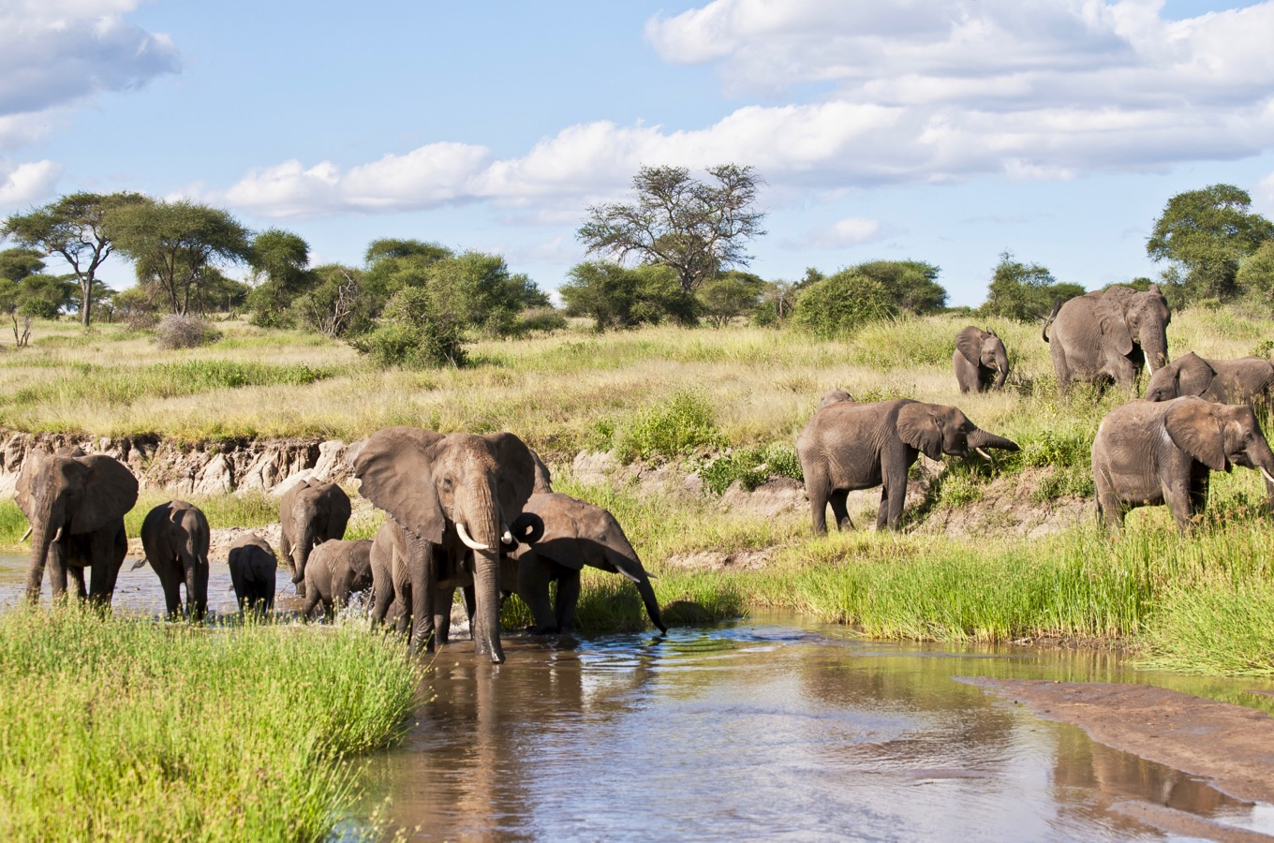 **SERENGETI NATIONAL PARK (NDUTU)**

**Accommodation:** Marera Valley Lodge / Farm of Dreams Lodge / Bougainvillea Safari Lodge

Meal: Full Board (Breakfast, Lunch & Dinner)

**DAY 3: KARATU TO SOUTHERN**

Early morning after breakfast, you will drive to the south of Serengeti known as Ndutu. This is where there are more than 250000 calves are born. From late January to February it is where this spectacular event happens and when you’re lucky enough you might spot hunting from the predators like the hyenas and the lions. Lunch will be held at your picnic site and after further game viewing, you will drive straight to your camp or lodge for inner and overnight stay.

**Destination: South Serengeti National Park**

**Accommodation:** Serengeti Heritage Tented Camp

Meal: Full Board (Breakfast, Lunch & Dinner)

**DAY 4: FULL DAY GAME DRIVE IN SOUTH SERENGETI NATIONAL PARK (NDUTU)**

Early morning after having breakfast at your accommodation inside southern Serengeti, you will continue to explore the southern Serengeti searching for the herds. Lunch will be served and after that you will have a final game drive to your accommodation for relaxation, dinner and overnight.

**Destination: South Serengeti National Park**

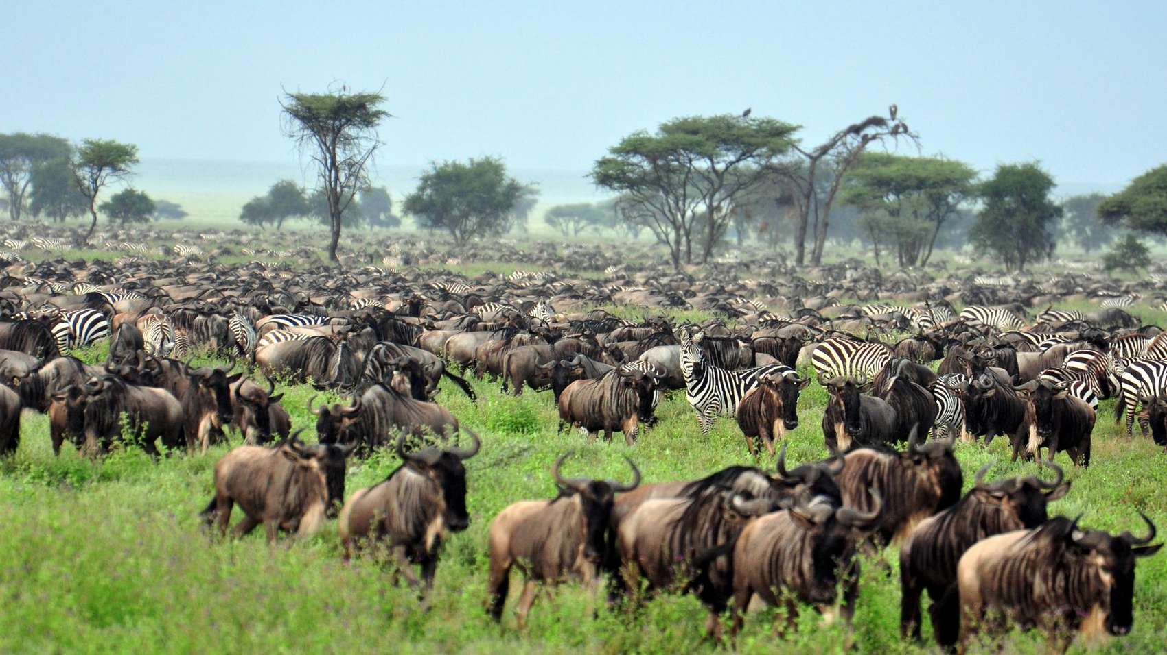

**Accommodation:** Serengeti Heritage Tented Camp

Meal: Full Board (Breakfast, Lunch & Dinner)

**DAY 5: SOUTH SERENGETI NATIONAL PARK TO NGORONGORO CRATER TO KARATU**

Early morning after having breakfast at your accommodation inside Serengeti, you will drive straight to Ngorongoro Conservation Area en-route whereby the drive is approximately 3 hours to the floor of the crater. Ngorongoro crater is a world heritage site as well as a geo-park. It is 600m deep and before you descend the crater you will stop at a view point where you can see the crater below. The Ngorongoro crater has approximately 25000 mammals and has more than 500 birds’ species where there are also migratory birds like the flamingos. The interesting part with Ngorongoro crater is that it is the best place in East Africa to witness the endangered black rhinos which completes the big 5. In Ngorongoro you can find animals like the Zebras, wildebeests, hyenas, lion prides, gazelles, impalas, kudus, waterbucks, buffalos and many more. The Ngorongoro crater has a diameter of approximately 20km whereby it is easy to spot animals and one can spend 5-6 hours exploring the park if you have a limited time. The other attraction in Ngorongoro crater is the Ngoitoktok picnic site which is a permanent hippo pool where most of the clients have their fabulous lunch at this place. The beauty of Ngorongoro can never be untold to the visitors who have visited this area. After having packed lunch at a picnic site at the hippo pool, you will finalize your game drive before you ascend the crater and drive straight to your accommodation in Karatu for relaxation, dinner and overnight.

**Destination: Ngorongoro crater**

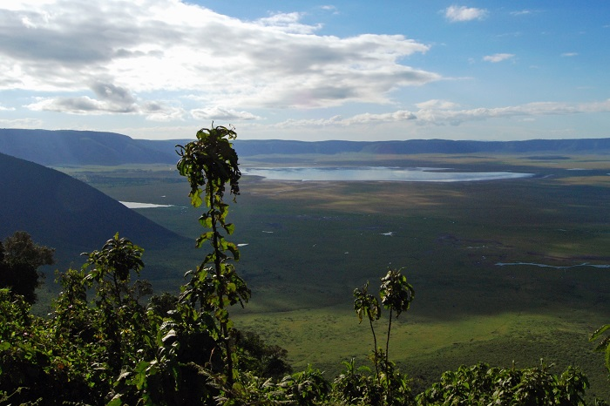

**Accommodation:** Marera Valley Lodge / Farm of Dreams Lodge / Bougainvillea Safari Lodge

Meal: Full Board (Breakfast, Lunch & Dinner)

**DAY 6: LAKE MANYARA NATIONAL PARK TO ARUSHA**

Early morning after having breakfast at your lodge in Karatu at around 0730hrs to 0800hrs you will departstraight to Lake Manyara National Park whereby the drive is approximately 1 hour to the gate. Lake Manyara National Park is well known for its birds’ life and also known as the home of tree climbing lions. The park has an area of about 325 square kilometers whereby a third of the area is the land and the rest is the lake which makes Lake Manyara the best attraction. Lake Manyara is a shallow alkaline lake that attracts a number of birds to the area. The birds’ species that can be found in Lake Manyara includes both migratory birds and native birds species like the flamingos, pelicans, storks, herons, cranes, secretary birds, ground hornbills, ostriches and many more birds species. Animals that can be found in lake Manyara are like the lions, elephants, giraffes, zebras, warthogs, wildebeests, baboons, blue monkeys, waterbucks, bushbucks, rarely leopards, buffalo etc. The park is located on the south western part of Arusha at the rift valley region which makes it easier to do different activities like the forest hike on the rift valley and other activities include canoeing, tree canopy walk, walking safari around the lake etc. Lunch will be served at the picnic site, and after that you will drive straight to Arusha where you will meet one of the representatives from Bapta African Safaris who will give you a special farewell. If you would like to have an extra night in Arusha we can arrange that for you in advance or if you have a flight, we will drive you straight to the airport to catch your on wards flight back home or to your next destination.

**Destination: Lake Manyara National Park**

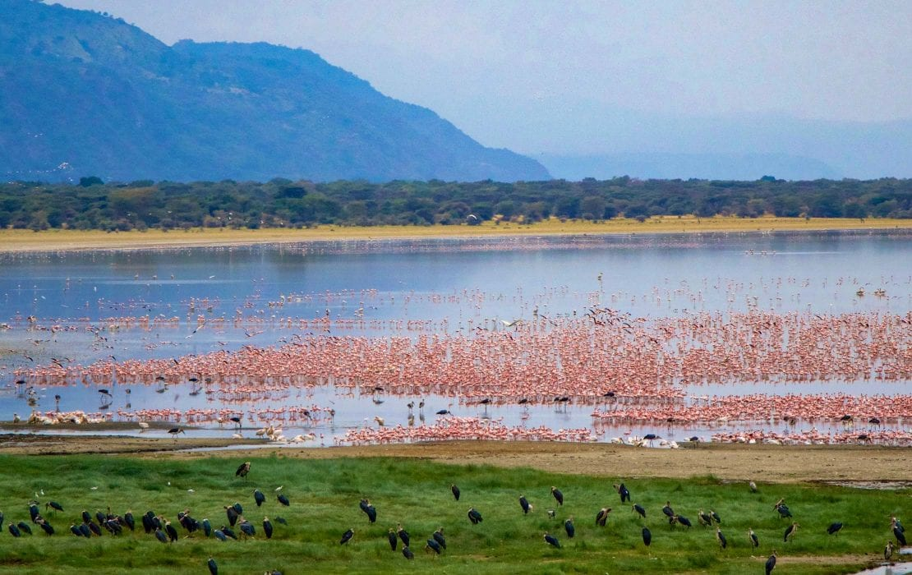

Meal: Breakfast & Lunch

**INCLUSIONS**

• Private Toyota Landcruiser 4x4 with pop-up roofs

• Private professional safari guide

• All nights’ accommodation in Arusha & during Safari

• All Park Fees

• Government Tax

• Unlimited drinking water, tea, coffee

• Some soft drinks & beers inside the safari vehicle

• Flying Doctors Insurance (AMREF)

• Domestic flights

**EXCLUSIONS**

International flights

• Tips

• Personal needs

• Visa

**ALL COST IN USD OK**

**$ 4,715 1 PAX $ 6,782 2PAX $ 8,990 3PAX $ 10,931 4PAX $ 13,059 5PAX $ 15,148 6PAX**

**$ 785 PPD $ 565 PPD $ 499 PPD $ 455 PPD $ 435 PPD $ 420 PPD**

**30% 22% 20 % 16% 15% 14%**

**8 DAYS LUXURY NORTH MIGRATION SAFARI**

**(Tarangire, Serengeti, Manyara & Ngorongoro Crater)**

**PARKS**

**• Tarangire National Park**

**• Ngorongoro crater**

**• Serengeti National Park**

**• Lake Manyara National Park**

OVERVIEW

This 8-day Luxury safari on the northern circuit of Tanzania, takes you to the most famous and incredible parks whereby you will visit all major parks which are Tarangire, Serengeti and Ngorongoro. In Tarangire, you will be astonished by the large African elephants as well as the huge and ancient baobab trees. Ngorogoro crater will be the icing on the cake and the best place to visit the endangered black rhinos and Serengeti will be the major highlight of the tour where you will visit the northern Serengeti following the great migration on the mara river. You will sleep in luxury lodges with private showers.

**DETAILED ITINERARY**

**DAY 1: ARRIVAL AT THE AIRPORT TO ARUSHA**

Upon arrival at the airport in Arusha (ARK) or Kilimanjaro international airport (JRO), you will be met and welcomed by your representative from Bapta African Safaris who will give you a short brief before you drive to your lodgings in Arusha for overnight.

**Destination: Arusha city**



**Accommodation:** Mount Meru Hotel / Arusha Coffee Lodge / Gran Melia Arusha

Meal: Bed & Breakfast

**DAY 2: ARUSHA TO TARANGIRE NATIONAL PARK**

Early morning after having breakfast at your hotel in Arusha at around 0730hrs to 0800hrs you will be pickedup by your personal driver guide and depart straight to Tarangire National Park whereby the drive isapproximately 2.5 hours to the gate. Tarangire National Park is located on the northern part of Tanzania with a wide variety of animals and landscape whereby the best part is the elephant herds. It is known to be the parkwhich has the greatest concentration of African elephants and the ancient baobab trees. Tarangire has an area of approximately 2603 square Kilometers and within the park it is possible to see plenty of animals like the giraffes, Zebras, Buffalos, warthogs, Lions, Leopards, Impala, gazelles, dik dik and many more species. In this park, there are more than 500 birds’ species like the bee eaters, swallows, ostriches, kori bustards, hammerkops, vultures etc. The word Tarangire comes from Mbugwe tribe whereby “Tara” means river and “Ngire” means warthogs therefore it is the river of warthogs. The Tarangire river is the life giving opportunity for both herbivores and carnivores and it is the best spot for the lions to hunt their prey as they search for water especially during the dry season. Lunch will be served at a picnic site at around 1200hrs to 1300hrs and after that you will proceed with your game drive until in the late afternoon where you will exit the park and drive straight to your luxury lodge in Karatu for relaxation, dinner and overnight.

**Destination: Tarangire National Park**

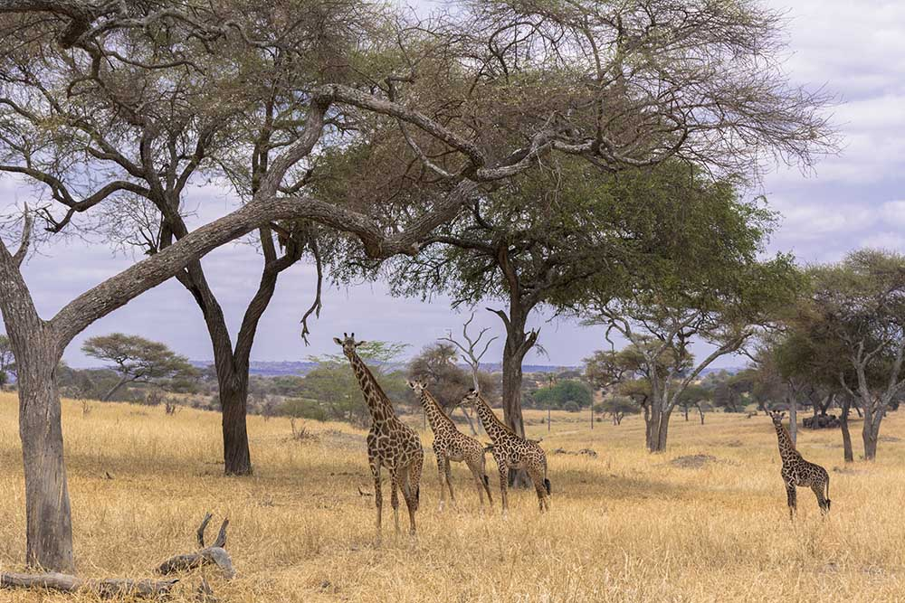

**Accommodation:** Kitela Lodge / Neptune Ngorongoro / Gibb’s Farm

Meal: Full Board (Breakfast, Lunch & Dinner)

**DAY 3: KARATU TO SERENGETI NATIONAL PARK**

Early morning after having breakfast at your lodge in Karatu at around 0730hrs to 0800hrs you will depart straight to Serengeti National Park passing through the Ngorongoro Conservation Area. Serengeti National Park is the most famous park on the northern circuit of Tanzania with the greatest population of wildlife than anywhere else on this planet. The word Serengeti originates from Maasai tribe, the word “Seringiti” which means endless plains. The park covers a total area of approximately 14,763 square kilometers with more than 2 million mammals inhabiting the park. The great annual migration involves more than a million wildebeests accompanied by some 250,000 zebras and antelopes and it is one of the 7 wonders of the world. This is exactly what makes this park the most famous park. The park is also home to more than 500 birds’ species including the ostriches, kori bustard, starlings, weavers, marabou storks, vultures, eagles, kingfishers, rollers etc. Animals that can be found inside the park are like the impalas, gazelles, topi, hartebeest, giraffes, hippo, buffalo, dik dik, waterbuck and predators such as lions, leopards, cheetahs, hyena, jackals, caracals, serval cats etc. The scenery of Serengeti on the south east is the short grass plains. The northern part of Serengeti also known as kogatende has more hills and rocks. To the western corridor known as Grumeti there are rivers, valleys as well as forests. Some areas in the heart of Serengeti heading up north of Serengeti are dotted with kopjes. The Serengeti National Park can be visited all year round but the best time to visit is during the dry season from June to October. Lunch will be served inside the park and afterwards, proceed with game viewing until the evening where you will drive straight to your accommodation for dinner and overnight.

**Destination: Serengeti National Park**

Accommodation: Kubu Kubu Tented Lodge / Serengeti Serena Safari Lodge / Melia Serengeti

Meal: Full Board (Breakfast, Lunch & Dinner)

**DAY 4: CENTRAL TO NORTH SERENGETI**

Early morning after breakfast at your accommodation inside Serengeti, you will drive to the northern part of Serengeti which is also known as kogatende following the great migration. We will do a game drive en-route. As we head to the north, good sightings of giraffes, herds of buffalo and elephants can often be seen. While the Serengeti has abundant wildlife, it is best known for the annual Great Migration.  Vast numbers of wildebeests accompanied by large numbers of zebra and antelope migrate in an annual pattern, constantly seeking fresh grazing.  The precise timing of the Migration is entirely dependent upon the rainfall patterns each year. During End of July to September the Migration can be found in the Northern Serengeti where they are crossing the Mara River following the greener pastures of Maasai Mara where the provide the Mara river resident Nile crocodiles with annual fist. After Lunch and an extensive game drive, we head for our partner tented camp for dinner and overnight.

**Destination: Serengeti National Park**

**Accommodation: Mara Mara Tented Lodge / Mara Under Canvas**

**Meal: Full Board (Breakfast, Lunch & Dinner)**

**DAY 5: FULL DAY GAME DRIVE ON NORTH SERENGETI**

Early morning after having breakfast at your accommodation will start with an early morning game drive following the great migration. If you’re lucky enough you can spot predators hunting their prey as well as themajestic river crossing while hungry crocodiles wait their meal. Lunch will be served at a picnic site and after that you will proceed with your game drive until the late evening where you will drive to your accommodation for sinner and overnight stay.

**Destination**: Serengeti National Park

A**ccommodation: Mara Mara Tented Lodge / Mara Under Canvas**

**Meal: Full Board (Breakfast, Lunch & Dinner)**

**DAY 6: NORTH SERENGETI TO CENTRAL SERENGETI**

Early morning after having breakfast at your accommodation will start with an early morning game drive en- route to the central Serengeti at your accommodation for relaxation, dinner and overnight.

**Destination: Serengeti National Park**

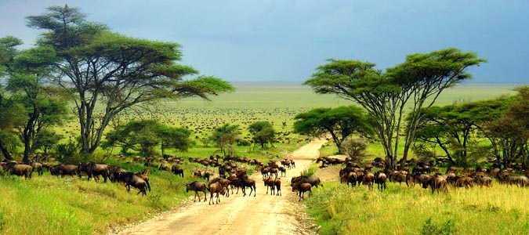

**Accommodation: Kubu Kubu Tented Lodge / Serengeti Serena Safari Lodge / Melia Serengeti**

**Meal: Full Board (Breakfast, Lunch & Dinner**)

**DAY 7: SERENGETI NATIONAL PARK TO NGORONGORO CRATER TO KARATU**

Early morning after having breakfast at your accommodation inside Serengeti, you will drive straight to Ngorongoro Conservation Area en-route whereby the drive is approximately 4 hours to the floor of the crater. Ngorongoro crater is a world heritage site as well as a geo-park. It is 600m deep and before you descend the crater you will stop at a view point where you can see the crater below. The Ngorongoro crater has approximately 25000 mammals and has more than 500 birds’ species where there are also migratory birds like the flamingos. The interesting part with Ngorongoro crater is that it is the best place in East Africa to witness the endangered black rhinos which completes the big 5. In Ngorongoro you can find animals like the Zebras, wildebeests, hyenas, lion prides, gazelles, impalas, kudus, waterbucks, buffalos and many more. The Ngorongoro crater has a diameter of approximately 20km whereby it is easy to spot animals and one can spend 5-6 hours exploring the park if you have a limited time. The other attraction in Ngorongoro crater is the Ngoitoktok picnic site which is a permanent hippo pool where most of the clients have their fabulous lunch at this place. The beauty of Ngorongoro can never be untold to the visitors who have visited this area. After having packed lunch at a picnic site at the hippo pool, you will finalize your game drive before you ascend the crater and drive straight to your accommodation in Karatu for relaxation, dinner and overnight.

**Destination: Ngorongoro crater**

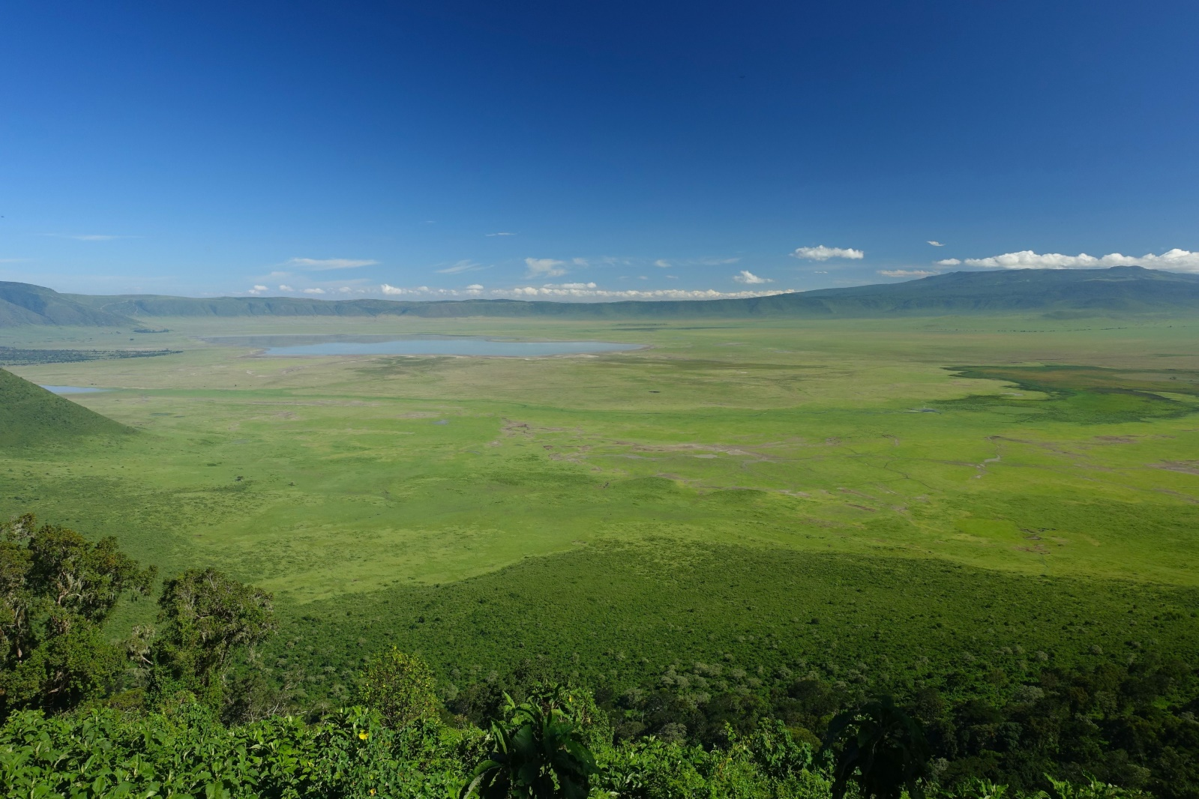

**Accommodation: Kitela Lodge / Neptune Ngorongoro / Gibb’s Farm**

**Meal: Full Board (Breakfast, Lunch & Dinner)**

**DAY 8: LAKE MANYARA NATIONAL PARK TO ARUSHA**

Early morning after having breakfast at your lodge in Karatu at around 0730hrs to 0800hrs you will depart straight to Lake Manyara National Park whereby the drive is approximately 1 hour to the gate. Lake Manyara National Park is well known for its birds’ life and also known as the home of tree climbing lions. The park has an area of about 325 square kilometers whereby a third of the area is the land and the rest is the lake which makes Lake Manyara the best attraction. Lake Manyara is a shallow alkaline lake that attracts a number of birds to the area. The birds’ species that can be found in Lake Manyara includes both migratory birds and native birds species like the flamingos, pelicans, storks, herons, cranes, secretary birds, ground hornbills, ostriches and many more birds species. Animals that can be found in lake Manyara are like the lions, elephants, giraffes, zebras, warthogs, wildebeests, baboons, blue monkeys, waterbucks, bushbucks, rarely leopards, buffalo etc. The park is located on the south western part of Arusha at the rift valley region which makes it easier to do different activities like the forest hike on the rift valley and other activities include canoeing, tree canopy walk, walking safari around the lake etc. Lunch will be served at the picnic site, and after that you will drive straight to Arusha where you will meet one of the representatives from Bapta African Safaris who will give you a special farewell. If you would like to have an extra night in Arusha we can arrange that for you in advance or if you have a flight, we will drive you straight to the airport to catch your onwards flight back home or to your next destination.

**Destination: Lake Manyara National Park**

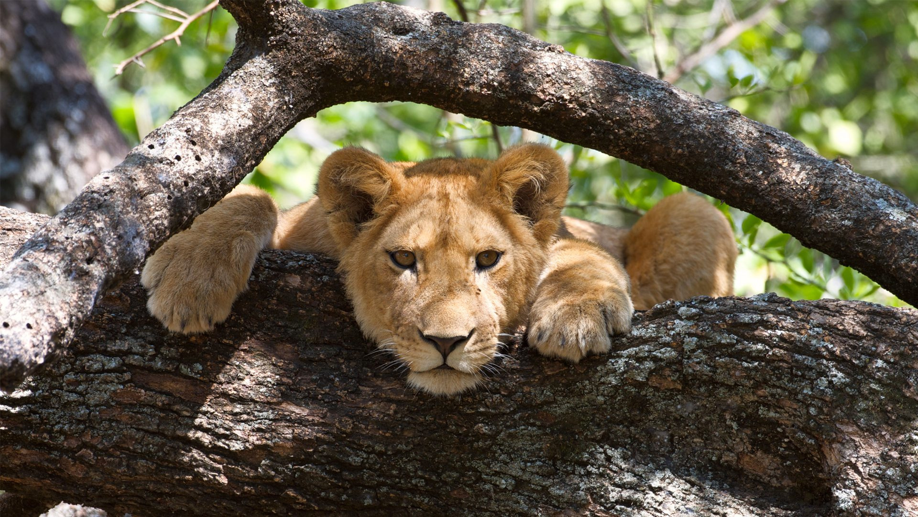

**Meal: Breakfast & Lunch**

**INCLUSIONS**

• Private Toyota Landcruiser 4x4 with pop-up roofs

• Private professional safari guide

• All nights’ accommodation in Arusha & during Safari

• All Park Fees

• Government Tax

• Unlimited drinking water, tea, coffee

• Some soft drinks & beers inside the safari vehicle

• Flying Doctors Insurance

• Domestic flights

(AMREF)

**EXCLUSIONS**

• International flights

• Tips

• Personal needs

• Visa

**ALL COST IN USD OK**

**$ 10,537 1 PAX $ 17,685 2PAX $ 23,670 3PAX $ 31,043,247 4PAX $ 37,759 5PAX $ 44,359 6pax**

**$ 1,317 PPD $ 1,105 PPD $ 987 PPD $ 970 PPD $ 943 PPD $ 1,050 PPD**

**30% 28% 25% 24% 22% 19%**

**7 MIDRANGE NORTH MIGRATION SAFARI**

**(Tarangire, Serengeti & Ngorongoro Crater)**

**PARKS**

**• Tarangire National Park**

**• Ngorongoro crater**

**• Serengeti National Park**

OVERVIEW

This 7-day midrange safari on the northern circuit of Tanzania, takes you to the most famous and incredible parks whereby you will visit all major parks which are Tarangire, Serengeti and Ngorongoro. In Tarangire, you will be astonished by the large African elephants as well as the huge and ancient baobab trees. Ngorogoro crater will be the icing on the cake and the best place to visit the endangered black rhinos and Serengeti will be the major highlight of the tour where you will visit the northern Serengeti following the great migration on the mara river. You will sleep in midrange lodges with private showers.

**DETAILED ITINERARY**

**DAY 1: ARRIVAL AT THE AIRPORT TO ARUSHA**

Upon arrival at the airport in Arusha (ARK) or Kilimanjaro international airport (JRO), you will be met and welcomed by your representative from Bapta African Safaris who will give you a short brief before you drive to your lodgings in Arusha for overnight.

**Destination: Arusha city**

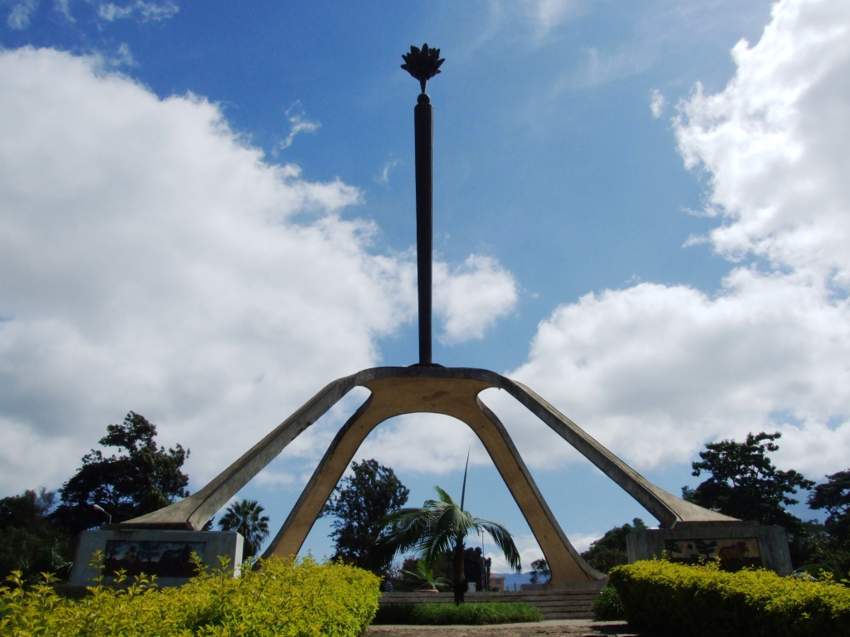

**Accommodation: Arusha Planet Lodge / A1 Hotel & Resort / Tulia Boutique Hotel & Spa**

**Meal: Bed & Breakfast**

**DAY 2: ARUSHA TO TARANGIRE NATIONAL PARK**

Early morning after having breakfast at your hotel in Arusha at around 0730hrs to 0800hrs you will be picked up by your personal driver guide and depart straight to Tarangire National Park whereby the drive is approximately 2.5 hours to the gate. Tarangire National Park is located on the northern part of Tanzania with a wide variety of animals and landscape whereby the best part is the elephant herds. It is known to be the park which has the greatest concentration of African elephants and the ancient baobab trees. Tarangire has an area of approximately 2603 square Kilometers and within the park it is possible to see plenty of animals like the giraffes, Zebras, Buffalos, warthogs, Lions, Leopards, Impala, gazelles, dik dik and many more species. In this park, there are more than 500 birds’ species like the bee eaters, swallows, ostriches, kori bustards, hammerkops, vultures etc. The word Tarangire comes from Mbugwe tribe whereby “Tara” means river and Ngire” means warthogs therefore it is the river of warthogs. The Tarangire river is the life giving opportunity for both herbivores and carnivores and it is the best spot for the lions to hunt their prey as they search for water especially during the dry season. Lunch will be served at a picnic site at around 1200hrs to 1300hrs and after that you will proceed with your game drive until in the late afternoon where you will exit the park and drive straight to your lodge in Karatu for relaxation, dinner and overnight.

**Destination: Tarangire National Park**

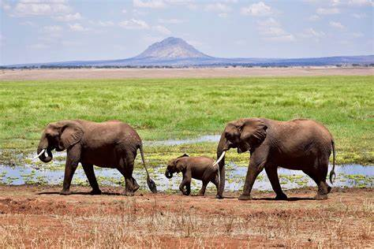

**Accommodation: Marera Valley Lodge / Farm of Dreams Lodge / Bougainvillea Safari Lodge**

**Meal: Full Board (Breakfast, Lunch & Dinner**)

**DAY 3: KARATU TO SERENGETI NATIONAL PARK**

Early morning after having breakfast at your lodge in Karatu at around 0730hrs to 0800hrs you will depart straight to Serengeti National Park passing through the Ngorongoro Conservation Area. Serengeti National Park is the most famous park on the northern circuit of Tanzania with the greatest population of wildlife than anywhere else on this planet. The word Serengeti originates from Maasai tribe, the word “Seringiti” which means endless plains. The park covers a total area of approximately 14,763 square kilometers with more than 2 million mammals inhabiting the park. The great annual migration involves more than a million wildebeests accompanied by some 250,000 zebras and antelopes and it is one of the 7 wonders of the world. This is exactly what makes this park the most famous park. The park is also home to more than 500 birds’ species including the ostriches, kori bustard, starlings, weavers, marabou storks, vultures, eagles, kingfishers, rollers etc. Animals that can be found inside the park are like the impalas, gazelles, topi, hartebeest, giraffes, hippo, buffalo, dik dik, waterbuck and predators such as lions, leopards, cheetahs, hyena, jackals, caracals, serval cats etc. The scenery of Serengeti on the south east is the short grass plains. The northern part of Serengeti also known as kogatende has more hills and rocks. To the western corridor known as Grumeti there are rivers, valleys as well as forests. Some areas in the heart of Serengeti heading up north of Serengeti are dotted with kopjes. The Serengeti National Park can be visited all year round but the best time to visit is during the dry season from June to October. Lunch will be served inside the park and afterwards, proceed with game viewing until the evening where you will drive straight to your accommodation for dinner and overnight.

**Destination: Serengeti National Park**

**Accommodation: Narudi Camp / Pamoja Serengeti Luxury Camp / Embalakai Authentic Camps**

**Meal: Full Board (Breakfast, Lunch & Dinner)**

**DAY 4: CENTRAL TO NORTH SERENGETI**

Early morning after breakfast at your accommodation inside Serengeti, you will drive to the northern part of Serengeti which is also known as kogatende following the great migration. We will do a game drive en-route. As we head to the north, good sightings of giraffes, herds of buffalo and elephants can often be seen. While the Serengeti has abundant wildlife, it is best known for the annual Great Migration.  Vast numbers of wildebeests accompanied by large numbers of zebra and antelope migrate in an annual pattern, constantly seeking fresh grazing.  The precise timing of the Migration is entirely dependent upon the rainfall patterns year. During End of July to September the Migration can be found in the Northern Serengeti where they are crossing the Mara River following the greener pastures of Maasai Mara where the provide the Mara river resident Nile crocodiles with annual fist.After Lunch and an extensive game drive, we head for our partner tented camp for dinner and overnight.

**Destination: North Serengeti National Park**

**Accommodation: Mara Kati Kati Tented Camp / Serengeti Heritage Tented Camp**

**Meal: Full Board (Breakfast, Lunch & Dinner)**

**DAY 5: FULL DAY GAME DRIVE ON NORTH SERENGETI.**

Early morning after having breakfast at your accommodation will start with an early morning game drive following the great migration. If you’re lucky enough you can spot predators hunting their prey as well as the majestic river crossing while hungry crocodiles wait their meal. Lunch will be served at a picnic site and after that you will proceed with your game drive until the late evening where you will drive to your accommodation for sinner and overnight stay.

**Destination: North Serengeti National Park**

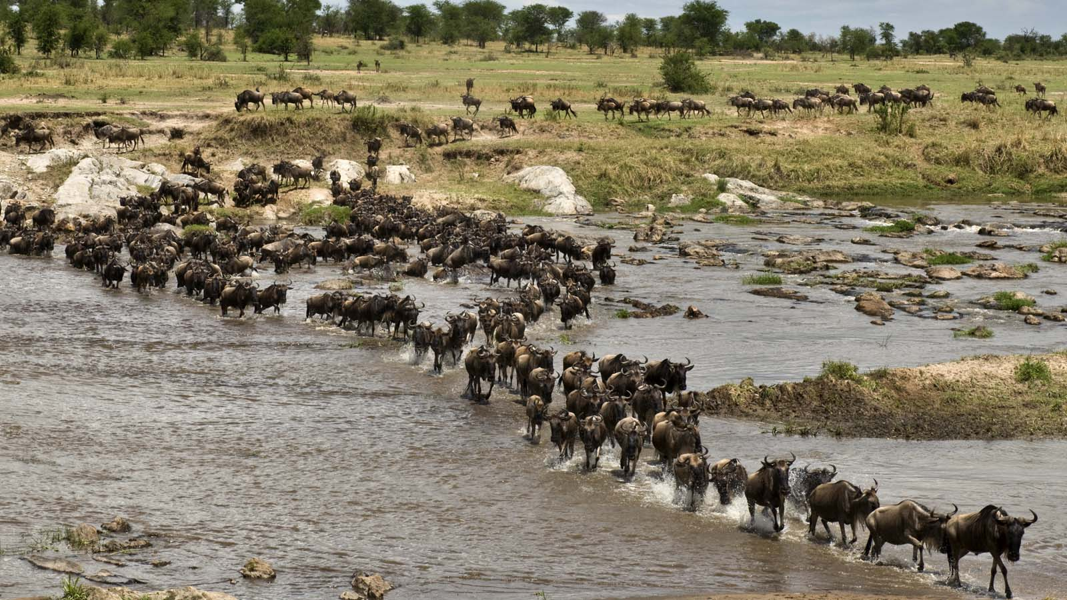

**Accommodation: Mara Kati Kati Tented Camp / Serengeti Heritage Tented Camp**

**Meal: Full Board (Breakfast, Lunch & Dinner)**

**DAY 6: NORTH SERENGETI NATIONAL PARK TO NGORONGORO CONSERVATION AREA**

Early morning after having breakfast at your accommodation inside Serengeti, you will drive straight to Ngorongoro Conservation Area to your accommodation for dinner and overnight stay.

**Destination: Ngorongoro Conservation Area**

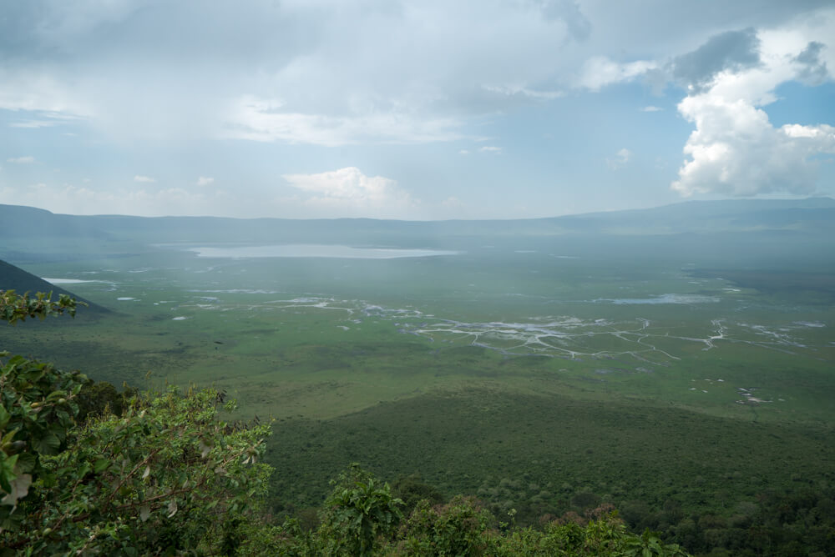

**Accommodation: Rhino Lodge / Ang’ata Ngorongoro**

**Meal: Full Board (Breakfast, Lunch & Dinner)**

**DAY 7: NGORONGORO CRATER TO ARUSHA**

Early morning after having breakfast at your accommodation, you will drive straight to the floor of the crater. Ngorongoro crater is a world heritage site as well as a geo-park. It is 600m deep and before you descend the crater you will stop at a view point where you can see the crater below. The Ngorongoro crater has approximately 25000 mammals and has more than 500 birds’ species where there are also migratory birds like the flamingos. The interesting part with Ngorongoro crater is that it is the best place in East Africa to witness the endangered black rhinos which completes the big 5. In Ngorongoro you can find animals like the Zebras, wildebeests, hyenas, lion prides, gazelles, impalas, kudus, waterbucks, buffalos and many more. The Ngorongoro crater has a diameter of approximately 20km whereby it is easy to spot animals and one can spend 5-6 hours exploring the park if you have a limited time. The other attraction in Ngorongoro crater is the Ngoitoktok picnic site which is a permanent hippo pool where most of the clients have their fabulous lunch at this place. The beauty of Ngorongoro can never be untold to the visitors who have visited this area. After having packed lunch at a picnic site at the hippo pool, you will finalize your game drive before you ascend the crater and drive straight to Arusha.

**Destination: Arusha**

**Meal: Full Board (Breakfast, Lunch & Dinner)**

**INCLUSIONS**

• Private Toyota Landcruiser 4x4 with pop-up roofs

• Private professional safari guide

• All nights’ accommodation in Arusha & during Safari

• All Park Fees

• Government Tax

• Unlimited drinking water, tea, coffee

• Some soft drinks & beers inside the safari vehicle

• Flying Doctors Insurance (AMREF)

• Domestic flights

**EXCLUSIONS**

• International flights

• Tips

• Personal needs

• Visa

**ALL COST IN USD OK**

**$ 5,532 PAX $ 8,215 2PAX $ 10,896 3PAX $ 13,642 4PAX $ 16259 5PAX $ 17,627 6pax**

**$ 790 PPD $ 587 PPD $ 518 PPD $ 487 PPD $ 464 PPD $ 419 PPD**

**30% 28% 27% 24% 17% 18%**

**8 DAYS MIDRANGE NORTH MIGRATION SAFARI**

**(Tarangire, Serengeti, Manyara Ngorongoro Crater)**

**PARKS**

**• Tarangire National Park**

**• Ngorongoro crater**

**• Serengeti National Park**

**• Lake Manyara National Park**

**OVERVIEW**

This 8-day midrange safari on the northern circuit of Tanzania, takes you to the most famous and incredible parks whereby you will visit all major parks which are Tarangire, Serengeti and Ngorongoro. In Tarangire, you will be astonished by the large African elephants as well as the huge and ancient baobab trees. Ngorogoro crater will be the icing on the cake and the best place to visit the endangered black rhinos and Serengeti will be the major highlight of the tour where you will visit the northern Serengeti following the great migration on the mara river. You will sleep in midrange lodges with private showers.

**DETAILED ITINERARY**

**DAY 1: ARRIVAL AT THE AIRPORT TO ARUSHA**

Upon arrival at the airport in Arusha (ARK) or Kilimanjaro international airport (JRO), you will be met and welcomed by your representative from Bapta African Safaris who will give you a short brief before you drive to your lodgings in Arusha for overnight.

**Destination: Arusha city**

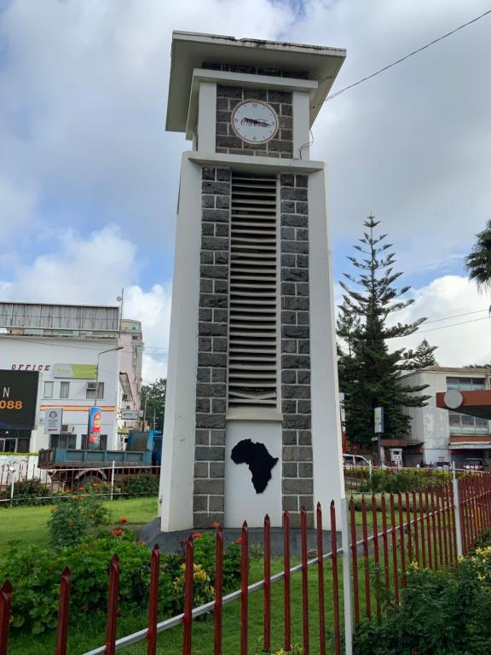

**Accommodation: Arusha Planet Lodge / A1 Hotel & Resort / Tulia Boutique Hotel & Spa**

**Meal: Bed & Breakfast**

**DAY 2: ARUSHA TO TARANGIRE NATIONAL PARK**

Early morning after having breakfast at your hotel in Arusha at around 0730hrs to 0800hrs you will be picked up by your personal driver guide and depart straight to Tarangire National Park whereby the drive is approximately 2.5 hours to the gate. Tarangire National Park is located on the northern part of Tanzania with a wide variety of animals and landscape whereby the best part is the elephant herds. It is known to be the park which has the greatest concentration of African elephants and the ancient baobab trees. Tarangire has an area of approximately 2603 square Kilometers and within the park it is possible to see plenty of animals like the giraffes, Zebras, Buffalos, warthogs, Lions, Leopards, Impala, gazelles, dik dik and many more species. In this park, there are more than 500 birds’ species like the bee eaters, swallows, ostriches, kori bustards, hammerkops, vultures etc. The word Tarangire comes from Mbugwe tribe whereby “Tara” means river and “Ngire” means warthogs therefore it is the river of warthogs. The Tarangire river is the life giving opportunity for both herbivores and carnivores and it is the best spot for the lions to hunt their prey as they search for water especially during the dry season. Lunch will be served at a picnic site at around 1200hrs to 1300hrs an after that you will proceed with your game drive until in the late afternoon where you will exit the park and drive straight to your midrange lodge in Karatu for relaxation, dinner and overnight.

**Destination: Tarangire National Park**

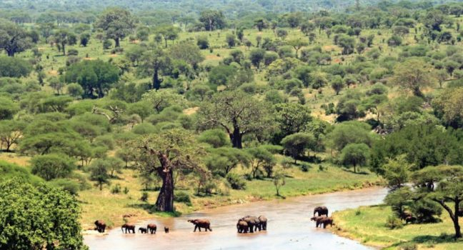

**Accommodation: Marera Valley Lodge / Farm of Dreams Lodge / Bougainvillea Safari Lodge**

**Meal: Full Board (Breakfast, Lunch & Dinner)**

**DAY 3: KARATU TO SERENGETI NATIONAL PARK**

Early morning after having breakfast at your lodge in Karatu at around 0730hrs to 0800hrs you will depart straight to Serengeti National Park passing through the Ngorongoro Conservation Area. Serengeti National Park is the most famous park on the northern circuit of Tanzania with the greatest population of wildlife than anywhere else on this planet. The word Serengeti originates from Maasai tribe, the word “Seringiti” which means endless plains. The park covers a total area of approximately 14,763 square kilometers with more than 2 million mammals inhabiting the park. The great annual migration involves more than a million wildebeests accompanied by some 250,000 zebras and antelopes and it is one of the 7 wonders of the world. This is exactly what makes this park the most famous park. The park is also home to more than 500 birds’ species including the ostriches, kori bustard, starlings, weavers, marabou storks, vultures, eagles, kingfishers, rollers etc. Animals that can be found inside the park are like the impalas, gazelles, topi, hartebeest, giraffes, hippo, buffalo, dik dik, waterbuck and predators such as lions, leopards, cheetahs, hyena, jackals, caracals, serval cats etc. The scenery of Serengeti on the south east is the short grass plains. The northern part of Serengeti also known as kogatende has more hills and rocks. To the western corridor known as Grumeti there are rivers, Valley as well as forests. Some areas in the heart of Serengeti heading up north of Serengeti are dotted with kopjes The Serengeti National Park can be visited all year round but the best time to visit is during the dry season from June to October. Lunch will be served inside the park and afterwards, proceed with game viewing until the evening where you drive straight to your accommodation for dinner and overnight.

**Destination: Serengeti National Park**

**Accommodation: Narudi Camp / Pamoja Serengeti Luxury Camp / Embalakai Authentic Camps**

**Meal: Full Board (Breakfast, Lunch & Dinner)**

**DAY 4: CENTRAL TO NORTH SERENGETI**

Early morning after breakfast at your accommodation inside Serengeti, you will drive to the northern part of Serengeti which is also known as kogatende following the great migration. We will do a game drive en-route. As we head to the north, good sightings of giraffes, herds of buffalo and elephants can often be seen. While the Serengeti has abundant wildlife, it is best known for the annual Great Migration.  Vast numbers of wildebeests accompanied by large numbers of zebra and antelope migrate in an annual pattern, constantly seeking fresh grazing.  The precise timing of the Migration is entirely dependent upon the rainfall patterns each year. During End of July to September the Migration can be found in the Northern Serengeti where they are crossing the Mara River following the greener pastures of Maasai Mara where the provide the Mara river resident Nile crocodiles with annual fist. After Lunch and an extensive game drive, we head for our partner tented camp for dinner and overnight.

**Destination: Serengeti National Park**

**Accommodation: Mara Kati Kati Tented Camp / Serengeti Heritage Tented Camp**

**Meal: Full Board (Breakfast, Lunch & Dinner)**

**DAY 5: FULL DAY GAME DRIVE ON NORTH SERENGETI**

Early morning after having breakfast at your accommodation will start with an early morning game drive following the great migration. If you’re lucky enough you can spot predators hunting their prey as well as the majestic river crossing while hungry crocodiles wait their meal. Lunch will be served at a picnic site and after that you will proceed with your game drive until the late evening where you will drive to your accommodation for sinner and overnight stay.

**Destination: Serengeti National Park**

**Accommodation: Mara Kati Kati Tented Camp / Serengeti Heritage Tented Camp**

**Meal: Full Board (Breakfast, Lunch & Dinner)**

**DAY 6: NORTH SERENGETI TO CENTRAL SERENGETI**

Early morning after having breakfast at your accommodation will start with an early morning game drive en- route to the central Serengeti at your accommodation for relaxation, dinner and overnight.

**Destination: Serengeti National Park**

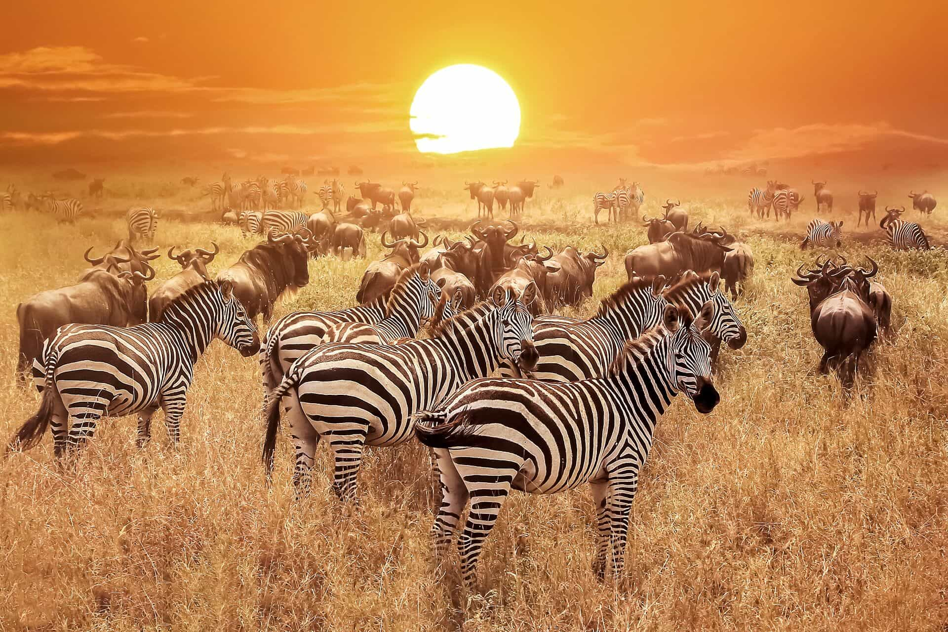

**Accommodation: Narudi Camp / Pamoja Serengeti Luxury Camp / Embalakai Authentic Camps**

**Meal: Full Board (Breakfast, Lunch & Dinner)**

**DAY 7: SERENGETI NATIONAL PARK TO NGORONGORO CRATER TO KARATU**

Early morning after having breakfast at your accommodation inside Serengeti, you will drive straight to Ngorongoro Conservation Area en-route whereby the drive is approximately 4 hours to the floor of the crater. Ngorongoro crater is a world heritage site as well as a geo-park. It is 600m deep and before you descend the crater you will stop at a view point where you can see the crater below. The Ngorongoro crater has approximately 25000 mammals and has more than 500 birds’ species where there are also migratory birds like the flamingos. The interesting part with Ngorongoro crater is that it is the best place in East Africa to witness the endangered black rhinos which completes the big 5. In Ngorongoro you can find animals like the Zebras, wildebeests, hyenas, lion prides, gazelles, impalas, kudus, waterbucks, buffalos and many more. The Ngorongoro crater has a diameter of approximately 20km whereby it is easy to spot animals and one can spend 5-6 hours exploring the park if you have a limited time. The other attraction in Ngorongoro crater is the Ngoitoktok picnic site which is a permanent hippo pool where most of the clients have their fabulous lunch at this place. The beauty of Ngorongoro can never be untold to the visitors who have visited this area. After having packed lunch at a picnic site at the hippo pool, you will finalize your game drive before you ascend the crater and drive straight to your accommodation in Karatu for relaxation, dinner and overnight.

**Destination: Ngorongoro crater**

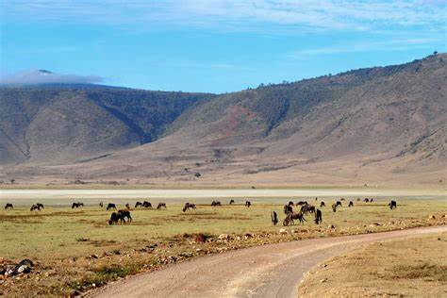

**Accommodation: Marera Valley Lodge / Farm of Dreams Lodge / Bougainvillea Safari Lodge**

**Meal: Full Board (Breakfast, Lunch & Dinner)**

**DAY 8: LAKE MANYARA NATIONAL PARK TO ARUSHA**

Early morning after having breakfast at your lodge in Karatu at around 0730hrs to 0800hrs you will depart straight to Lake Manyara National Park whereby the drive is approximately 1 hour to the gate. Lake Manyara National Park is well known for its birds’ life and also known as the home of tree climbing lions. The park has an area of about 325 square kilometers whereby a third of the area is the land and the rest is the lake which makes Lake Manyara the best attraction. Lake Manyara is a shallow alkaline lake that attracts a number of birds to the area. The birds’ species that can be found in Lake Manyara includes both migratory birds and native birds species like the flamingos, pelicans, storks, herons, cranes, secretary birds, ground hornbills, ostriches and many more birds species. Animals that can be found in lake Manyara are like the lions,elephants, giraffes, zebras, warthogs, wildebeests, baboons, blue monkeys, waterbucks, bushbucks, rarely leopards, buffalo etc. The park is located on the south western part of Arusha at the rift valley region which makes it easier to do different activities like the forest hike on the rift valley and other activities include canoeing, tree canopy walk, walking safari around the lake etc. Lunch will be served at the picnic site, and after that you will drive straight to Arusha where you will meet one of the representatives from Bapta African Safaris who will give you a special farewell. If you would like to have an extra night in Arusha we can arrange that for you in advance or if you have a flight, we will drive you straight to the airport to catch your onwards flight back home or to your next destination.

**Destination: Lake Manyara National Park**

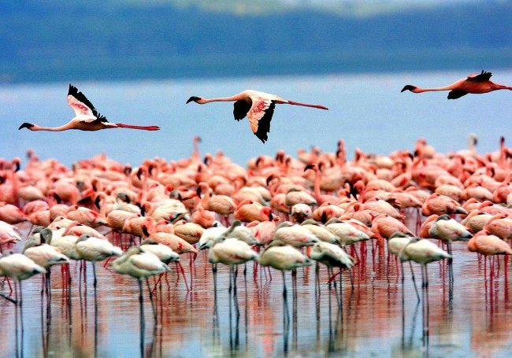

**Meal: Breakfast & Lunch**

**INCLUSIONS**

• Private Toyota Landcruiser 4x4 with pop-up roofs

• Private professional safari guide

• All nights’ accommodation in Arusha & during Safari

• All Park Fees

• Government Tax

• Unlimited drinking water, tea, coffee

• Some soft drinks & beers inside the safari vehicle

• Flying Doctors Insurance (AMREF)

• Domestic flights

**EXCLUSIONS**

• International flights

• Tips

• Personal needs

• Visa

**ALL COST IN USD OK**

**$ 7,943 1 PAX $ 12,621 2PAX $ 17,561 3PAX $ 22,048 4PAX $ 26,598 5PAX $ 30,313 6pax**

**$ 992 PPD $ 795 PPD $ 731 PPD $ 670 PPD $ 664 PPD $ 631 PPD**

**28% 27% 26% 25% %24 20%**

**8 DAYS LUXURY FAMILY SAFARI**

**(Tarangire, Serengeti, Manyara & Ngorongoro Crater)**

**PARKS**

**• Tarangire National Park**

**• Ngorongoro crater**

**• Serengeti National Park**

**• Lake Manyara National Park**

**OVERVIEW**

This 8-day Luxury family safari on the northern circuit of Tanzania, takes you to the most famous and incredible parks whereby you will visit all major parks which are Tarangire, Serengeti and Ngorongoro. In Tarangire, you will be astonished by the large African elephants as well as the huge and ancient baobab trees. Ngorogoro crater will be the icing on the cake and the best place to visit the endangered black rhinos and Serengeti National Park which is the endless plains and home to more than millions of animals. You will sleep in luxury lodges with private showers.

**DETAILED ITINERARY**

**DAY 1: ARRIVAL AT THE AIRPORT TO ARUSHA**

Upon arrival at the airport in Arusha (ARK) or Kilimanjaro international airport (JRO), you will be met and welcomed by your representative from Bapta African Safaris who will give you a short brief before you drive to your lodgings in Arusha for overnight.

**Destination: Arusha city**

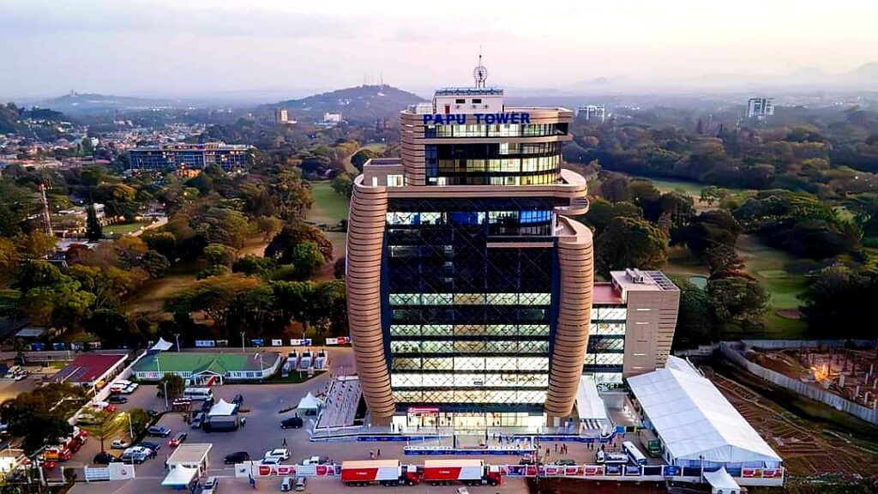

**Accommodation: Mount Meru Hotel / Arusha Coffee Lodge / Gran Melia Arusha**

**Meal: Bed & Breakfast**

**DAY 2: ARUSHA TO TARANGIRE NATIONAL PARK**

Early morning after having breakfast at your hotel in Arusha at around 0730hrs to 0800hrs you will be pickedup by your personal driver guide and depart straight to Tarangire National Park whereby the drive isapproximately 2.5 hours to the gate. Tarangire National Park is located on the northern part of Tanzania with awide variety of animals and landscape whereby the best part is the elephant herds. It is known to be the parkwhich has the greatest concentration of African elephants and the ancient baobab trees. Tarangire has an areaof approximately 2603 square Kilometers and within the park it is possible to see plenty of animals like thegiraffes, Zebras, Buffalos, warthogs, Lions, Leopards, Impala, gazelles, dik dik and many more species. In thispark, there are more than 500 birds’ species like the bee eaters, swallows, ostriches, kori bustards,hammerkops, vultures etc. The word Tarangire comes from Mbugwe tribe whereby “Tara” means river and“Ngire” means warthogs therefore it is the river of warthogs. The Tarangire river is the life giving opportunityfor both herbivores and carnivores and it is the best spot for the lions to hunt their prey as they search forwater especially during the dry season. Lunch will be served at a picnic site at around 1200hrs to 1300hrs andafter that you will proceed with your game drive until in the late afternoon where you drive straight to yourluxury lodge in Tarangire for relaxation, dinner and overnight.

**Destination: Tarangire National Park**

**Accommodation: Nimali Tarangire / Oliver’s Camp / Tarangire Treetops**

**Meal: Full Board (Breakfast, Lunch & Dinner)**

**DAY 3: FULL DAY GAME DRIVE IN TARANGIRE NATIONAL PARK**

Early morning after having breakfast at your accommodation, you will proceed with your game drive in Tarangire National Park with hot lunch. After having lunch, you will finalize your game drive until late afternoon where you will drive back to your accommodation for relaxation, dinner and overnight. If you prefer to have lunch at the lodge, it’s quite possible as we can arrange that for you.

**Destination: Tarangire National Park**

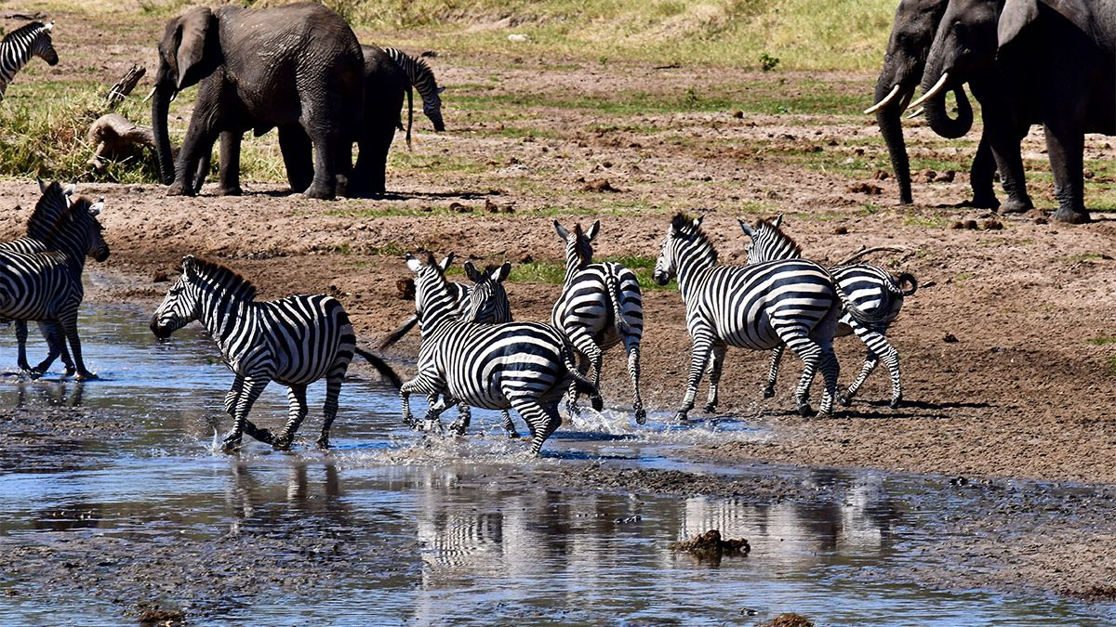

**Accommodation: Nimali Tarangire / Oliver’s Camp / Tarangire Treetops**

**Meal: Full Board (Breakfast, Lunch & Dinner)**

**DAY 4: TARANGIRE TO LAKE MANYARA NATIONAL PARK**

Early morning after having breakfast at your lodge in Tarangire at around 0730hrs to 0800hrs you will depart straight to Lake Manyara National Park whereby the drive is approximately 1 hour to the gate. Lake Manyara National Park is well known for its birds’ life and also known as the home of tree climbing lions. The park has an area of about 325 square kilometers whereby a third of the area is the land and the rest is the lake which makes Lake Manyara the best attraction. Lake Manyara is a shallow alkaline lake that attracts a number of birds to the area. The birds’ species that can be found in Lake Manyara includes both migratory birds and native birds species like the flamingos, pelicans, storks, herons, cranes, secretary birds, ground hornbills, ostriches and many more birds species. Animals that can be found in lake Manyara are like the lions, elephants, giraffes, zebras, warthogs, wildebeests, baboons, blue monkeys, waterbucks, bushbucks, rarely leopards, buffalo etc. The park is located on the south western part of Arusha at the rift valley region which makes it easier to do different activities like the forest hike on the rift valley and other activities include canoeing, tree canopy walk, walking safari around the lake etc. Lunch will be served at the picnic site, and after that you will drive straight to your accommodation in Karatu for relaxation, dinner and overnight.

**Destination: Lake Manyara National Park**

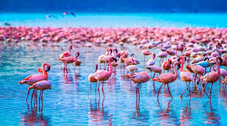

**Accommodation: Kitela Lodge / Neptune Ngorongoro / Gibb’s Farm**

**Meal: Full Board (Breakfast, Lunch & Dinner)**

**DAY 5: KARATU NGORONGORO CRATER**

Early morning after having breakfast at your accommodation in Karatu, you will drive straight to Ngorongoro Conservation Area en-route whereby the drive is approximately 4 hours to the floor of the crater. Ngorongoro crater is a world heritage site as well as a geo-park. It is 600m deep and before you descend the crater you will stop at a view point where you can see the crater below. The Ngorongoro crater has approximately 25000 mammals and has more than 500 birds’ species where there are also migratory birds like the flamingos. The part with Ngorongoro crater is that it is the best place in East Africa to witness the endangered black rhinos which completes the big 5. In Ngorongoro you can find animals like the Zebras, wildebeests, hyenas, lion prides, gazelles, impalas, kudus, waterbucks, buffalos and many more. The Ngorongoro crater has a diameter of approximately 20km whereby it is easy to spot animals and one can spend 5-6 hours exploring the park if you have a limited time. The other attraction in Ngorongoro crater is the Ngoitoktok picnic site which is a permanent hippo pool where most of the clients have their fabulous lunch at this place. The beauty of Ngorongoro can never be untold to the visitors who have visited this area. After having packed lunch at a picnic site at the hippo pool, you will finalize your game drive before you ascend the crater and drive straight to your accommodation at the rim of the crater for dinner and overnight.

**Destination: Ngorongoro Crater**

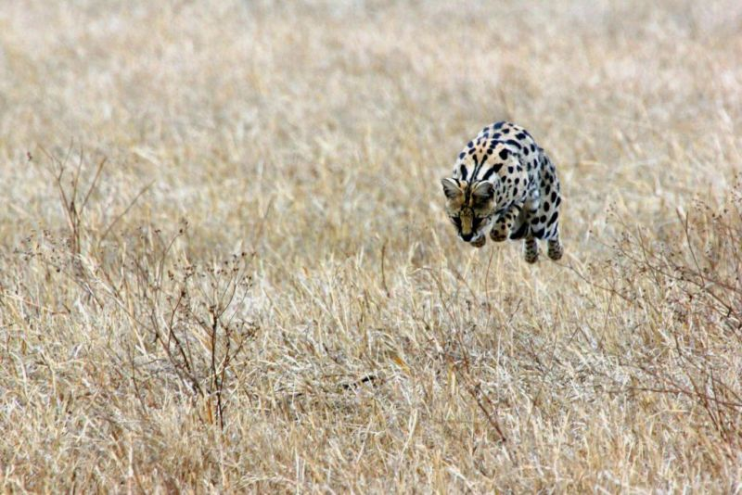

**Accommodation: Ngorongoro Serena Safari Lodge / Ngorongoro Lion’s Paw**

**Meal: Full Board (Breakfast, Lunch & Dinner)**

**DAY 6: NGORONGORO CONSERVATION AREA TO SERENGETI NATIONAL PARK**

Early morning after having breakfast at your lodge in Ngorongoro at around 0730hrs to 0800hrs you will depart straight to Serengeti National Park. Serengeti National Park is the most famous park on the northern circuit of Tanzania with the greatest population of wildlife than anywhere else on this planet. The word Serengeti originates from Maasai tribe, the word “Seringiti” which means endless plains. The park covers a total area of approximately 14,763 square kilometers with more than 2 million mammals inhabiting the park. The great annual migration involves more than a million wildebeests accompanied by some 250,000 zebras and antelopes and it is one of the 7 wonders of the world. This is exactly what makes this park the most famous park. The park is also home to more than 500 birds’ species including the ostriches, kori bustard, starlings, weavers, marabou storks, vultures, eagles, kingfishers, rollers etc. Animals that can be found inside the park are like the impalas, gazelles, topi, hartebeest, giraffes, hippo, buffalo, dik dik, waterbuck and predators such as lions, leopards, cheetahs, hyena, jackals, caracals, serval cats etc. The scenery of Serengeti on the south east is the short grass plains. The northern part of Serengeti also known as kogatende has more hills and rocks. To the western corridor known as Grumeti there are rivers, valleys as well as forests. Some areas in the heart of Serengeti heading up north of Serengeti are dotted with &#39;kopjes&#39;. The Serengeti National Park can be visited all year round but the best time to visit is during the dry season from June to October. Lunch will be served inside the park and afterwards, proceed with game viewing until the evening where you will drive straight to your accommodation for dinner and overnight.

**Destination: Serengeti National Park**

**Accommodation: Kubu Kubu Tented Lodge / Serengeti Serena Safari Lodge / Melia Serengeti**

**Meal: Full Board (Breakfast, Lunch & Dinner)**

**DAY 7: FULL DAY GAME DRIVE IN SERENGETI NATIONAL PARK**

Early morning after breakfast at your accommodation, you will proceed with your full day game drive looking for the big cats and other animals found in this area. Lunch will be served at around 1230hrs or 1300hrs. After lunch and further game viewing, you will drive straight to your lodge for relaxation, dinner and overnight.

**Destination: Serengeti National Park**

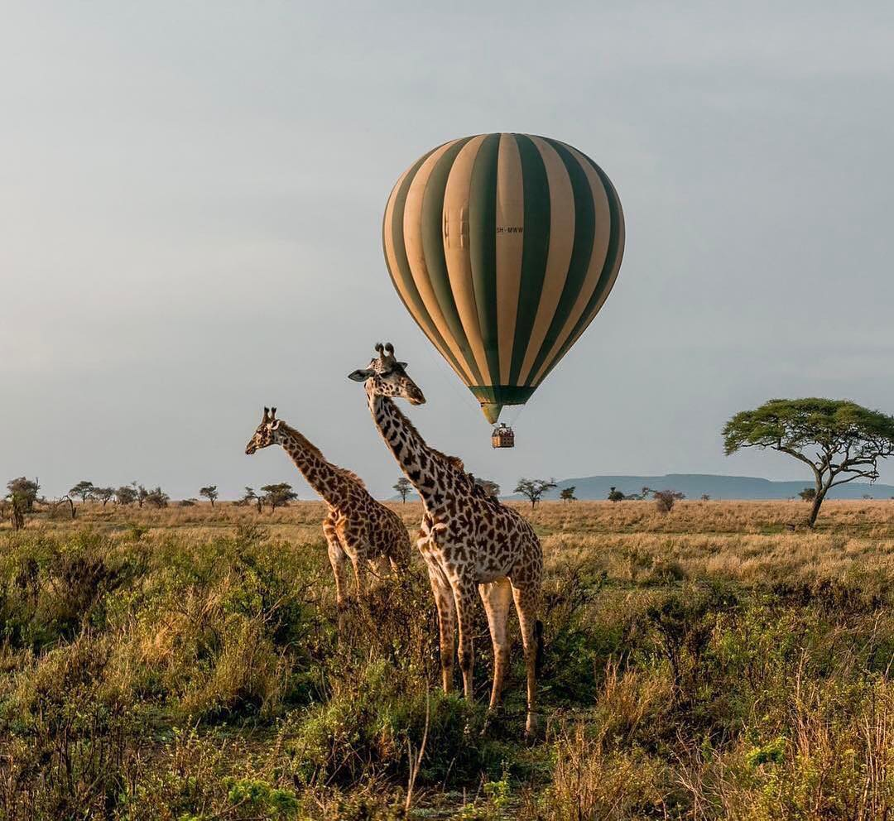

**Meal: (Breakfast & Lunch**)

**Accommodation: Kubu Kubu Tented Lodge / Serengeti Serena Safari Lodge / Melia Serengeti**

**Meal: Full Board (Breakfast, Lunch & Dinner)**

**DAY 8: ONWARDS FLIGHT TO ZANZIBAR/ARUSHA**

Early morning after having breakfast, you will pack your luggage and get ready for your transfer to Seronera airstrip at the heart of Serengeti to catch your flight to Arusha. Upon arrival in Arusha, you will meet one of our representatives who will take you to Kilimanjaro International Airport for your flight back home or if you’re planning to fly to Zanzibar, you will catch a flight at the same airport with one of our staff’s guidance to make sure you have boarded your flight safely.

**INCLUSIONS**

• Private Toyota Landcruiser 4x4 with pop-up roofs

• Private professional safari guide

• All nights’ accommodation in Arusha & during Safari

• All Park Fees

• Government Tax

• Unlimited drinking water, tea, coffee

• Some soft drinks & beers inside the safari vehicle

• Flying Doctors Insurance (AMREF)

• Flight from Seronera to Arusha

**EXCLUSIONS**

• International flights

• Tips

• Personal items

• Visa

**ALL COST IN USD OK**

**$ 10,537 1 PAX $ 17,685 2PAX $ 23,670 3PAX $ 31,043,247 4PAX $ 37,759 5PAX $ 44,359 6pax**

**$ 1,317 PPD $ 1,105 PPD $ 987 PPD $ 970 PPD $ 943 PPD $ 1,050 PPD**

**30% 28% 25% 24% 22% 19%**

**12 DAYS LUXURY HONEYMOON SAFARI + BEACH**

**(Tarangire, Serengeti, Manyara, Ngorongoro Crater & Zanzibar)**

**DESTINATIONS**

**• Tarangire National Park**

**• Ngorongoro crater**

**• Serengeti National Park**

**• Lake Manyara National Park**

**• Zanzibar (Nungwi)**

**OVERVIEW**

This 12-day Luxury Honeymoon safari & Beach vacation in Zanzibar, takes you to the most famous and

incredible parks whereby you will visit all major parks which are Tarangire, Serengeti and Ngorongoro. In

Tarangire, you will be astonished by the large African elephants as well as the huge and ancient baobab trees.

Ngorogoro crater will be the icing on the cake and the best place to visit the endangered black rhinos and

Serengeti National Park which is the endless plains and home to more than millions of animals. After your

safari, you will visit the northern coast of Zanzibar at a 5-star luxury resort for your honeymoon. You will sleep

in luxury lodges with private showers.

DETAILED ITINERARY

**DAY 1: ARRIVAL AT THE AIRPORT TO ARUSHA**

Upon arrival at the airport in Arusha (ARK) or Kilimanjaro international airport (JRO), you will be met and

welcomed by your representative from Bapta African Safaris who will give you a short brief before you

drive to your lodgings in Arusha for overnight.

**Destination: Arusha city**

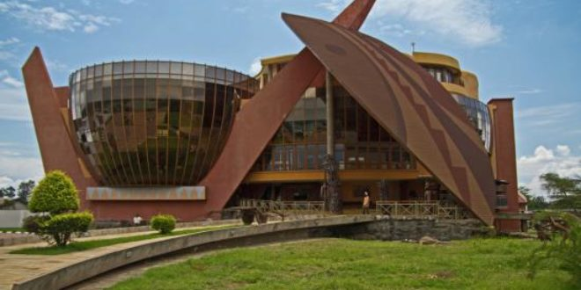

**Accommodation: Mount Meru Hotel / Arusha Coffee Lodge / Gran Melia Arusha**

**Meal: Bed &amp; Breakfast**

**DAY 2: ARUSHA TO TARANGIRE NATIONAL PARK**

Early morning after having breakfast at your hotel in Arusha at around 0730hrs to 0800hrs you will be picked up by your personal driver guide and depart straight to Tarangire National Park whereby the drive is approximately 2.5 hours to the gate. Tarangire National Park is located on the northern part of Tanzania with a wide variety of animals and landscape whereby the best part is the elephant herds. It is known to be the park which has the greatest concentration of African elephants and the ancient baobab trees. Tarangire has an area of approximately 2603 square Kilometers and within the park it is possible to see plenty of animals like the giraffes, Zebras, Buffalos, warthogs, Lions, Leopards, Impala, gazelles, dik dik and many more species. In this park, there are more than 500 birds’ species like the bee eaters, swallows, ostriches, kori bustards ,hammerkops, vultures etc. The word Tarangire comes from Mbugwe tribe whereby “Tara” means river **and “Ngire” means warthogs therefore it is the river of warthogs. The Tarangire river is the life giving** opportunity for both herbivores and carnivores and it is the best spot for the lions to hunt their prey as they search for water especially during the dry season. Lunch will be served at a picnic site at around 1200hrs to 1300hrs and after that you will proceed with your game drive until in the late afternoon where you drive straight to your luxury lodge in Tarangire for relaxation, dinner and overnight.

**Destination: Tarangire National Park**

**Accommodation: Nimali Tarangire / Oliver’s Camp / Tarangire Treetops**

**Meal: Full Board (Breakfast, Lunch & Dinner)**

**DAY 3: FULL DAY GAME DRIVE IN TARANGIRE NATIONAL PARK**

Early morning after having breakfast at your accommodation, you will proceed with your game drive in Tarangire National Park with hot lunch. After having lunch, you will finalize your game drive until late afternoon where you will drive back to your accommodation for relaxation, dinner and overnight. If you prefer to have lunch at the lodge, it’s quite possible as we can arrange that for you.

**Destination: Tarangire National Park**

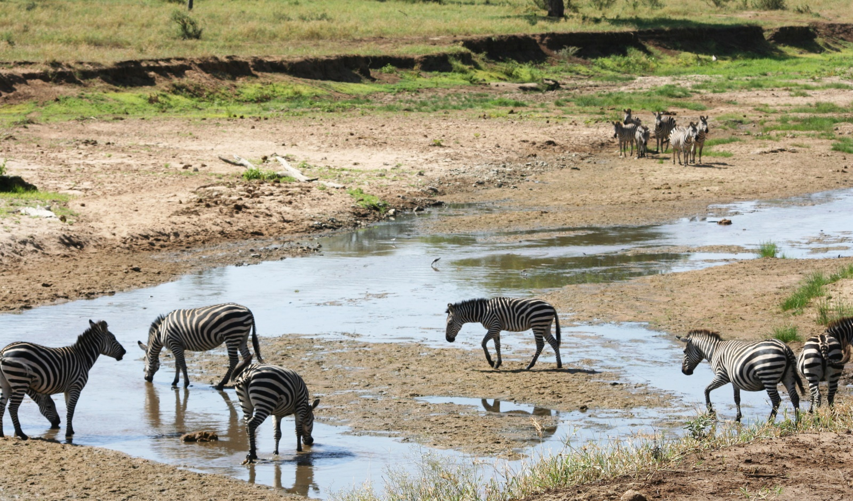

**Accommodation: Nimali Tarangire / Oliver’s Camp / Tarangire Treetops**

**Meal: Full Board (Breakfast, Lunch & Dinner)**

**DAY 4: TARANGIRE TO LAKE MANYARA NATIONAL PARK**

Early morning after having breakfast at your lodge in Tarangire at around 0730hrs to 0800hrs you will depart straight to Lake Manyara National Park whereby the drive is approximately 1 hour to the gate. Lake Manyara National Park is well known for its birds’ life and also known as the home of tree climbing lions. The park has an area of about 325 square kilometers whereby a third of the area is the land and the rest is the lake which makes Lake Manyara the best attraction. Lake Manyara is a shallow alkaline lake that attracts a number of birds to the area. The birds’ species that can be found in Lake Manyara includes both migratory birds and native birds species like the flamingos, pelicans, storks, herons, cranes, secretary birds, ground hornbills,ostriches and many more birds species. Animals that can be found in lake Manyara are like the lions, elephants, giraffes, zebras, warthogs, wildebeests, baboons, blue monkeys, waterbucks, bushbucks, rarely leopards, buffalo etc. The park is located on the south western part of Arusha at the rift valley region which makes it easier to do different activities like the forest hike on the rift valley and other activities include canoeing, tree canopy walk, walking safari around the lake etc. Lunch will be served at the picnic site, and after that you will drive straight to your accommodation in Karatu for relaxation, dinner and overnight.

**Destination: Lake Manyara National Park**

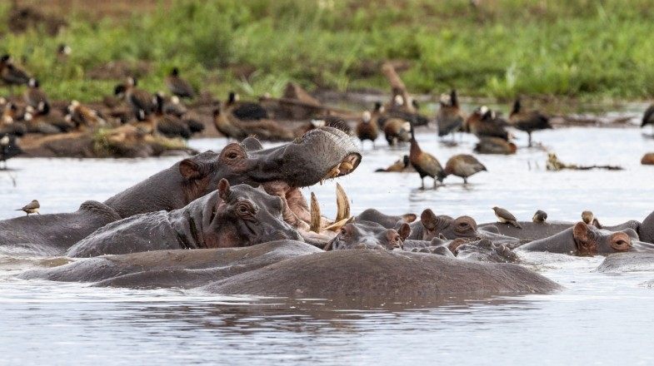

**Accommodation: Kitela Lodge / Neptune Ngorongoro / Gibb’s Farm**

**Meal: Full Board (Breakfast, Lunch & Dinner)**

**DAY 5: KARATU TO NGORONGORO CRATER**

Early morning after having breakfast at your accommodation in Karatu, you will drive straight to Ngorongoro Conservation Area en-route whereby the drive is approximately 4 hours to the floor of the crater. Ngorongoro crater is a world heritage site as well as a geo-park. It is 600m deep and before you descend the crater you will stop at a view point where you can see the crater below. The Ngorongoro crater has approximately 25000 mammals and has more than 500 birds’ species where there are also migratory birds like the flamingos. The interesting part with Ngorongoro crater is that it is the best place in East Africa to witness the endangered black rhinos which completes the big 5. In Ngorongoro you can find animals like the Zebras, wildebeests, hyenas, lion prides, gazelles, impalas, kudus, waterbucks, buffalos and many more. The Ngorongoro crater has diameter of approximately 20km whereby it is easy to spot animals and one can spend 5-6 hours exploring the park if you have a limited time. The other attraction in Ngorongoro crater is the Ngoitoktok picnic site which is a permanent hippo pool where most of the clients have their fabulous lunch at this place. The beauty of Ngorongoro can never be untold to the visitors who have visited this area. After having packed lunch at a picnic site at the hippo pool, you will finalize your game drive before you ascend the crater and drive straight to your accommodation at the rim of the crater for dinner and overnight.

**Destination: Ngorongoro Crater**

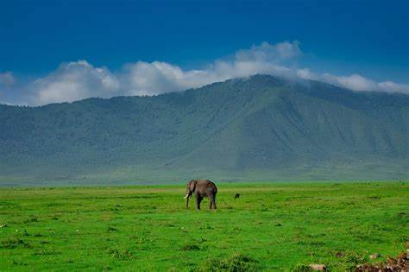

**Accommodation: Ngorongoro Serena Safari Lodge / Ngorongoro Lion’s Paw**

**Meal: Full Board (Breakfast, Lunch & Dinner)**

**DAY 6: NGORONGORO CONSERVATION AREA TO SERENGETI NATIONAL PARK**

Early morning after having breakfast at your lodge in Ngorongoro at around 0730hrs to 0800hrs you will depart straight to Serengeti National Park. Serengeti National Park is the most famous park on the northern circuit of Tanzania with the greatest population of wildlife than anywhere else on this planet. The word Serengeti originates from Maasai tribe, the word “Seringiti” which means endless plains. The park covers a total area of approximately 14,763 square kilometers with more than 2 million mammals inhabiting the park. The great annual migration involves more than a million wildebeests accompanied by some 250,000 zebras and antelopes and it is one of the 7 wonders of the world. This is exactly what makes this park the most famous park. The park is also home to more than 500 birds’ species including the ostriches, kori bustard, starlings, weavers, marabou storks, vultures, eagles, kingfishers, rollers etc. Animals that can be found inside the park are like the impalas, gazelles, topi, hartebeest, giraffes, hippo, buffalo, dik dik, waterbuck and predators such as lions, leopards, cheetahs, hyena, jackals, caracals, serval cats etc. The scenery of Serengetion the south east is the short grass plains. The northern part of Serengeti also known as kogatende has more hills and rocks. To the western corridor known as Grumeti there are rivers, valleys as well as forests. Some areas in the heart of Serengeti heading up north of Serengeti are dotted with &#39;kopjes&#39;. The Serengeti National Park can be visited all year round but the best time to visit is during the dry season from June to October. Lunch will be served inside the park and afterwards, proceed with game viewing until the evening where you will drive straight to your accommodation for dinner and overnight.

**Destination: Serengeti National Park**

**Accommodation: Kubu Kubu Tented Lodge / Serengeti Serena Safari Lodge / Melia Serengeti**

**Meal: Full Board (Breakfast, Lunch & Dinner)**

**DAY 7: FULL DAY GAME DRIVE IN SERENGETI NATIONAL PARK**

Early morning after breakfast at your accommodation, you will proceed with your full day game drive looking for the big cats and other animals found in this area. Lunch will be served at around 1230hrs or 1300hrs. After lunch and further game viewing, you will drive straight to your lodge for relaxation, dinner and overnight.

**Destination: Serengeti National Park**

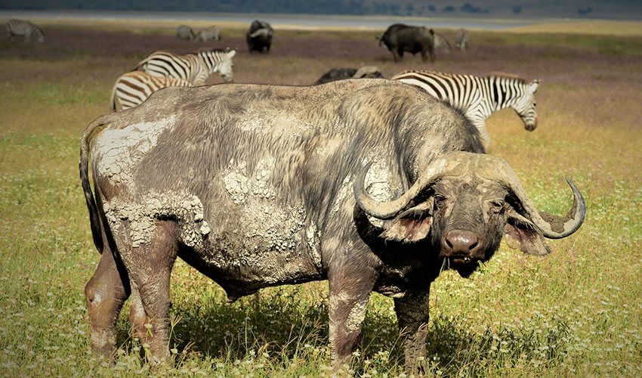

**Accommodation: Kubu Kubu Tented Lodge / Serengeti Serena Safari Lodge / Melia Serengeti**

**Meal: Full Board (Breakfast, Lunch & Dinner)**

**DAY 8: ONWARDS FLIGHT TO ZANZIBAR**

Early morning after having breakfast, you will pack your luggage and get ready for your transfer to Seronera airstrip at the heart of Serengeti to catch your flight to Zanzibar. Upon arrival at Zanzibar airport (ZNZ), our private representative will meet you and drive straight to your luxury hotel for relaxation, dinner and overnight stay.

**Destination: Zanzibar (Nungwi)**

**Accommodation: Riu Palace Hotel / Zuri Zanzibar / Royal Zanzibar Beach Resort**

**Meal: Full Board (Breakfast, Lunch & Dinner**)

**DAY 9-11: FULL DAYS RELAXATION**

Nungwi is located on the northern tip of Zanzibar with white sands and turquoise clear water where you can relax and enjoy your honeymoon stay. You can choose to stay at the hotel or go swimming at the ocean. If you would like to do different activities such as snorkeling, dolphin tour, safari blue, diving, we can arrange that for you or you can arrange at the hotel and you will be guided. The changes of the tides in Nungwi is different than other parts therefore it is calm. You will spend a total of 4 nights in Nungwi.

**Destination: Zanzibar (Nungwi)**

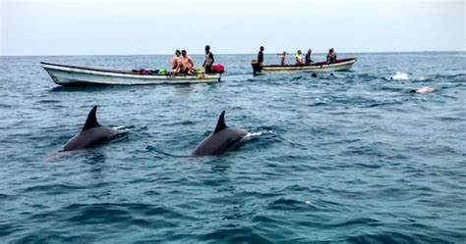

**Accommodation: Riu Palace Hotel / Zuri Zanzibar / Royal Zanzibar Beach Resort**

**Meal: Full Board (Breakfast, Lunch & Dinner)**

**DAY 12: ONWARDS FLIGHT TO THE YOUR DESTINATION**

According to your flight time, you will get ready and you will get a private transfer from your hotel to the airport to catch your onwards flight to the next destination or back home. This marks your epic honeymoon adventure with us.

**Meals: Breakfast & Lunch**

**INCLUSIONS**

• Private Toyota Landcruiser 4x4 with pop-up roofs

• Private professional safari guide

• All nights’ accommodation in Arusha & during Safari

• All Park Fees

• Government Tax

• Unlimited drinking water, tea, coffee

• Some soft drinks & beers inside the safari vehicle

• Flying Doctors Insurance (AMREF)

• Flight from Seronera to Zanzibar

• Accommodation in Zanzibar

• All airport & hotel transfers

• Activities in Zanzibar

**EXCLUSIONS**

• International flights

• Tips

• Personal items

• Visa fees

**ALL COST IN USD**

**$ 24,700 2PAX**

**$1,029 PPD**

**30%**

**THE GREAT MIGRATION**

What’s the Great Migration?

The Serengeti wildebeest migration is one of the most spectacular events to see in Tanzania. This is the periodic regular movement of more than a million of wildebeests accompanied by some 250,000 zebras, 200,000 gazelles and some 12,000 elands seeking for fresh food and water. Also predators including leopards, cheetah, hyena, lions and crocs make sure only the strongest will survive in this natural spectacle. The position of the migration depends on the periodic rains and relatively predictable on where to find the herds.

**A SHORT SUMMARY OF THE GREAT MIGRATION:**

The short rains begin in the months of November and December where the herds move to the short grass plains in Serengeti. This is far south of Serengeti and Ndutu which is part of Ngorongoro Conservation Area. They stay at these areas through January, February and March where they give birth of than 500000 new born calves by January and February. These areas are safer because predators can be spotted making it an ideal place for calving. Predators are after the new borns during this time and you may witness stalking and hunting during this period of time. After the plains dry, the wildebeest are forced to move in search of fresh grass in the western corridor. After bearing their young ones, around April the wildebeest herds begin to drift northwest towards the central Serengeti, drawing with them thousands of zebra and lower groups ofantelope. During May, they spread out heading to the western part of Serengeti National Park. In June, they spread out heading further west to the Grumeti river which is a channel of pools where they congregate and blocked on their trip towards the northern part. This is where the crocodiles of the Grumeti River get their feast. Each migrating animal must face the challenge of crossing the crocodile- infested river. As June moves into July, the hundreds of thousands of wildebeest and zebra accompanied by antelopes continue to head north along the western edge of the Serengeti toward the Mara River in the north of the Serengeti. These river crossings are arguably one of the most famous wildlife events on Earth. During late July and August, the migration moves far north of Serengeti National Park known as Kogatende passing through the central part of Serengeti and Grumeti reserve. Arriving on the north Serengeti, this is where the spectacular crossing happens at the mara river which goes through until September. The migration arrives at the Mara River in groups of thousands where they gather and cross. A huge number of adults and calves are lost to crocodile and predators attacks, drowned or crushed by the herd and many of the young ones are separated from their mothers. During October, the herds move on the far north to the Masai Mara reserve. During November, the herds move towards the south following the short grass plains through eastern part of Serengeti and this is where the migration pattern begin.

**Month by Month**

**Jan - Feb -** Calving season, you should prepare for wobbly babies and lots of heart break as predators swoop in. Grazing is great and the herds remain in the far south.

**March - April:-** Grass has all been munched up and the herds are starting to gather in preparation for a next leg. They

begin their northward journey and many have left already and they are in the central and western Serengeti.

**May - June:-**The massed herds are on the go, huge columns of up to 40km in length can be seen central and western

Serengeti. End of June they get ready for the toughest part of their odyssey.

**July - August:-** Big event, river crossing- survivors celebrate by feasting in the northern Serengeti and begin cross

into Kenya Maasai Mara. You need a passport and they are exempted.

**Sept - Oct:-** Herds break up into smaller groups about half of the animals remain in northern Serengeti, the rest are

swapping stories in Maasai Mara-(Did you hear George couldn't make it across the Mara river?).

**November:-** Short rains has began propelling the herds to leave the denuded grassland of Maasai Mara and back

into rejuvenated Serengeti.

**Dec:-** Fresh grazing in the Serengeti Lobo and southern Serengeti again.

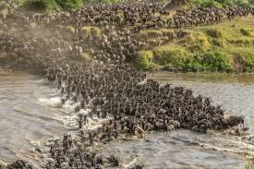

**9 DAYS MIDRANGE HONEYMOON TANZANIA SAFARI**

**(Tarangire, Serengeti, Ngorongoro Crater & Zanzibar)**

**DESTINATIONS**

**• Tarangire National Park**

**• Ngorongoro crater**

**• Serengeti National Park**

**• Zanzibar**

**OVERVIEW**

This 9-day midrange safari on the northern circuit of Tanzania, takes you to the most famous and incredible parks whereby you will visit the major parks which are Tarangire, Serengeti, and Ngorongoro. In Tarangire, you will be astonished by the large African elephants as well as the huge and ancient baobab trees. Ngorogoro crater will be the icing on the cake and the best place to visit the endangered black rhinos and Lake Manyara N ational Park which is famous for the tree climbing lions and the birds’ population. After your safari, you will visit Zanzibar beach for your honeymoon extension. You will sleep in midrange lodges with private showers.

DETAILED ITINERARY

**DAY 1: ARRIVAL AT THE AIRPORT TO ARUSHA**

Upon arrival at the airport in Arusha (ARK) or Kilimanjaro international airport (JRO), you will be met and welcomed by your representative from Bapta African Safaris who will give you a short brief before you drive to your lodgings in Arusha for overnight.

**Destination: Arusha city**

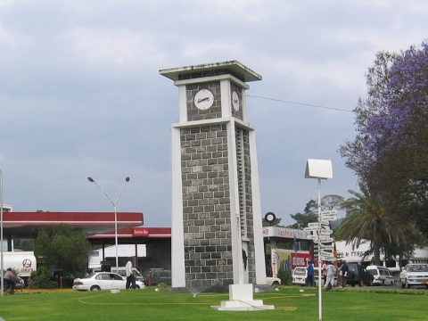

**Accommodation: Arusha Planet Lodge / A1 Hotel &amp; Resort / Tulia Boutique Hotel &amp; Spa**

**Meal: Bed & Breakfast**

**DAY 2: ARUSHA TO TARANGIRE NATIONAL PARK.**

Early morning after having breakfast at your hotel in Arusha at around 0730hrs to 0800hrs you will be picked up by your personal driver guide and depart straight to Tarangire National Park whereby the drive is approximately 2.5 hours to the gate. Tarangire National Park is located on the northern part of Tanzania with a wide variety of animals and landscape whereby the best part is the elephant herds. It is known to be the park which has the greatest concentration of African elephants and the ancient baobab trees. Tarangire has an area of approximately 2603 square Kilometers and within the park it is possible to see plenty of animals like the giraffes, Zebras, Buffalos, warthogs, Lions, Leopards, Impala, gazelles, dik dik and many more species. In this park, there are more than 500 birds’ species like the bee eaters, swallows, ostriches, kori bustards, hammerkops, vultures etc. The word Tarangire comes from Mbugwe tribe whereby “Tara” means river an “Ngire” means warthogs therefore it is the river of warthogs. The Tarangire river is the life giving opportunity for both herbivores and carnivores and it is the best spot for the lions to hunt their prey as they search for water especially during the dry season. Lunch will be served at a picnic site at around 1200hrs to 1300hrs and after that you will proceed with your game drive until in the late afternoon where you will exit the park and drive straight to your lodge in Karatu for relaxation, dinner and overnight.

**Destination: Tarangire National Park**

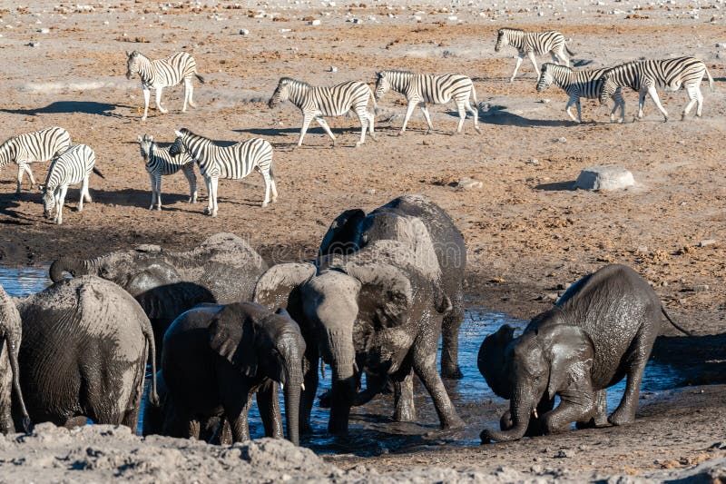

**Accommodation: Marera Valley Lodge / Farm of Dreams Lodge / Bougainvillea Safari Lodge**

**Meal: Full Board (Breakfast, Lunch & Dinner**)

**DAY 3: KARATU TO SERENGETI NATIONAL PARK**

Early morning after having breakfast at your lodge in Karatu at around 0730hrs to 0800hrs you will depart straight to Serengeti National Park passing through the Ngorongoro Conservation Area. Serengeti National Park is the most famous park on the northern circuit of Tanzania with the greatest population of wildlife than anywhere else on this planet. The word Serengeti originates from Maasai tribe, the word “Seringiti” which means endless plains. The park covers a total area of approximately 14,763 square kilometers with more than 2 million mammals inhabiting the park. The great annual migration involves more than a million wildebeests accompanied by some 250,000 zebras and antelopes and it is one of the 7 wonders of the world. This is exactly what makes this park the most famous park. The park is also home to more than 500 birds’ species includingthe ostriches, kori bustard, starlings, weavers, marabou storks, vultures, eagles, kingfishers, rollers etc. Animals that can be found inside the park are like the impalas, gazelles, topi, hartebeest, giraffes, hippo,buffalo, dik dik, waterbuck and predators such as lions, leopards, cheetahs, hyena, jackals, caracals, serval catsetc. The scenery of Serengeti on the south east is the short grass plains. The northern part of Serengeti alsoknown as kogatende has more hills and rocks. To the western corridor known as Grumeti there are rivers, valleys as well as forests. Some areas in the heart of Serengeti heading up north of Serengeti are dotted with kopjes. The Serengeti National Park can be visited all year round but the best time to visit is during the dry season from June to October. Lunch will be served inside the park and afterwards, proceed with game viewing until the evening where you will drive straight to your accommodation for dinner and overnight.

**Destination: Serengeti National Park**

**Accommodation: Narudi Camp / Pamoja Serengeti Luxury Camp / Embalakai Authentic Camps**

**Meal: Full Board (Breakfast, Lunch & Dinner)**

**DAY 4: FULL DAY GAME DRIVE IN SERENGETI NATIONAL PARK.**

Early morning after having breakfast at your accommodation inside Serengeti, you will start an early morninggame drive looking for the big cats and the active animals. Lunch will be served inside the park whereby afterthat you will proceed exploring the park and all that it has to offer from the landscape, wildlife and manymore. In the evening, you will drive back to your lodge or tented camp for relaxation, dinner and overnight stay.

**Destination: Serengeti National Park**

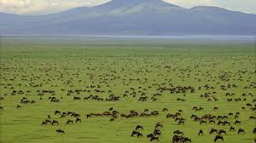

**Accommodation: Narudi Camp / Pamoja Serengeti Luxury Camp / Embalakai Authentic Camps**

**Meal: Full Board (Breakfast, Lunch & Dinner)**

**DAY 5: SERENGETI NATIONAL PARK TO NGORONGORO CRATER TO KARATU.**

Early morning after having breakfast at your accommodation inside Serengeti, you will drive straight to

Ngorongoro Conservation Area en-route whereby the drive is approximately 3 hours to the floor of the crater. Ngorongoro crater is a world heritage site as well as a geo-park. It is 600m deep and before you descend the crater you will stop at a view point where you can see the crater below. The Ngorongoro crater has approximately 25000 mammals and has more than 500 birds’ species where there are also migratory birds like the flamingos. The interesting part with Ngorongoro crater is that it is the best place in East Africa to witness the endangered black rhinos which completes the big 5. In Ngorongoro you can find animals like the Zebras, wildebeests, hyenas, lion prides, gazelles, impalas, kudus, waterbucks, buffalos and many more. The Ngorongoro crater has a diameter of approximately 20km whereby it is easy to spot animals and one can spend 5-6 hours exploring the park if you have a limited time. The other attraction in Ngorongoro crater is the Ngoitoktok picnic site which is a permanent hippo pool where most of the clients have their fabulous lunch at this place. The beauty of Ngorongoro can never be untold to the visitors who have visited this area. After having packed lunch at a picnic site at the hippo pool, you will finalize your game drive before you ascend the crater and drive straight to your accommodation in Karatu for relaxation, dinner and overnight.

**Destination: Ngorongoro crater**

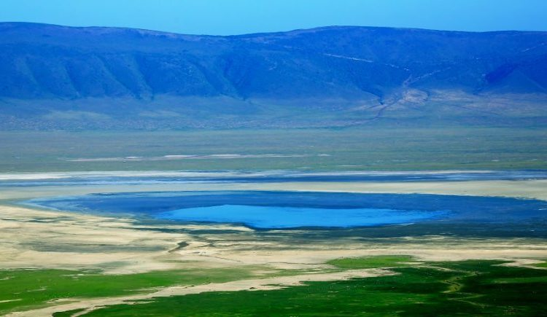

**Accommodation: Marera Valley Lodge / Farm of Dreams Lodge / Bougainvillea Safari Lodge**

**Meal: Full Board (Breakfast, Lunch & Dinner)**

**DAY 6: KARATU TO ARUSHA THEN FLY TO ZANZIBAR**

Early morning after having breakfast at your lodge in Karatu, you will drive straight to the airport in Arusha tocatch your fligh t to Zanzibar. Upon arrival at Zanzibar airport (ZNZ), our private representative will meet you and drive straight to your hotel for relaxation, dinner and overnight stay.

**Destination: Zanzibar (Nungwi)**

**Accommodation: The Z Hotel / Nungwi dreams**

**Meal: Full Board (Breakfast & Lunch & Dinner)**

**DAY 7-8: FULL DAYS RELAXATION**.

Nungwi is located on the northern tip of Zanzibar with white sands and turquoise clear water where you can relax and enjoy your honeymoon stay. You can choose to stay at the hotel or go swimming at the ocean. If youwould like to do dif ferent activities such as snorkeling, dolphin tour, safari blue, diving, we can arrange that for you or you can arrange at the hotel and you will be guided. The changes of the tides in Nungwi are different than other parts therefore it is calm. You will spend a total of 3 nights in Nungwi.

**Destination: Zanzibar (Nungwi)**

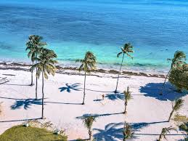

**Accommodation: The Z Hotel / Nungwi dreams**

**Meal: Full Board (Breakfast, Lunch & Dinner)**

**DAY 9: ONWARDS FLIGHT TO THE YOUR DESTINATION**

According to your flight time, you will get ready and you will get a private transfer from your hotel to the airport to catch your onwards flight to the next destination or back home. This marks your epic honeymoonadventure with us.

**Meals: Breakfast & Lunch**

**INCLUSIONS**

• Private Toyota Landcruiser 4x4 with pop-up roofs

• Private professional safari guide

• All nights’ accommodation in Arusha & during Safari

• All Park Fees

• Government Tax

• Unlimited drinking water, tea, coffee

• Some soft drinks & beers inside the safari vehicle

• Flying Doctors Insurance (AMREF)

• Flight from Arusha to Zanzibar

• Accommodation in Zanzibar

• All airport & hotel transfers

• Activities in Zanzibar

**EXCLUSIONS**

• International flights

• Tips

• Personal items

• Visa fees

**ALL COST IN USD**

**$ 8,117 2PAX**

**$451 PPD**

**30%**

**9 DAYS MIDRANGE FAMILY TANZANIA SAFARI**

**(Tarangire, Serengeti, Ngorongoro Crater & Zanzibar)**

**DESTINATIONS**

**• Tarangire National Park**

**• Ngorongoro crater**

**• Serengeti National Park**

**• Zanzibar**

OVERVIEW

This 9-day midrange safari on the northern circuit of Tanzania, takes you to the most famous and incredible parks whereby you will visit the major parks which are Tarangire, Serengeti, and Ngorongoro. In Tarangire, you will be astonished by the large African elephants as well as the huge and ancient baobab trees. Ngorogoro crater will be the icing on the cake and the best place to visit the endangered black rhinos and Lake ManyaraNational Park which is famous for the tree climbing lions and the birds’ population. After your safari, you will visit Zanzibar beach for your extension. You will sleep in midrange lodges with private showers.

**DETAILED ITINERARY**

**DAY 1: ARRIVAL AT THE AIRPORT TO ARUSHA**

Upon arrival at the airport in Arusha (ARK) or Kilimanjaro international airport (JRO), you will be met and welcomed by your representative from Bapta African Safaris who will give you a short brief before you drive to your lodgings in Arusha for overnight.

**Destination: Arusha city**

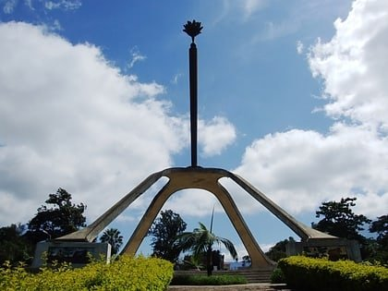

**Accommodation: Arusha Planet Lodge / A1 Hotel &amp; Resort / Tulia Boutique Hotel & Spa**

**Meal: Bed & Breakfast**

**DAY 2: ARUSHA TO TARANGIRE NATIONAL PARK**

Early morning after having breakfast at your hotel in Arusha at around 0730hrs to 0800hrs you will be picked by your personal driver guide and depart straight to Tarangire National Park whereby the drive is approximately 2.5 hours to the gate. Tarangire National Park is located on the northern part of Tanzania with a wide variety of animals and landscape whereby the best part is the elephant herds. It is known to be the park which has the greatest concentration of African elephants and the ancient baobab trees. Tarangire has an area of approximately 2603 square Kilometers and within the park it is possible to see plenty of animals like the giraffes, Zebras, Buffalos, warthogs, Lions, Leopards, Impala, gazelles, dik dik and many more species. In this park, there are more than 500 birds’ species like the bee eaters, swallows, ostriches, kori bustards, hammerkops, vultures etc. The word Tarangire comes from Mbugwe tribe whereby “Tara” means river and “Ngire” means warthogs therefore it is the river of warthogs. The Tarangire river is the life giving opportunity for both herbivores and carnivores and it is the best spot for the lions to hunt their prey as they search forwater especially during the dry season. Lunch will be served at a picnic site at around 1200hrs to 1300hrs and

after that you will proceed with your game drive until in the late afternoon where you will exit the park and drive straight to your lodge in Karatu for relaxation, dinner and overnight.

**Destination: Tarangire National Park**

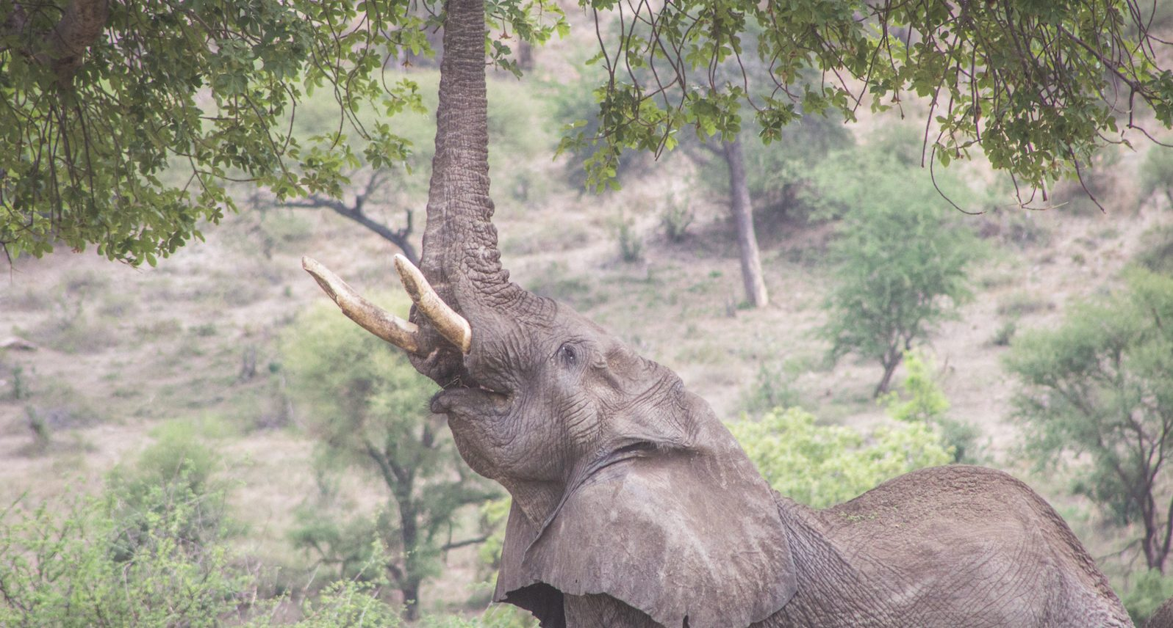

**Accommodation: Marera Valley Lodge / Farm of Dreams Lodge / Bougainvillea Safari Lodge**

**Meal: Full Board (Breakfast, Lunch & Dinner)**

**DAY 3: KARATU TO SERENGETI NATIONAL PARK**

Early morning after having breakfast at your lodge in Karatu at around 0730hrs to 0800hrs you will depart straight to Serengeti National Park passing through the Ngorongoro Conservation Area. Serengeti National Park is the most famous park on the northern circuit of Tanzania with the greatest population of wildlife than anywhere else on this planet. The word Serengeti originates from Maasai tribe, the word “Seringiti” which means endless plains. The park covers a total area of approximately 14,763 square kilometers with more than 2 million mammals inhabiting the park. The great annual migration involves more than a million wildebeests accompanied by some 250,000 zebras and antelopes and it is one of the 7 wonders of the world. This is exactly what makes this park the most famous park. The park is also home to more than 500 birds’ species including the ostriches, kori bustard, starlings, weavers, marabou storks, vultures, eagles, kingfishers, rollers etc. Animals that can be found inside the park are like the impalas, gazelles, topi, hartebeest, giraffes, hippo, buffalo, dik dik, waterbuck and predators such as lions, leopards, cheetahs, hyena, jackals, caracals, serval cats etc. The scenery of Serengeti on the south east is the short grass plains. The northern part of Serengeti also known as kogatende has more hills and rocks. To the western corridor known as Grumeti there are rivers, valleys as well as forests. Some areas in the heart of Serengeti heading up north of Serengeti are dotted with kopjes. The Serengeti National Park can be visited all year round but the best time to visit is during the dry season from June to October. Lunch will be served inside the park and afterwards, proceed with game viewing until the evening where you will drive straight to your accommodation for dinner and overnight.

**Destination: Serengeti National Park**

**Accommodation: Narudi Camp / Pamoja Serengeti Luxury Camp / Embalakai Authentic Camps**

**Meal: Full Board (Breakfast, Lunch & Dinner**)

**DAY 4: FULL DAY GAME DRIVE IN SERENGETI NATIONAL PARK**

Early morning after having breakfast at your accommodation inside Serengeti, you will start an early morning game drive looking for the big cats and the active animals. Lunch will be served inside the park whereby after that you will proceed exploring the park and all that it has to offer from the landscape, wildlife and many more. In the evening, you will drive back to your lodge or tented camp for relaxation, dinner and overnight stay.

**Destination: Serengeti National Park**

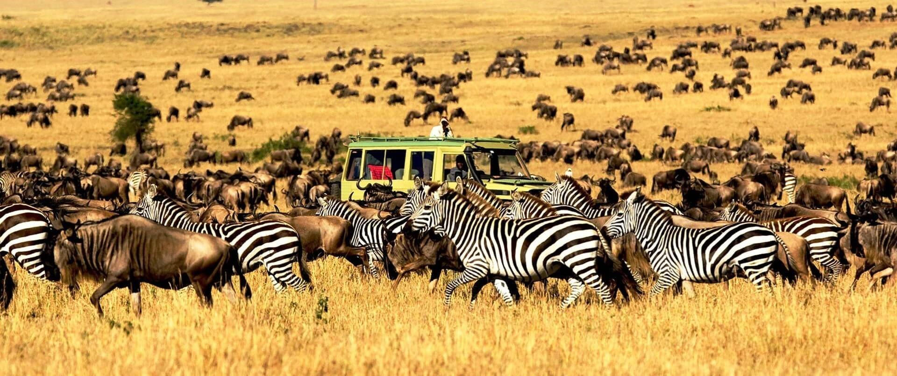

**Accommodation: Narudi Camp / Pamoja Serengeti Luxury Camp / Embalakai Authentic Camps**

**Meal: Full Board (Breakfast, Lunch & Dinner)**

**DAY 5: SERENGETI NATIONAL PARK TO NGORONGORO CRATER TO KARATU**

Early morning after having breakfast at your accommodation inside Serengeti, you will drive straight to ngorongoro Conservation Area en-route whereby the drive is approximately 3 hours to the floor of the crater. crater is a world heritage site as well as a geo-park. It is 600m deep and before you descend the crater you will stop at a view point where you can see the crater below. The Ngorongoro crater has approximately 25000 mammals and has more than 500 birds’ species where there are also migratory birds like the flamingos. The interesting part with Ngorongoro crater is that it is the best place in East Africa to witness the endangered black rhinos which completes the big 5. In Ngorongoro you can find animals like the Zebras, wildebeests, hyenas, lion prides, gazelles, impalas, kudus, waterbucks, buffalos and many more. The Ngorongoro crater has a diameter of approximately 20km whereby it is easy to spot animals and one can spend 5-6 hours exploring the park if you have a limited time. The other attraction in Ngorongoro crater is the Ngoitoktok picnic site which is a permanent hippo pool where most of the clients have their fabulous lunch at this place. The beauty of Ngorongoro can never be untold to the visitors who have visited this area. After having packed lunch at a picnic site at the hippo pool, you will finalize your game drive before you ascend the crater and drive straight to your accommodation in Karatu for relaxation, dinner and overnight.

**Destination: Ngorongoro crater**

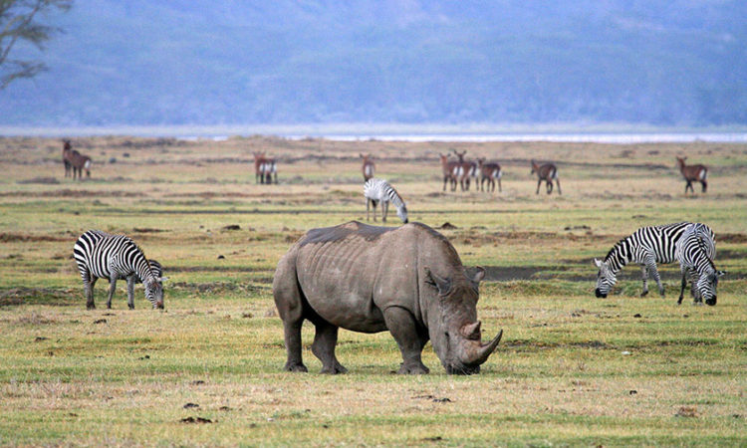

**Accommodation: Marera Valley Lodge / Farm of Dreams Lodge / Bougainvillea Safari Lodge**

**Meal: Full Board (Breakfast, Lunch & Dinner)**

**DAY 6: KARATU TO ARUSHA THEN FLY TO ZANZIBAR**

Early morning after having breakfast at your lodge in Karatu, you will drive straight to the airport in Arusha to catch your flight to Zanzibar. Upon arrival at Zanzibar airport (ZNZ), our private representative will meet you and drive straight to your hotel for relaxation, dinner and overnight stay.

**Destination: Zanzibar (Nungwi)**

**Accommodation: The Z Hotel / Nungwi dreams**

**Meal: Full Board (Breakfast & Lunch & Dinner)**

**DAY 7-8: FULL DAYS RELAXATION**

Nungwi is located on the northern tip of Zanzibar with white sands and turquoise clear water where you can relax and enjoy your honeymoon stay. You can choose to stay at the hotel or go swimming at the ocean. If you would like to do different activities such as snorkeling, dolphin tour, safari blue, diving, we can arrange that for you or you can arrange at the hotel and you will be guided. The changes of the tides in Nungwi is different than other parts therefore it is calm.You will spend a total of 3 nights in Nungwi.

**Destination: Zanzibar (Nungwi)**

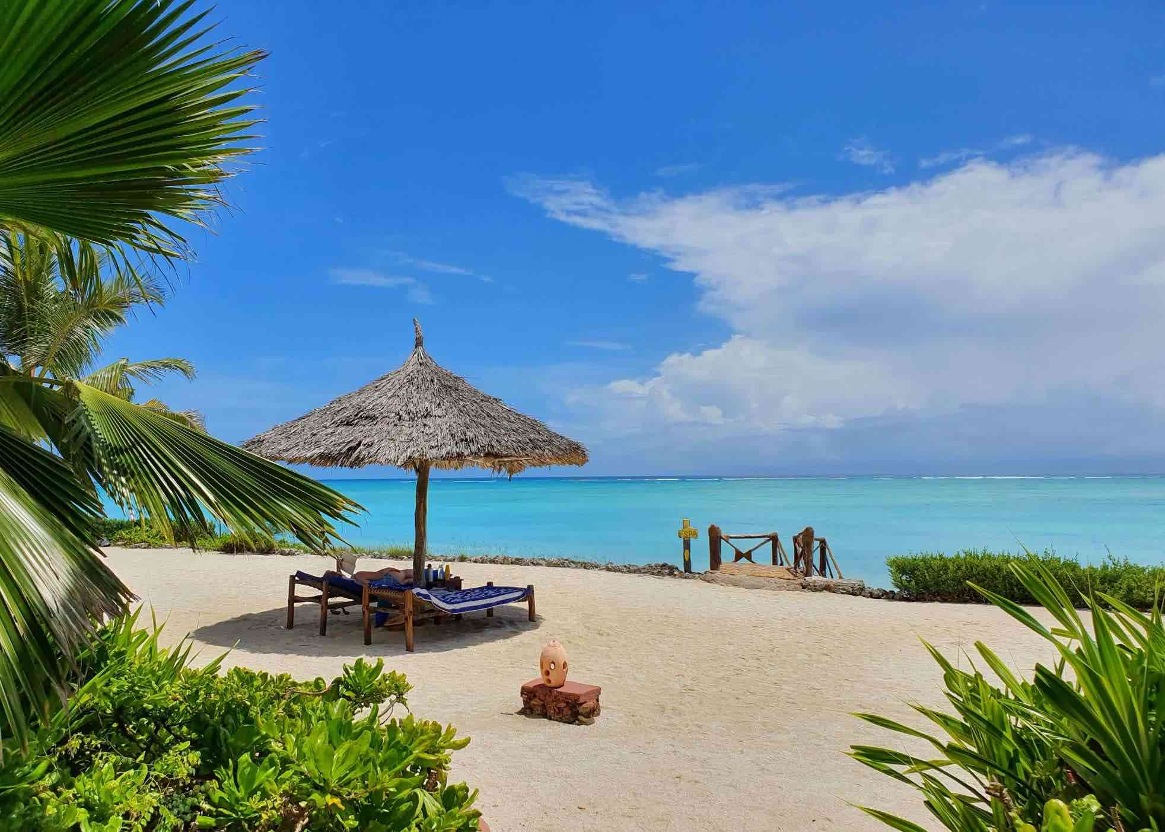

**Accommodation: The Z Hotel / Nungwi dreams**

**Meal: Full Board (Breakfast, Lunch & Dinner)**

**DAY 9: ONWARDS FLIGHT TO THE YOUR DESTINATION**

According to your flight time, you will get ready and you will get a private transfer from your hotel to theairport to catch your onwards flight to the next destination or back home. This marks your epic honeymoon adventure with us.

**Meals: Breakfast & Lunch**

**INCLUSIONS**

• Private Toyota Land cruiser 4x4 with pop-up roofs

• Private professional safari guide

• All nights’ accommodation in Arusha & during Safari

• All Park Fees

• Government Tax

• Unlimited drinking water, tea, coffee

• Some soft drinks & beers inside the safari vehicle

• Flying Doctors Insurance (AMREF)

• Flight from Arusha to Zanzibar

• Accommodation in Zanzibar

• All airport & hotel transfers

• Activities in Zanzibar

**EXCLUSIONS**

• International flights

• Tips

• Personal items

• Visa fees

**$ 5,809 1 PAX $ 9,071 2PAX $ 12,369 3PAX $ 15,613 4PAX $ 18,804 5PAX $ 21,763 6pax**

**$ 646 PPD $ 508 PPD $ 458 PPD $ 433 PPD $ 417 PPD $ 403 PPD**

**30% 27% 26% 25% %24 22%**

**NGORONGORO CRATER DAY TRIP**

**DESTINATION**

**• Ngorongoro Crater**

**OVERVIEW**

This day trip to Ngorongoro crater, you will get a chance to see a huge number of mammals and enjoy your game viewing experience as animals are easily spotted. You will also get a chance to see variety of birds and other animal species. With the help of your professional driver guide, you will be able to learn more about the flora and fauna of this incredible place.

**DETAILED ITINERARY**

**DAY 1: ARUSHA TO NGORONGORO CRATER**

Early morning after having breakfast at your hotel in Arusha at around 0730hrs to 0800hrs you will be picked up by your personal driver guide and depart straight to Ngorongoro Conservation Area en-route whereby the drive is approximately 3.5 hours to the floor of the crater. Ngorongoro crater is a world heritage site as well as a geo-park. It is 600m deep and before you descend the crater you will stop at a view point where you can see the crater below. The Ngorongoro crater has approximately 25000 mammals and has more than 500 birds’ species where there are also migratory birds like the flamingos. The interesting part with Ngorongoro crater is that it is the best place in East Africa to witness the endangered black rhinos which completes the big 5. In Ngorongoro you can find animals like the Zebras, wildebeests, hyenas, lion prides, gazelles, impalas, kudus, waterbucks, buffalos and many more. The Ngorongoro crater has a diameter of approximately 20km whereby it is easy to spot animals and one can spend 5-6 hours exploring the park if you have a limited time. The other attraction in Ngorongoro crater is the Ngoitoktok picnic site which is a permanent hippo pool where most of the clients have their fabulous lunch at this place. The beauty of Ngorongoro can never be untold to the visitors who have visited this area. After having packed lunch at a picnic site at the hippo pool, you will finalize your game drive before you ascend the crater and drive straight to Arusha.



**Destination: Arusha .**

**Meal: Lunch**

**INCLUSIONS**

• Private Toyota Landcruiser 4x4 with pop-up roofs

• Private professional safari guide

• Park Fees

• Government Tax

• Unlimited drinking water, tea, coffee

• Some soft drinks & beers inside the safari vehicle

**$ 865**

**TARANGIRE NATIONAL PARK DAY TRIP**

**DESTINATION**

**• Tarangire National Park**

**OVERVIEW**

This day trip to Tarangire National Park, you will be astonished by the large African elephants as well as the huge and ancient baobab trees. You will also get a chance to see variety of birds and other animal species. With the help of your professional driver guide, you will be able to learn more about the flora and fauna of this incredible park.

**DETAILED ITINERARY**

**DAY 1: ARUSHA TO TARANGIRE NATIONAL PARK**

Early morning after having breakfast at your hotel in Arusha at around 0730hrs to 0800hrs you will be picked up by your personal driver guide and depart straight to Tarangire National Park whereby the drive is approximately 2.5 hours to the gate. Tarangire National Park is located on the northern part of Tanzania with a wide variety of animals and landscape whereby the best part is the elephant herds. It is known to be the park which has the greatest concentration of African elephants and the ancient baobab trees. Tarangire has an area of approximately 2603 square Kilometers and within the park it is possible to see plenty of animals like the giraffes, Zebras, Buffalos, warthogs, Lions, Leopards, Impala, gazelles, dik dik and many more species. In this park, there are more than 500 birds’ species like the bee eaters, swallows, ostriches, kori bustards, hammerkops, vultures etc. The word Tarangire comes from Mbugwe tribe whereby “Tara” means river and Ngire” means warthogs therefore it is the river of warthogs. The Tarangire river is the life giving opportunity for both herbivores and carnivores and it is the best spot for the lions to hunt their prey as they search for water especially during the dry season. Lunch will be served at a picnic site at around 1200hrs to 1300hrs and after that you will proceed with your game drive until in the late afternoon where you will exit the park and drive back to Arusha.

**Destination: Tarangire National Park**

**Meal: Lunch**

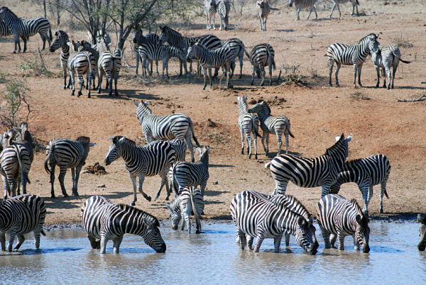

**NCLUSIONS**

• Private Toyota Landcruiser 4x4 with pop-up roofs

• Private professional safari guide

• Park Fees

• Government Tax

• Unlimited drinking water, tea, coffee

• Some soft drinks & beers inside the safari vehicle

**$ 410.**

**LAKE MANYARA NATIONAL PARK DAY TRIP**

**DESTINATION**

**• Lake Manyara National Park**

**OVERVIEW**

This day trip to Lake Manyara National Park, you will be astonished by the massive population of birds as well as the tree climbing lions. You will also get a chance to see variety different animal species. With the help of your professional driver guide, you will be able to learn more about the flora and fauna of this incredible park.

DETAILED ITINERARY

**DAY 1: ARUSHA TO LAKE MANYARA NATIONAL PARK**

Early morning after having breakfast at your hotel in Arusha at around 0730hrs to 0800hrs you will be picked up by your personal driver guide and depart straight to Lake Manyara National Park whereby the drive is approximately 1 hour to the gate. Lake Manyara National Park is well known for its birds’ life and also known as the home of tree climbing lions. The park has an area of about 325 square kilometers whereby a third of the area is the land and the rest is the lake which makes Lake Manyara the best attraction. Lake Manyara is a shallow alkaline lake that attracts a number of birds to the area. The birds’ species that can be found in Lake Manyara includes both migratory birds and native birds’ species like the flamingos, pelicans, storks, herons, cranes, secretary birds, ground hornbills, ostriches and many more birds species. Animals that can be found in lake Manyara are like the lions, elephants, giraffes, zebras, warthogs, wildebeests, baboons, blue monkeys, waterbucks, bushbucks, rarely leopards, buffalo etc. The park is located on the south western part of Arusha at the rift valley region which makes it easier to do different activities like the forest hike on the rift valley and other activities include canoeing, tree canopy walk, walking safari around the lake etc. Lunch will be served at the picnic site, and after an extensive game drive you will drive straight to Arusha.

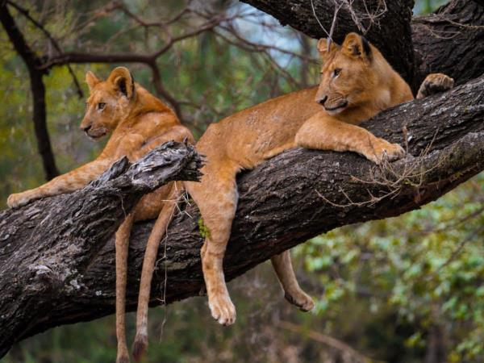

**Destination: Arusha**

**Meal: Lunch**

**INCLUSIONS**

• Private Toyota Landcruiser 4x4 with pop-up roofs

• Private professional safari guide

• Park Fees

• Government Tax

• Unlimited drinking water, tea, coffee

• Some soft drinks & beers inside the safari vehicle

• Flying Doctors Insurance (AMREF)

• Public liability insurance

**$410**

**7 DAYS LUXURY TANZANIA SAFARI**

**(Tarangire, Serengeti, Ngorongoro Crater & Lake Manyara)**

**PARKS**

**• Tarangire National Park**

**• Ngorongoro crater**

**• Lake Manyara National Park**

**• Serengeti National Park**

OVERVIEW

This 7-day Luxury safari on the northern circuit of Tanzania, takes you to the most famous and incredible parks whereby you will visit all major parks which are Tarangire, Serengeti, Lake Manyara and Ngorongoro. In Tarangire, you will be astonished by the large African elephants as well as the huge and ancient baobab trees. Ngorogoro crater will be the icing on the cake and the best place to visit the endangered black rhinos and Lake Manyara National Park which is famous for the tree climbing lions and the birds’ population. You will sleep in luxury lodges with private showers.

DETAILED ITINERARY

**DAY 1: ARRIVAL AT THE AIRPORT TO ARUSHA**

Upon arrival at the airport in Arusha (ARK) or Kilimanjaro international airport (JRO), you will be met and welcomed by your representative from Bapta African Safaris who will give you a short brief before you drive to your lodgings in Arusha for overnight.

**Destination: Arusha city**



**Accommodation: Mount Meru Hotel / Arusha Coffee Lodge / Gran Melia Arusha**

**Meal: Bed & Breakfast**

**DAY 2: ARUSHA TO TARANGIRE NATIONAL PARK**

Early morning after having breakfast at your hotel in Arusha at around 0730hrs to 0800hrs you will be picked up by your personal driver guide and depart straight to Tarangire National Park whereby the drive is approximately 2.5 hours to the gate. Tarangire National Park is located on the northern part of Tanzania with a wide variety of animals and landscape whereby the best part is the elephant herds. It is known to be the park which has the greatest concentration of African elephants and the ancient baobab trees. Tarangire has an area of approximately 2603 square Kilometers and within the park it is possible to see plenty of animals like the giraffes, Zebras, Buffalos, warthogs, Lions, Leopards, Impala, gazelles, dik dik and many more species. In this park, there are more than 500 birds’ species like the bee eaters, swallows, ostriches, kori bustards, hammerkops, vultures etc. The word Tarangire comes from Mbugwe tribe whereby “Tara” means river and “Ngire” means warthogs therefore it is the river of warthogs. The Tarangire river is the life giving opportunity for both herbivores and carnivores and it is the best spot for the lions to hunt their prey as they search for water especially during the dry season. Lunch will be served at a picnic site at around 1200hrs to 1300hrs and after that you will proceed with your game drive until in the late afternoon where you will exit the park and drive straight to your luxury lodge in Karatu for relaxation, dinner and overnight.

**Destination: Tarangire National Park**

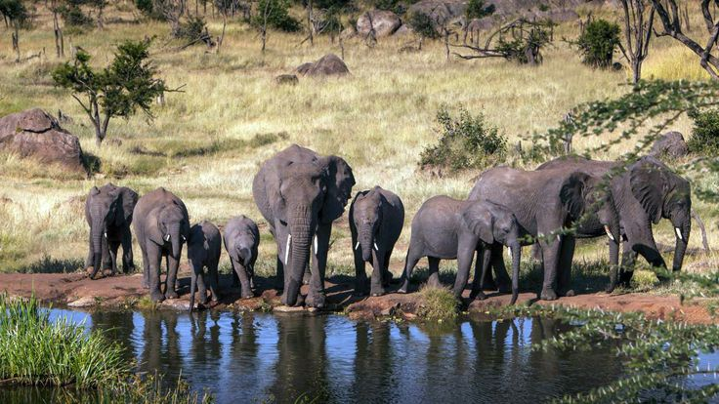

**Accommodation: Kitela Lodge / Neptune Ngorongoro / Gibb’s Farm**

**Meal: Full Board (Breakfast, Lunch & Dinner)**

**DAY 3: KARATU TO SERENGETI NATIONAL PARK**

Early morning after having breakfast at your lodge in Karatu at around 0730hrs to 0800hrs you will depart straight to Serengeti National Park passing through the Ngorongoro Conservation Area. Serengeti National Park is the most famous park on the northern circuit of Tanzania with the greatest population of wildlife than anywhere else on this planet. The word Serengeti originates from Maasai tribe, the word “Seringiti” which means endless plains. The park covers a total area of approximately 14,763 square kilometers with more than 2 million mammals inhabiting the park. The great annual migration involves more than a million wildebeests accompanied by some 250,000 zebras and antelopes and it is one of the 7 wonders of the world. This is exactly what makes this park the most famous park. The park is also home to more than 500 birds’ species including the ostriches, kori bustard, starlings, weavers, marabou storks, vultures, eagles, kingfishers, rollers etc.Animals that can be found inside the park are like the impalas, gazelles, topi, hartebeest, giraffes, hippo, buffalo, dik dik, waterbuck and predators such as lions, leopards, cheetahs, hyena, jackals, caracals, serval cats etc. The scenery of Serengeti on the south east is the short grass plains. The northern part of Serengeti also known as kogatende has more hills and rocks. To the western corridor known as Grumeti there are rivers, valleys as well as forests. Some areas in the heart of Serengeti heading up north of Serengeti are dotted with &#39;kopjes&#39;. The Serengeti National Park can be visited all year round but the best time to visit is during the dry season from June to October. Lunch will be served inside the park and afterwards, proceed with game viewing until the evening where you will drive straight to your accommodation for dinner and overnight.

**Destination: Serengeti National Park**

**Accommodation: Kubu Kubu Tented Lodge / Serengeti Serena Safari Lodge / Melia Serengeti**

**Meal: Full Board (Breakfast, Lunch & Dinner)**

**DAY 4: FULL DAY GAME DRIVE IN SERENGETI NATIONAL PARK**

Early morning after having breakfast at your accommodation inside Serengeti, you will start an early morning game drive looking for the big cats and the active animals. Lunch will be served inside the park whereby after that you will proceed exploring the park and all that it has to offer from the landscape, wildlife and many more. In the evening, you will drive back to your lodge or tented camp for relaxation, dinner and overnight stay.

**Destination: Serengeti National Park**

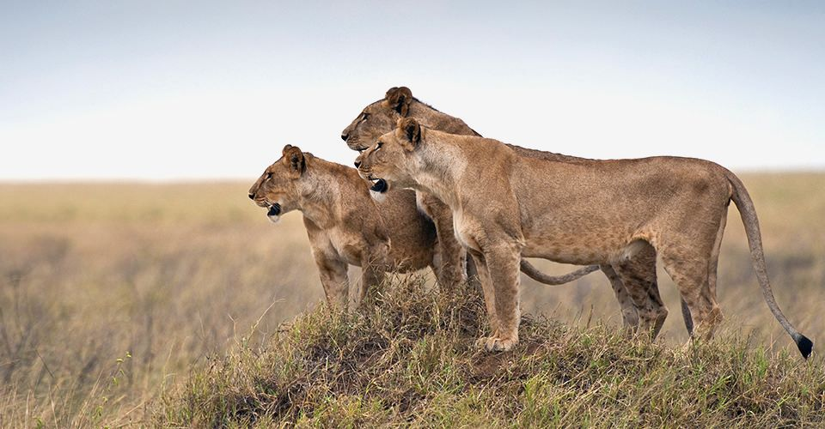

**Accommodation: Kubu Kubu Tented Lodge / Serengeti Serena Safari Lodge / Melia Serengeti**

**Meal: Full Board (Breakfast, Lunch & Dinner)**

**DAY 5: SERENGETI NATIONAL PARK TO NGORONGORO CONSERVATION AREA**

Early morning after having breakfast at your accommodation inside Serengeti, you will drive straight to Ngorongoro Conservation Area to your accommodation for dinner and overnight stay.

**Destination: Ngorongoro Conservation Area**

**Accommodation: Ngorongoro Serena Safari Lodge / Ngorongoro Lion’s Paw**

**Meal: Full Board (Breakfast, Lunch & Dinner)**

**DAY 6: NGORONGORO CRATER TO KARATU**

Early morning after having breakfast at your accommodation, you will drive straight to the floor of the crater. Ngorongoro crater is a world heritage site as well as a geo-park. It is 600m deep and before you descend the crater you will stop at a view point where you can see the crater below. The Ngorongoro crater has approximately 25000 mammals and has more than 500 birds’ species where there are also migratory birds like the flamingos. The interesting part with Ngorongoro crater is that it is the best place in East Africa to witness the endangered black rhinos which completes the big 5. In Ngorongoro you can find animals like the Zebras, wildebeests, hyenas, lion prides, gazelles, impalas, kudus, waterbucks, buffalos and many more. The Ngorongoro crater has a diameter of approximately 20km whereby it is easy to spot animals and one can spend 5-6 hours exploring the park if you have a limited time. The other attraction in Ngorongoro crater is the Ngoitoktok picnic site which is a permanent hippo pool where most of the clients have their fabulous lunch at this place. The beauty of Ngorongoro can never be untold to the visitors who have visited this area. After having packed lunch at a picnic site at the hippo pool, you will finalize your game drive before you ascend the crater and drive straight to your accommodation in Karatu for relaxation, dinner and overnight.

**Destination: Ngorongoro crater**

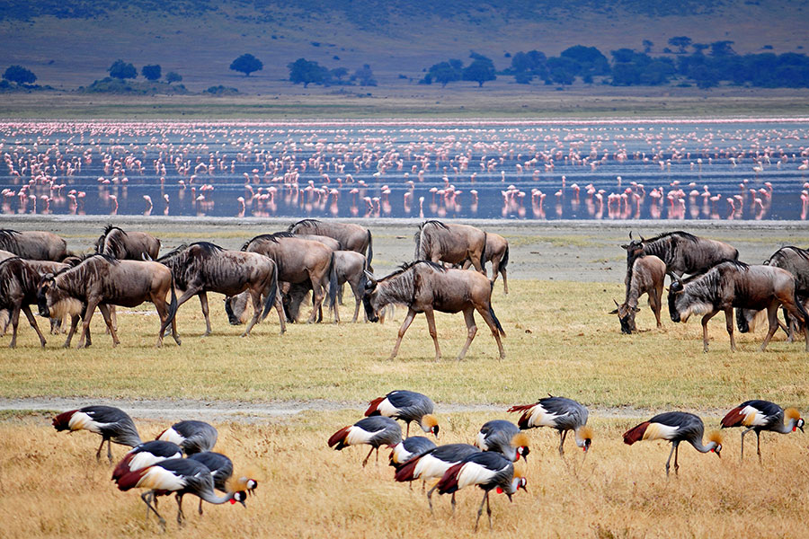

**Accommodation: Kitela Lodge / Neptune Ngorongoro / Gibb’s Farm**

**Meal: Full Board (Breakfast, Lunch & Dinner)**

**DAY 7: LAKE MANYARA NATIONAL PARK TO ARUSHA**

Early morning after having breakfast at your lodge in Karatu at around 0730hrs to 0800hrs you will depart straight to Lake Manyara National Park whereby the drive is approximately 1 hour to the gate. Lake Manyara National Park is well known for its birds’ life and also known as the home of tree climbing lions. The park has an area of about 325 square kilometers whereby a third of the area is the land and the rest is the lake which makes Lake Manyara the best attraction. Lake Manyara is a shallow alkaline lake that attracts a number of birds to the area. The birds’ species that can be found in Lake Manyara includes both migratory birds and native birds species like the flamingos, pelicans, storks, herons, cranes, secretary birds, ground hornbills, ostriches and many more birds species. Animals that can be found in lake Manyara are like the lions, elephants, giraffes, zebras, warthogs, wildebeests, baboons, blue monkeys, waterbucks, bushbucks, rarely leopards, buffalo etc. The park is located on the south western part of Arusha at the rift valley region which makes it easier to do different activities like the forest hike on the rift valley and other activities include canoeing, tree canopy walk, walking safari around the lake etc. Lunch will be served at the picnic site, and after that you will drive straight to Arusha where you will meet one of the representatives from Gardenia African Safaris who will give you a special farewell. If you would like to have an extra night in Arusha we can arrange that for you in advance or if you have a flight, we will drive you straight to the airport to catch your onwards flight back home or to your next destination.

**Destination: Lake Manyara National Park**

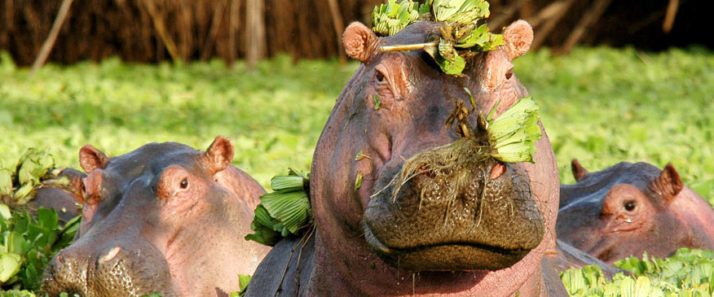

**Meal: Breakfast & Lunch**

**INCLUSIONS**

• Private Toyota Landcruiser 4x4 with pop-up roofs

• Private professional safari guide

• All nights’ accommodation in Arusha & during Safari

• All Park Fees

• Government Tax

• Unlimited drinking water, tea, coffee

• Some soft drinks & beers inside the safari vehicle

• Flying Doctors Insurance (AMREF)

• Domestic flights

**EXCLUSIONS**

• International flights

• Tips

• Personal needs

• Visa

**ALL COST IN USD**

**$ 9,200 PAX $ 15,478 2PAX $ 21,658 3PAX $ 27,748 4PAX $ 33,731 5PAX $ 39,616 6PAX**

**$ 1,314 PPD $ 1,105 PPD $ 1,031 PPD $ 991 PPD $ 963 PPD $ 943 PPD**

**30% 29% 28% 27% 26% 25%**

**7 DAYS MIDRANGE TANZANIA SAFARI**

**(Tarangire, Serengeti, Ngorongoro Crater & Lake Manyara)**

**PARKS**

**• Tarangire National Park**

**• Ngorongoro crater**

**• Lake Manyara National Park**

**• Serengeti National Park**

OVERVIEW

This 7-day midrange safari on the northern circuit of Tanzania, takes you to the most famous and incredible parks whereby you will visit all major parks which are Tarangire, Serengeti, Lake Manyara and Ngorongoro. In Tarangire, you will be astonished by the large African elephants as well as the huge and ancient baobab trees. Ngorogoro crater will be the icing on the cake and the best place to visit the endangered black rhinos and Lake Manyara National Park which is famous for the tree climbing lions and the birds’ population. You will sleep in midrange lodges with private showers.

DETAILED ITINERARY

**DAY 1: ARRIVAL AT THE AIRPORT TO ARUSHA**

Upon arrival at the airport in Arusha (ARK) or Kilimanjaro international airport (JRO), you will be met and welcomed by your representative from Gardenia African Safaris who will give you a short brief before you drive to your lodgings in Arusha for overnight.

**Destination: Arusha city**

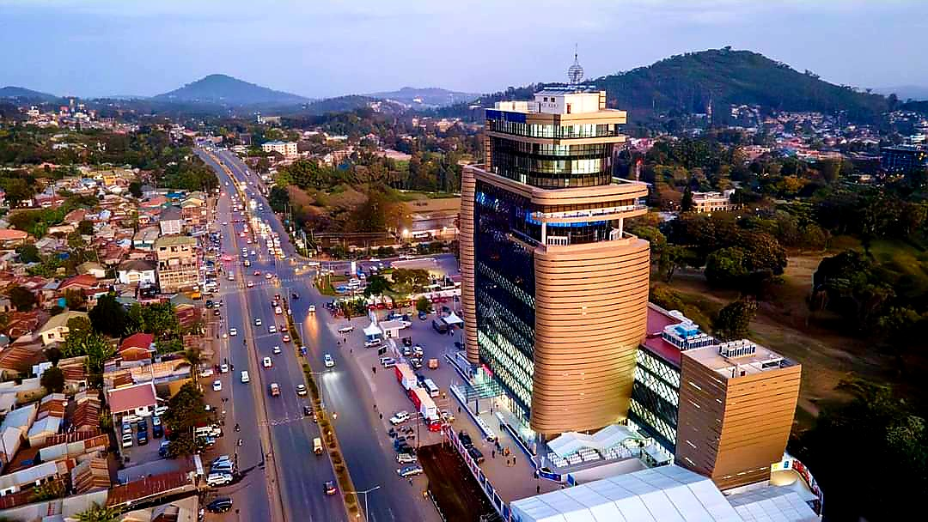

**Accommodation: Arusha Planet Lodge / A1 Hotel &amp; Resort / Tulia Boutique Hotel &amp; Spa**

**Meal: Bed & Breakfast**

**DAY 2: ARUSHA TO TARANGIRE NATIONAL PARK**

Early morning after having breakfast at your hotel in Arusha at around 0730hrs to 0800hrs you will be picked up by your personal driver guide and depart straight to Tarangire National Park whereby the drive is approximately 2.5 hours to the gate. Tarangire National Park is located on the northern part of Tanzania with a wide variety of animals and landscape whereby the best part is the elephant herds. It is known to be the park which has the greatest concentration of African elephants and the ancient baobab trees. Tarangire has an area of approximately 2603 square Kilometers and within the park it is possible to see plenty of animals like the giraffes, Zebras, Buffalos, warthogs, Lions, Leopards, Impala, gazelles, dik dik and many more species. In this park, there are more than 500 birds’ species like the bee eaters, swallows, ostriches, kori bustards, hammerkops, vultures etc. The word Tarangire comes from Mbugwe tribe whereby “Tara” means river and “Ngire” means warthogs therefore it is the river of warthogs. The Tarangire river is the life giving opportunity for both herbivores and carnivores and it is the best spot for the lions to hunt their prey as they search for water especially during the dry season. Lunch will be served at a picnic site at around 1200hrs to 1300hrs and after that you will proceed with your game drive until in the late afternoon where you will exit the park and drive straight to your lodge in Karatu for relaxation, dinner and overnight.

**Destination: Tarangire National Park**

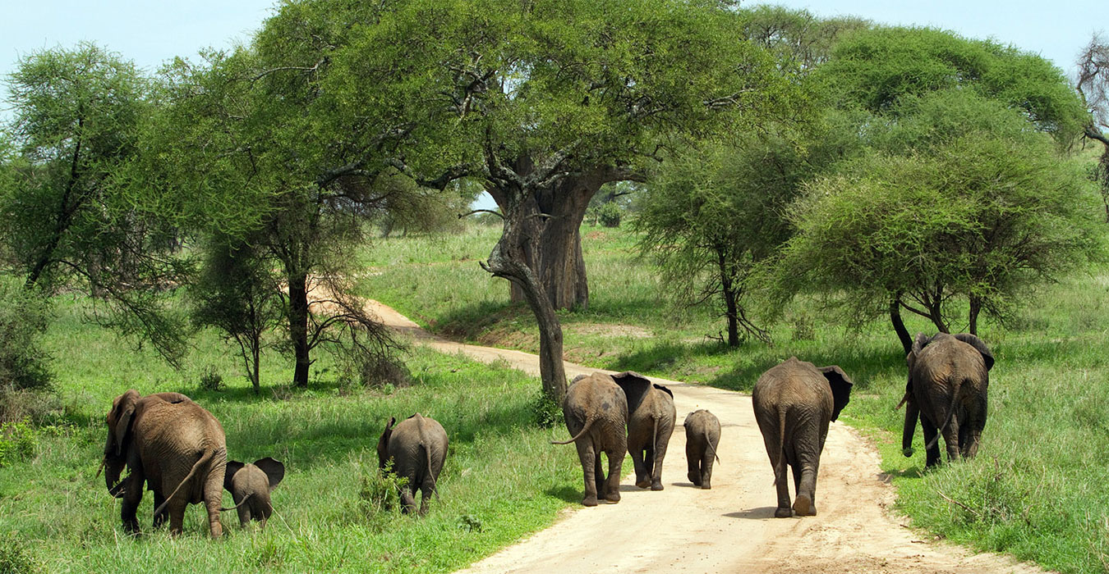

**Accommodation: Marera Valley Lodge / Farm of Dreams Lodge / Bougainvillea Safari Lodge**

**Meal: Full Board (Breakfast, Lunch & Dinner)**

**DAY 3: KARATU TO SERENGETI NATIONAL PARK**

Early morning after having breakfast at your lodge in Karatu at around 0730hrs to 0800hrs you will depart straight to Serengeti National Park passing through the Ngorongoro Conservation Area. Serengeti National Park is the most famous park on the northern circuit of Tanzania with the greatest population of wildlife than anywhere else on this planet. The word Serengeti originates from Maasai tribe, the word “Seringiti” which means endless plains. The park covers a total area of approximately 14,763 square kilometers with more than2 million mammals inhabiting the park. The great annual migration involves more than a million wildebeestsaccompanied by some 250,000 zebras and antelopes and it is one of the 7 wonders of the world. This is exactlywhat makes this park the most famous park. The park is also home to more than 500 birds’ species includingthe ostriches, kori bustard, starlings, weavers, marabou storks, vultures, eagles, kingfishers, rollers etc.Animals that can be found inside the park are like the impalas, gazelles, topi, hartebeest, giraffes, hippo,buffalo, dik dik, waterbuck and predators such as lions, leopards, cheetahs, hyena, jackals, caracals, serval cats etc. The scenery of Serengeti on the south east is the short grass plains. The northern part of Serengeti also known as kogatende has more hills and rocks. To the western corridor known as Grumeti there are rivers, valleys as well as forests. Some areas in the heart of Serengeti heading up north of Serengeti are dotted with kopjes. The Serengeti National Park can be visited all year round but the best time to visit is during the dry season from June to October. Lunch will be served inside the park and afterwards, proceed with \game viewing until the evening where you will drive straight to your accommodation for dinner and overnight.

**Destination: Serengeti National Park**

**Accommodation: Narudi Camp / Pamoja Serengeti Luxury Camp / Embalakai Authentic Camps**

**Meal: Full Board (Breakfast, Lunch & Dinner)**

**DAY 4: FULL DAY GAME DRIVE IN SERENGETI NATIONAL PARK**

Early morning after having breakfast at your accommodation inside Serengeti, you will start an early morning game drive looking for the big cats and the active animals. Lunch will be served inside the park whereby after that you will proceed exploring the park and all that it has to offer from the landscape, wildlife and many more. In the evening, you will drive back to your lodge or tented camp for relaxation, dinner and overnight stay.

**Destination: Serengeti National Park**

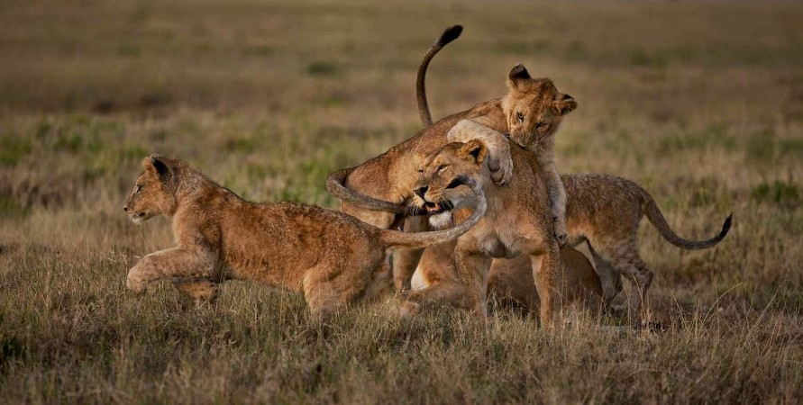

**Accommodation: Narudi Camp / Pamoja Serengeti Luxury Camp / Embalakai Authentic Camps**

**Meal: Full Board (Breakfast, Lunch & Dinner**)

**DAY 5: SERENGETI NATIONAL PARK TO NGORONGORO CONSERVATION AREA**

Early morning after having breakfast at your accommodation inside Serengeti, you will drive straight to Ngorongoro Conservation Area to your accommodation for dinner and overnight stay.

**Destination: Ngorongoro Conservation Area**

**Accommodation: Rhino Lodge / Ang’ata Ngorongoro**

**Meal: Full Board (Breakfast, Lunch & Dinner)**

**DAY 6: NGORONGORO CRATER TO KARATU**

Early morning after having breakfast at your accommodation, you will drive straight to the floor of the crater. Ngorongoro crater is a world heritage site as well as a geo-park. It is 600m deep and before you descend the crater you will stop at a view point where you can see the crater below. The Ngorongoro crater has approximately 25000 mammals and has more than 500 birds’ species where there are also migratory birds like the flamingos. The interesting part with Ngorongoro crater is that it is the best place in East Africa to witness the endangered black rhinos which completes the big 5. In Ngorongoro you can find animals like the Zebras, wildebeests, hyenas, lion prides, gazelles, impalas, kudus, waterbucks, buffalos and many more. The Ngorongoro crater has a diameter of approximately 20km whereby it is easy to spot animals and one can pend 5-6 hours exploring the park if you have a limited time. The other attraction in Ngorongoro crater is the Ngoitoktok picnic site which is a permanent hippo pool where most of the clients have their fabulous lunch at this place. The beauty of Ngorongoro can never be untold to the visitors who have visited this area. After having packed lunch at a picnic site at the hippo pool, you will finalize your game drive before you ascend the crater and drive straight to your accommodation in Karatu for relaxation, dinner and overnight.

**Destination: Ngorongoro crater**

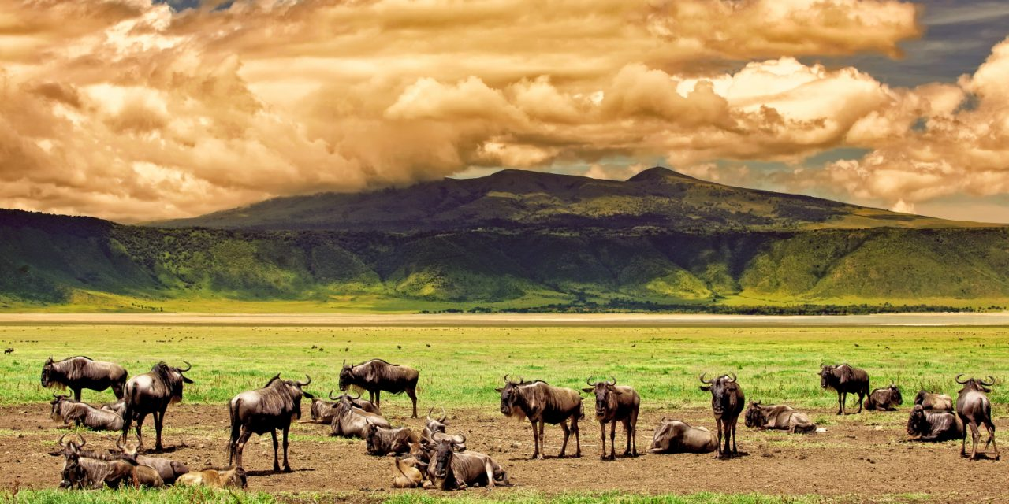

**Accommodation: Marera Valley Lodge / Farm of Dreams Lodge / Bougainvillea Safari Lodge**

**Meal: Full Board (Breakfast, Lunch & Dinner)**

**DAY 7: LAKE MANYARA NATIONAL PARK TO ARUSHA**

Early morning after having breakfast at your lodge in Karatu at around 0730hrs to 0800hrs you will depart straight to Lake Manyara National Park whereby the drive is approximately 1 hour to the gate. Lake Manyara National Park is well known for its birds’ life and also known as the home of tree climbing lions. The park has an area of about 325 square kilometers whereby a third of the area is the land and the rest is the lake which makes Lake Manyara the best attraction. Lake Manyara is a shallow alkaline lake that attracts a number of birds to the area. The birds’ species that can be found in Lake Manyara includes both migratory birds andnative birds species like the flamingos, pelicans, storks, herons, cranes, secretary birds, ground hornbills, ostriches and many more birds species. Animals that can be found in lake Manyara are like the lions, elephants, giraffes, zebras, warthogs, wildebeests, baboons, blue monkeys, waterbucks, bushbucks, rarely leopards, buffalo etc. The park is located on the south western part of Arusha at the rift valley region which makes it easier to do different activities like the forest hike on the rift valley and other activities include canoeing, tree canopy walk, walking safari around the lake etc. Lunch will be served at the picnic site, and after that you will drive straight to Arusha where you will meet one of the representatives from Gardenia African Safaris who will give you a special farewell. If you would like to have an extra night in Arusha we can arrange that for you in advance or if you have a flight, we will drive you straight to the airport to catch your onwards flight back home or to your next destination.

**Destination: Lake Manyara National Park**

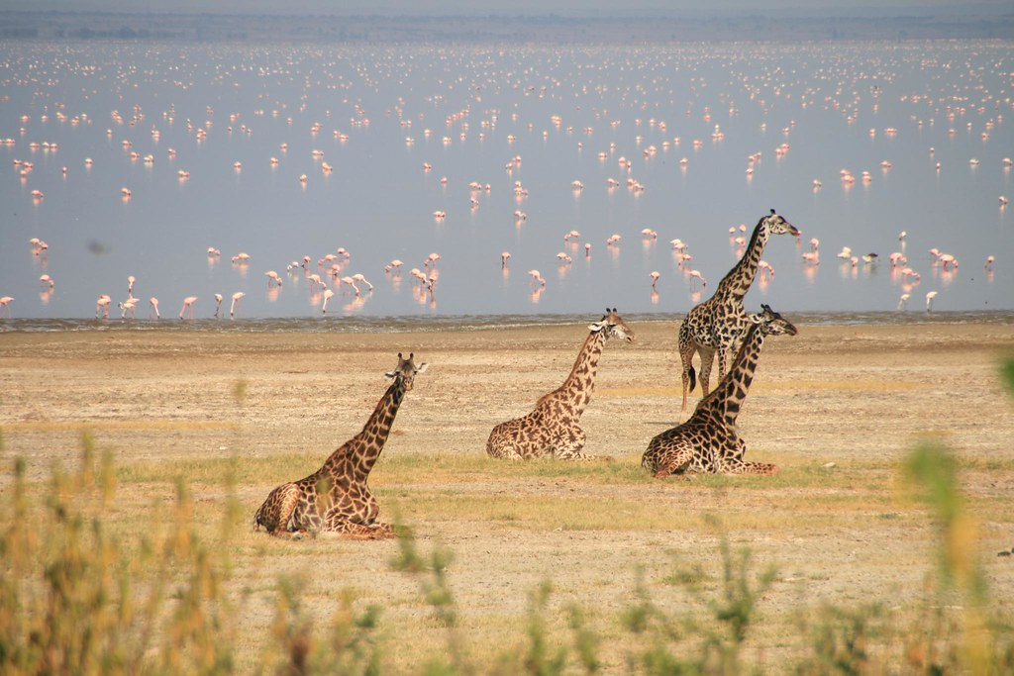

**Meal: Breakfast & Lunch**

**INCLUSIONS**

• Private Toyota Land cruiser 4x4 with pop-up roofs

• Private professional safari guide

• All nights’ accommodation in Arusha &amp; during Safari

• All Park Fees

• Government Tax

• Unlimited drinking water, tea, coffee

• Some soft drinks & beers inside the safari vehicle

• Flying Doctors Insurance (AMREF)

• Domestic flights

**EXCLUSIONS**

• International flights

• Tips

• Personal needs

• Visa

**$ 5,438 1 PAX $ 7,907 2PAX $ 10,382 3PAX $ 12,822 4PAX $15,222 5PAX $ 17,433 6pax**

**$ 776 PPD $ 564 PPD $ 494 PPD $ 457 PPD $ 434 PPD $ 415 PPD**

**30% 27% 26% 25% %24 20%**

**7 DAYS CAMPING SAFARI**

(**Tarangire, Ngorongoro Crater, Serengeti & Lake Manyara)**

**PARKS**

**• Tarangire National Park**

**• Ngorongoro crater**

**• Lake Manyara National Park**

**• Serengeti National Park**

**OVERVIEW**

This 7-day camping safari on the northern circuit of Tanzania, takes you to the most famous and incredible parks whereby you will visit all major parks which are Tarangire, Serengeti, Lake Manyara and Ngorongoro. In Tarangire, you will be astonished by the large African elephants as well as the huge and ancient baobab trees. Ngorogoro crater will be the icing on the cake and the best place to visit the endangered black rhinos, Serengeti National Park which has the largest concentration of wildlife and Lake Manyara National Park which is famous for the tree climbing lions and the birds’ population. You will sleep in tents set on the ground with the crew and you will also have a private chef who will prepare all your meals.

DETAILED ITINERARY

**DAY 1: ARRIVAL AT THE AIRPORT TO ARUSHA**

Upon arrival at the airport in Arusha (ARK) or Kilimanjaro international airport (JRO), you will be met and

Welcomed by your representative from Bapta African Safaris who will give you a short brief before you drive to your lodgings in Arusha for overnight.

**Destination: Arusha city**

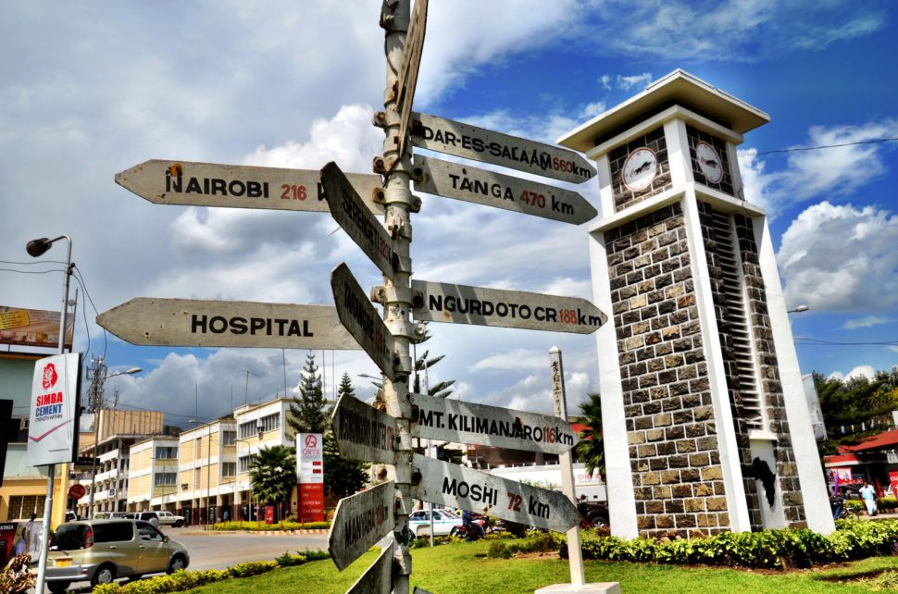

**Accommodation: Venus Premier Hotel / Venice Hotel**

**Meal: Bed & Breakfast**

**DAY 2: ARUSHA TO TARANGIRE NATIONAL PARK**

Early morning after having breakfast at your hotel in Arusha at around 0730hrs to 0800hrs you will be picked up by your personal driver guide and depart straight to Tarangire National Park whereby the drive is approximately 2.5 hours to the gate. Tarangire National Park is located on the northern part of Tanzania with a wide variety of animals and landscape whereby the best part is the elephant herds. It is known to be the park which has the greatest concentration of African elephants and the ancient baobab trees. Tarangire has an area of approximately 2603 square Kilometers and within the park it is possible to see plenty of animals like the giraffes, Zebras, Buffalos, warthogs, Lions, Leopards, Impala, gazelles, dik dik and many more species. In this park, there are more than 500 birds’ species like the bee eaters, swallows, ostriches, kori bustards, hammerkops, vultures etc. The word Tarangire comes from Mbugwe tribe whereby “Tara” means river and “Ngire” means warthogs therefore it is the river of warthogs. The Tarangire river is the life giving opportunity for both herbivores and carnivores and it is the best spot for the lions to hunt their prey as they search for water especially during the dry season. Lunch will be served at a picnic site at around 1200hrs to 1300hrs and after that you will proceed with your game drive until in the late afternoon where you will exit the park and drive straight to your campsite in Mto wa mbu for relaxation, dinner and overnight.

**Destination: Tarangire National Park**

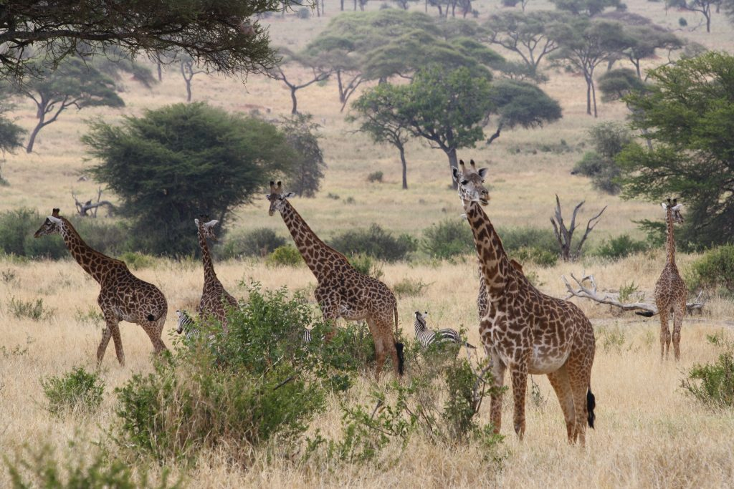

**Accommodation: Migombani Campsite**

**Meal: Full Board (Breakfast, Lunch & Dinner)**

**DAY 3: MTO WA MBU TO SERENGETI NATIONAL PARK**

Early morning after having breakfast at your lodge in Mto wa mbu at around 0730hrs to 0800hrs you will depart straight to Serengeti National Park passing through the Ngorongoro Conservation Area. Serengeti National Park is the most famous park on the northern circuit of Tanzania with the greatest population of wildlife than anywhere else on this planet. The word Serengeti originates from Maasai tribe, the word “Seringiti” which means endless plains. The park covers a total area of approximately 14,763 square kilometers with more than 2 million mammals inhabiting the park. The great annual migration involves more than a million wildebeests accompanied by some 250,000 zebras and antelopes and it is one of the 7 wonders of the world. This is exactly what makes this park the most famous park. The park is also home to more than 500 birds’ species including the ostriches, kori bustard, starlings, weavers, marabou storks, vultures, eagles, kingfishers, rollers etc. Animals that can be found inside the park are like the impalas, gazelles, topi, hartebeest, giraffes, hippo, buffalo, dik dik, waterbuck and predators such as lions, leopards, cheetahs, hyena, jackals, caracals, serval cats etc. The scenery of Serengeti on the south east is the short grass plains. The northern part of Serengeti also known as kogatende has more hills and rocks. To the western corridor known as Grumeti there are rivers, valleys as well as forests. Some areas in the heart of Serengeti heading up north of Serengeti are dotted with &#39;kopjes&#39;. The Serengeti National Park can be visited all year round but the best time to visit is during the dry season from June to October. Lunch will be served inside the park and afterwards, proceed with game viewing until the evening where you will drive straight to your accommodation for dinner and overnight.

**Destination: Serengeti National Park**

**Accommodation: Nyani campsite or similar**

**Meal: Full Board (Breakfast, Lunch & Dinner)**

**DAY 4: FULL DAY GAME DRIVE IN SERENGETI NATIONAL PARK**

Early morning after having breakfast at your accommodation inside Serengeti, you will start an early morning game drive looking for the big cats and the active animals. Lunch will be served inside the park whereby after you will proceed exploring the park and all that it has to offer from the landscape, wildlife and manymore. In the evening, you will drive back to your camp for relaxation, dinner and overnight stay.

**Destination: Serengeti National Park**

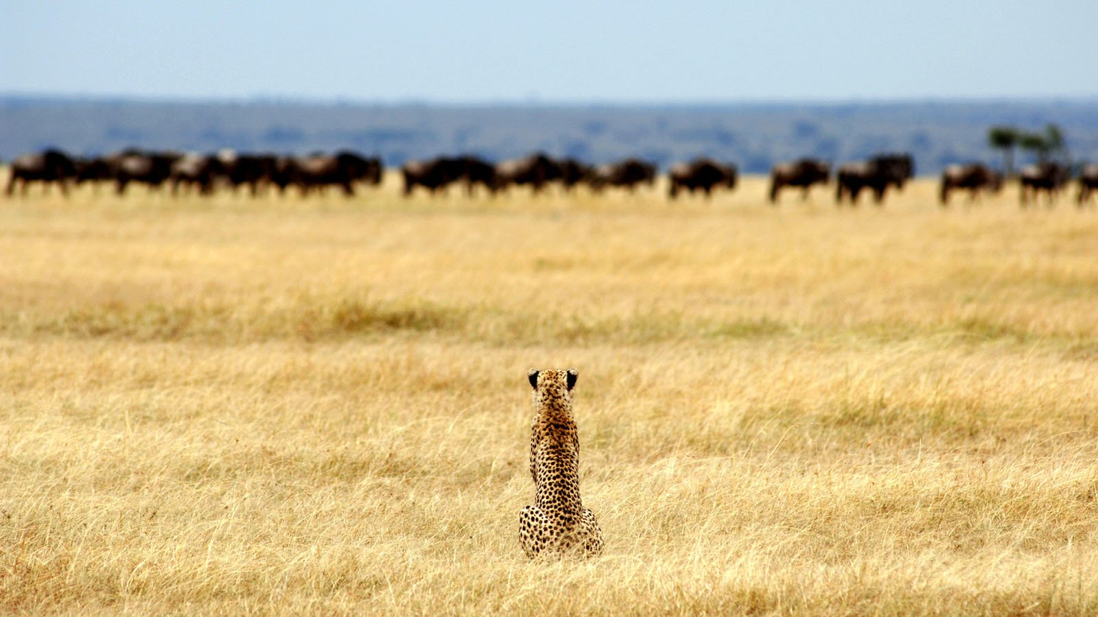

**Accommodation: Nyani campsite or similar**

**Meal: Full Board (Breakfast, Lunch & Dinner)**

**DAY 5: SERENGETI NATIONAL PARK TO NGORONGORO CONSERVATION AREA**

Early morning after having breakfast at your accommodation inside Serengeti, you will drive straight to Ngorongoro Conservation Area en-route to your campsite for dinner and overnight stay.

**Destination: Ngorongoro Conservation Area**

**Accommodation: Simba campsite**

**Meal: Full Board (Breakfast, Lunch & Dinner)**

**DAY 6: NGORONGORO CRATER TO MTO WA MBU**

Early morning after having breakfast at your campsite, you will drive straight to the floor of the crater. Ngorongoro crater is a world heritage site as well as a geo-park. It is 600m deep and before you descend the crater you will stop at a view point where you can see the crater below. The Ngorongoro crater has approximately 25000 mammals and has more than 500 birds’ species where there are also migratory birds like the flamingos. The interesting part with Ngorongoro crater is that it is the best place in East Africa to witness the endangered black rhinos which completes the big 5. In Ngorongoro you can find animals like the Zebras, wildebeests, hyenas, lion prides, gazelles, impalas, kudus, waterbucks, buffalos and many more. The Ngorongoro crater has a diameter of approximately 20km whereby it is easy to spot animals and one can spend 5-6 hours exploring the park if you have a limited time. The other attraction in Ngorongoro crater is the Ngoitoktok picnic site which is a permanent hippo pool where most of the clients have their fabulous lunch at this place. The beauty of Ngorongoro can never be untold to the visitors who have visited this area. After having packed lunch at a picnic site at the hippo pool, you will finalize your game drive before you ascend the crater and drive straight to your accommodation in Mto wa mbu for relaxation, dinner and overnight.

**Destination: Ngorongoro crater**



**Accommodation: Migombani Campsite**

**Meal: Full Board (Breakfast, Lunch & Dinner)**

**DAY 7: LAKE MANYARA NATIONAL PARK TO ARUSHA**

Early morning after having breakfast at your camp at around 0730hrs to 0800hrs you will depart straight to Lake Manyara National Park whereby the drive is approximately 1 hour to the gate. Lake Manyara National Park is well known for its birds’ life and also known as the home of tree climbing lions. The park has an area of about 325 square kilometers whereby a third of the area is the land and the rest is the lake which makes Lake Manyara the best attraction. Lake Manyara is a shallow alkaline lake that attracts a number of birds to the area. The birds’ species that can be found in Lake Manyara includes both migratory birds and native birds species like the flamingos, pelicans, storks, herons, cranes, secretary birds, ground hornbills, ostriches and many more birds species. Animals that can be found in lake Manyara are like the lions, elephants, giraffes, zebras, warthogs, wildebeests, baboons, blue monkeys, waterbucks, bushbucks, rarely leopards, buffalo etc. The park is located on the south western part of Arusha at the rift valley region which makes it easier to do different activities like the forest hike on the rift valley and other activities include canoeing, tree canopy walk, walking safari around the lake etc. Lunch will be served at the picnic site, and after that you will drive straight to Arusha where you will meet one of the representatives from Bapta African Safaris who will give you a special farewell. If you would like to have an extra night in Arusha we can arrange that for you in advance or if you have a flight, we will drive you straight to the airport to catch your onwards flight back home or to your next destination.

**Destination: Lake Manyara National Park**

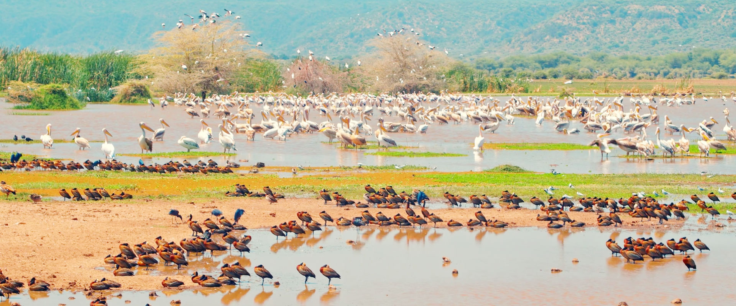

**Meal: Breakfast & Lunch**

**INCLUSION**S

• Private Toyota Landcruiser 4x4 with pop-up roofs

• Private professional safari guide

• Private Chef

• All camping gears

• All Park Fees

• Government Tax

• Unlimited drinking water, tea, coffee

• Some soft drinks & beers inside the safari vehicle

• Flying Doctors Insurance (AMREF)

• Domestic flights

**EXCLUSIONS**

• International flights

• Tips

• Personal needs

• Visa

**ALL C0ST IN US DOLLARS**

**$ 3620 1 PAX $ 4,796 2PAX $ 6015 3PAX $ 7190 4PAX $ 8,395 5PAX $ 9577 6PAX**

**$ 517 PPD $ 342 PPD $ 286 PPD $ 256 PPD $ 239 PPD $ 228 PPD**

**25% 20% 18 % 16% 15% 14%**

**Activies can be done in Arusha when clients have leisure day.**

**Lake Duluti Activities**

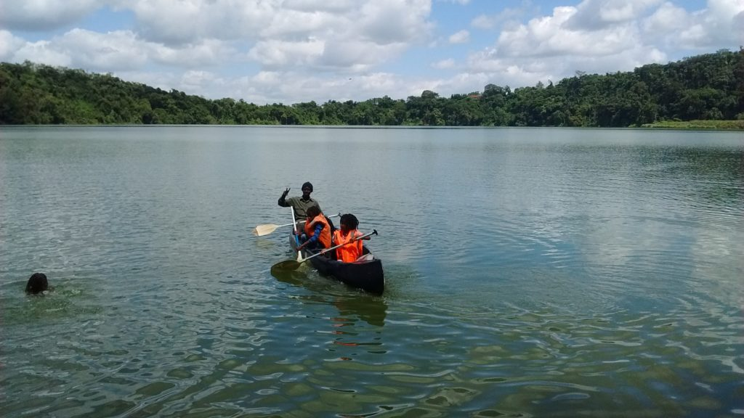

Lake Duluti is a small crater lake located in the eastern part of Arusha. The drive takes approximately 20-25 minutes from the city of Arusha. Lake Duluti is surrounded by a very thick forest that is home to a huge number of reptiles like the snakes and lizards while the lake itself is a paradise for varieties of bird species. Exploring the area around Lake Duluti is extremely fun. Enjoy the canoeing activity at Lake Duluti and the hike at Duluti Forest and get to see the varieties of animals and plant species. Lake Duluti is formed inside a volcanic crater and has plenty of water throughout the year, mainly from seasonal rainfall and groundwater. The crater is subsidiary vent to the Mount Meru (4566m) that towers over the lake. You will cross the surface of this Crater Lake and view the majestic birdlife including Giant kingfishers, Fish eagles, Darters, pelicans and many more. Surrounded by forested crater walls this is a very unique and quiet 1.5-hour canoeing experience.

**MATERUNI WATERFALLS & COFFEE TOUR**

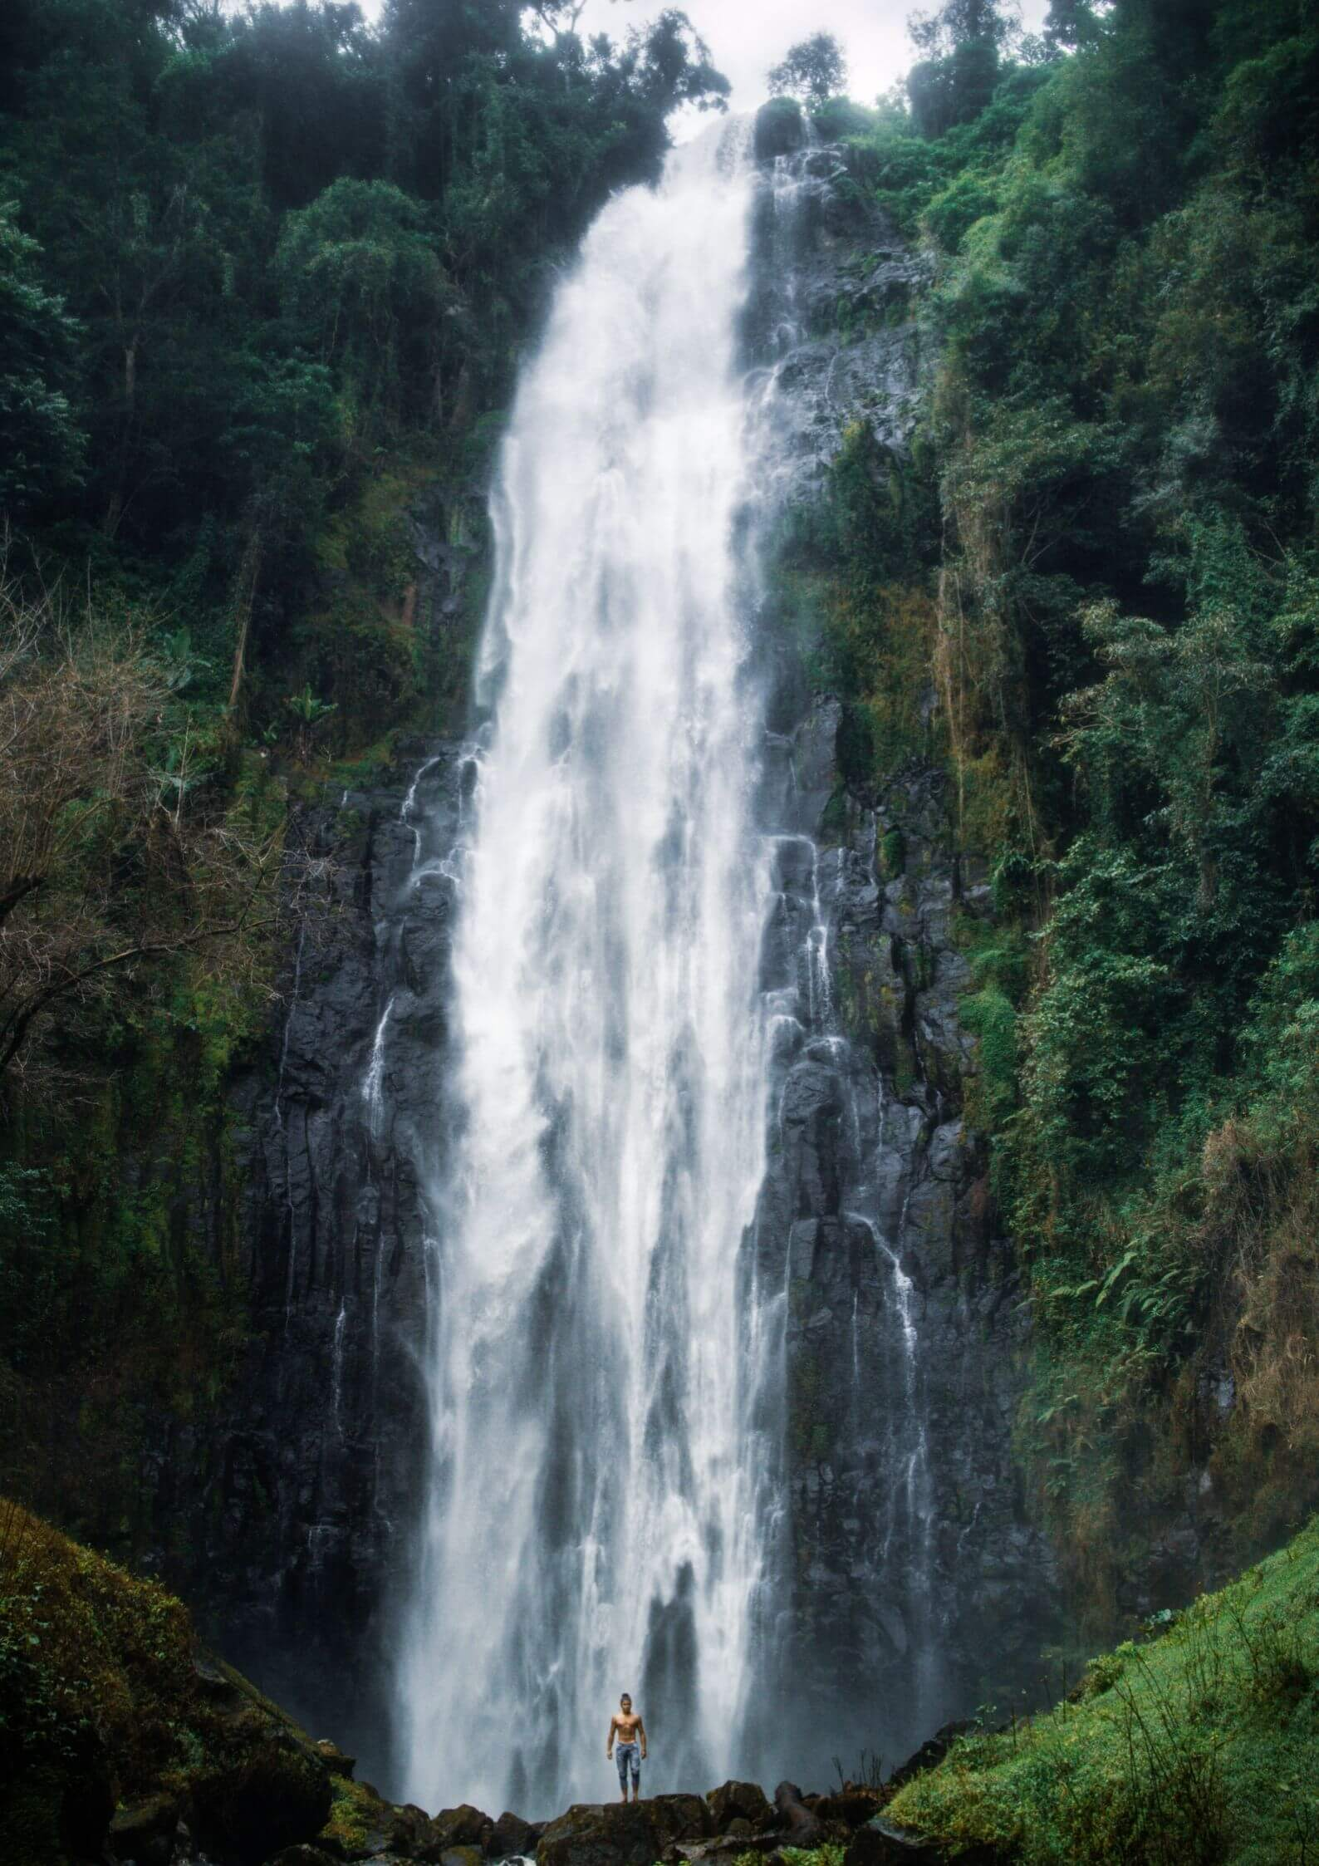

A day trip to Materuni Village and Waterfalls is a unique way to enjoy your day either from Arusha city or Moshi town. This walk to Materuni Waterfalls offers can be also great for people who are preparing to climb Mount Kilimanjaro for acclimatization or enjoyment after or before safari trip. This tour begins with a gentle walk to Materuni Waterfall which might be sloppy a times. On the way you will get a chance to see different fruits are grown by the local people such as bananas, mangos, lemons, avocados as well as learn more about people from the village including their history, agriculture, economy, traditions and their daily life. You will continue with your trail up to the waterfall where you can be able to swim in the natural pool so make sure you bring your swim suits. After that you will head back to the village and learn about how coffee is grown in the area and processed from bean to cup. You will also participate in the coffee making process while the chagga people sing and bring energy to the activity. You will also make your own cup of coffee. After that you will depart back to your next destination.

 Duration: 3-4 hours

**BALLOON SAFARI**

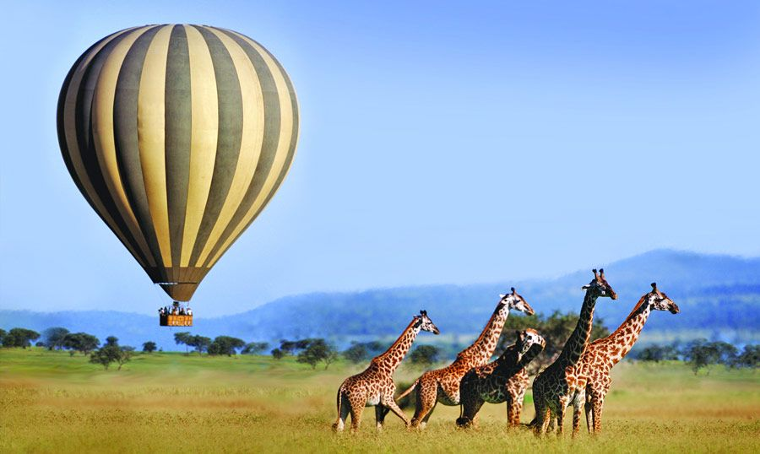

This is a very unique way to experience wildlife in a different perspective whereby you will be exploring the safari from the sky. This is done in different areas such as Ngorongoro conservation area, Serengeti National Park and Tarangire. If you are following the great migration, this will be a major highlight of your whole safari. How it works;

Pre-arrangements are made early and your tickets will show the drop-off locations where your guide will take you there so that you can start early before sunrise. When you arrive at the launch site, the pilot will explain to you about the sitting positions and precautions before take-off. Snacks will be offered before you start. You may take pictures which will be a great memory for this special event. The time is to take-off at around 6am and this normally takes 1-1.5-hours but this depends on the weather condition. It might take a bit longer or shorter for safety reasons. Upon landing, you will be surprised with a hearty breakfast and champagne where you will celebrate this special event. After that you will drive to your accommodation for the arranged breakfast and drive off for game drives.

**RUNDUGAI HOTSPRING**

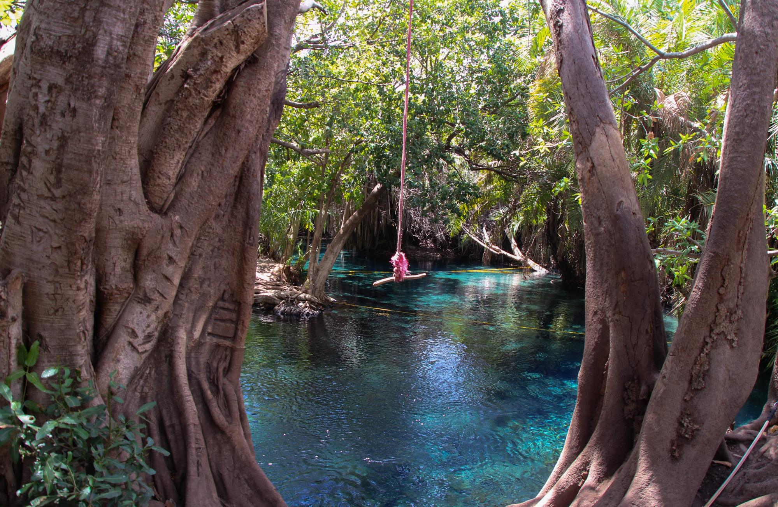

The beautiful Rundugai Hot Springs are located in the middle of the Sanya Plains, about 35 km from Moshi. It is a small oasis in the heart of a dry and dusty landscape. Locals call this wonder the ‘Chemka Maji Moto’ meaning ‘boiling warm water’. This refers to the way in which the bubbling water emerges from under ground. The water has a nice temperature and is crystal clear, so you can see all the way to the bottom. The Rundugai Hot Springs are surrounded by tropical palm trees and impressive roots of big fig trees. It’s a true paradise and a great place to swim, relax, picnic and enjoy the beauty nature has to offer. There is also a rope swing for jumping into the water. On clear days you can even see the majestic Mount Kilimanjaro from here.

**HORSE RIDING ATIVITES**

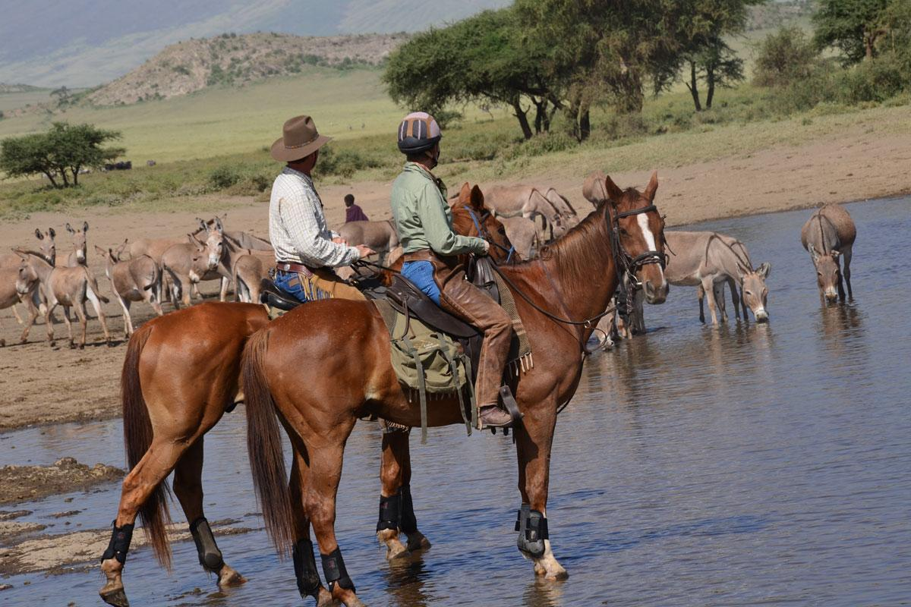

The ride takes place on the Wildlife Estate and whether you are a complete beginner or an advanced rider, it is an opportunity and experience for everyone. If you wish to, the activity can also be organized somewhere else, for example in any other national environment. It is also often done at Longido area or Lake Natron as you can see on the pictures. Those with little horse-riding experience can enjoy a gentle hack along dusty tracks were wildebeest and antelopes graze contentedly. Led by experienced guides, one can explore the meandering paths, spotting a rich array of wildlife like zebras, wildebeests, eland and other gazelles and antelopes along your way. Regularly seen on the horse ride is one of the most elegant and rarest mammals found in Tanzania – the Gerenuk.

**TOWN TOUR**

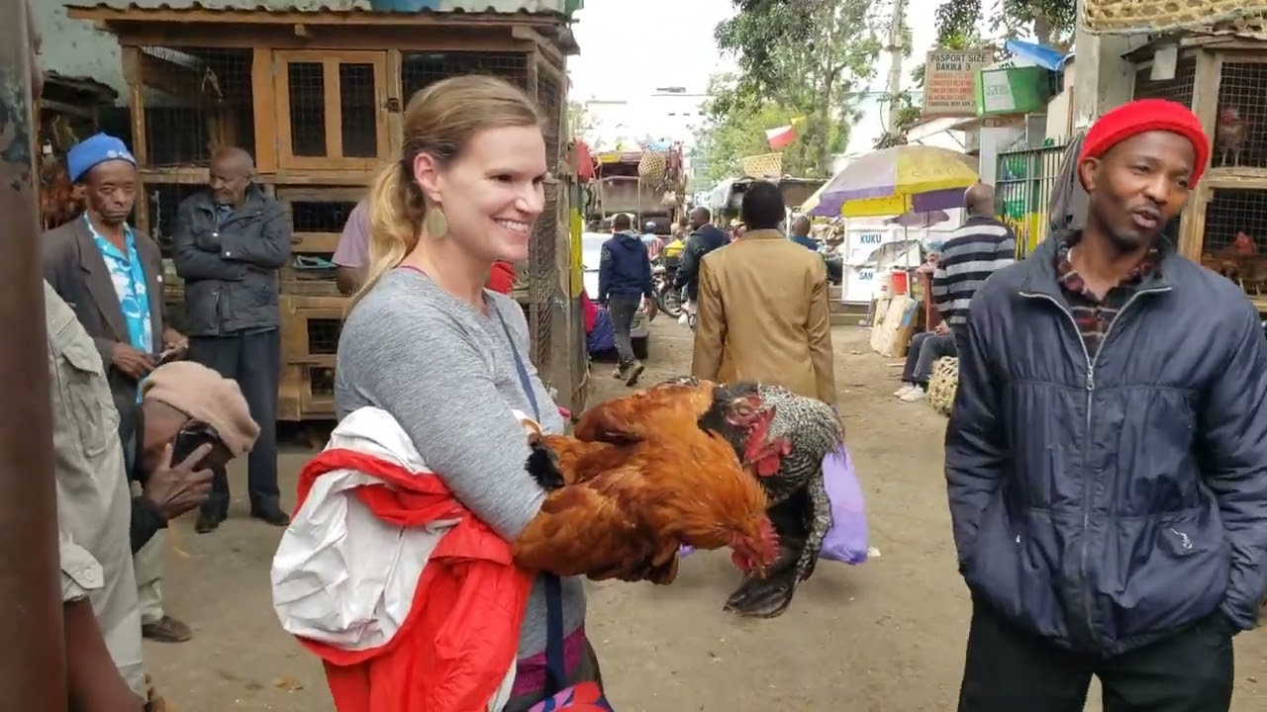

Clients can do town tour half day, and enjoying seen attraction different wonders like uhuru torch which build in 1967 when Arusha Declaration launched. Also, clients will visit clock tower which is Center of Afrika between Cairo and Cape town also center of three countries Kenya, Uganda and Tanzania. Clients will visit local markets where will see and enjoy fresh fruits from farm and experience local people buy and sale. Also, clients will visit Locomotive Railways which was built in 1929 by Germany empire for purpose of transporting factory row material from Morogoro Dar es salaam, Tanga, and Moshi Regions. Which is still working till now.